**Databases:**

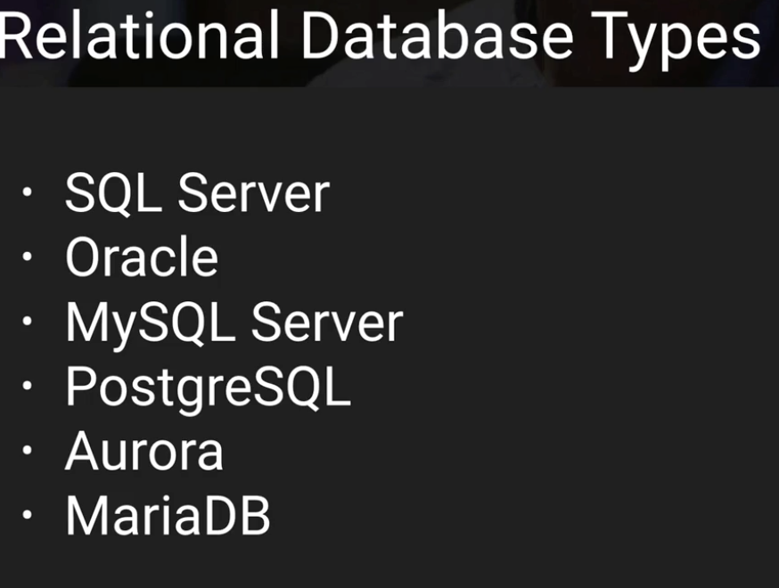

JSON <-> NoSQL

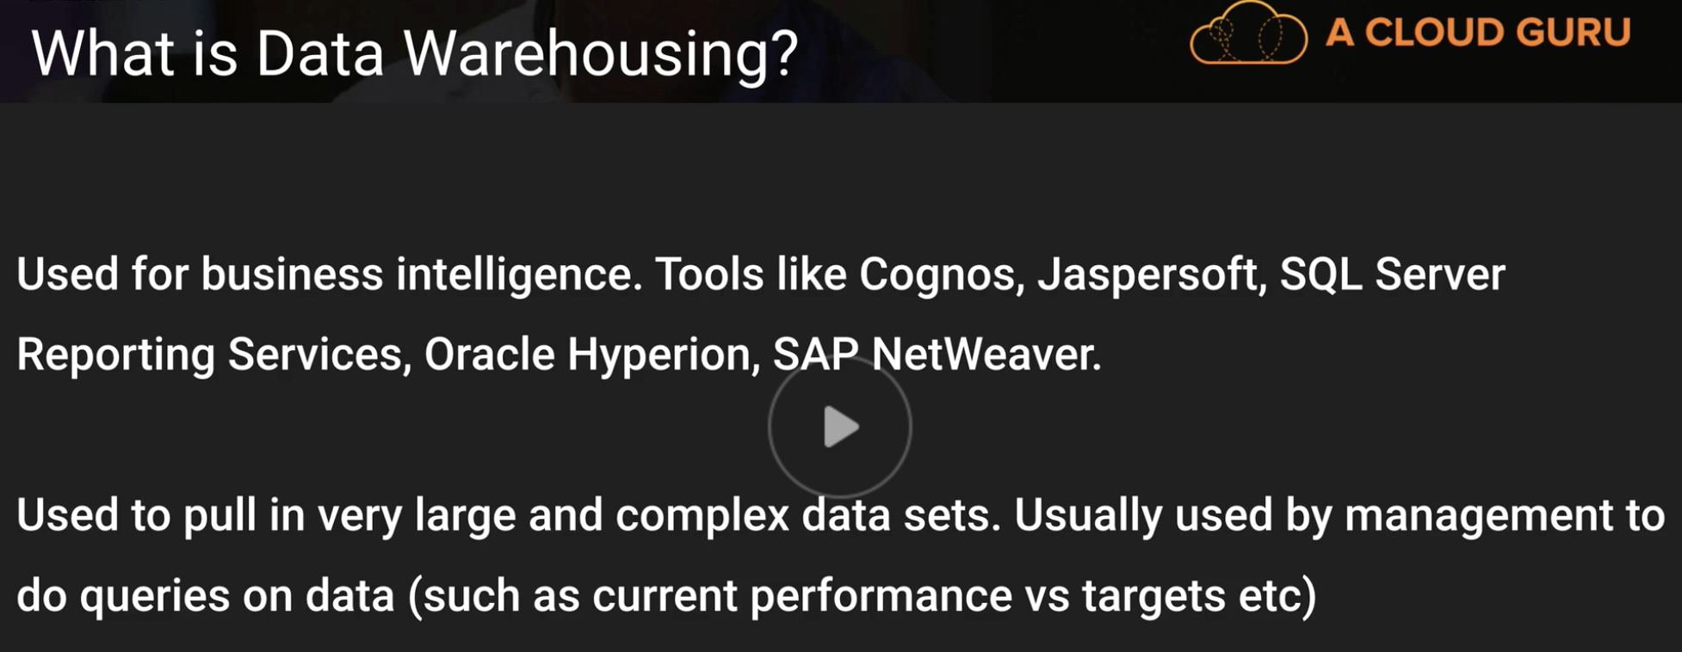

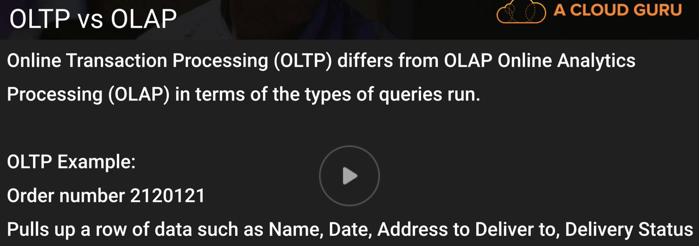

OLAP -

OLTP -

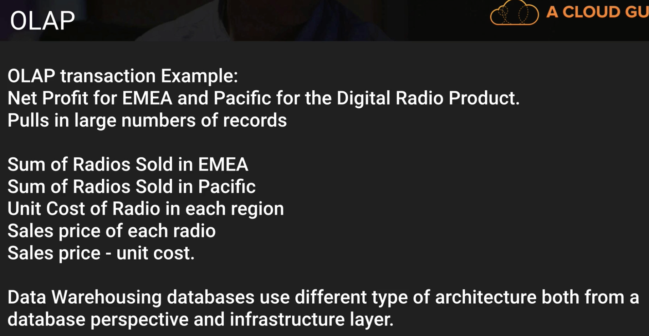

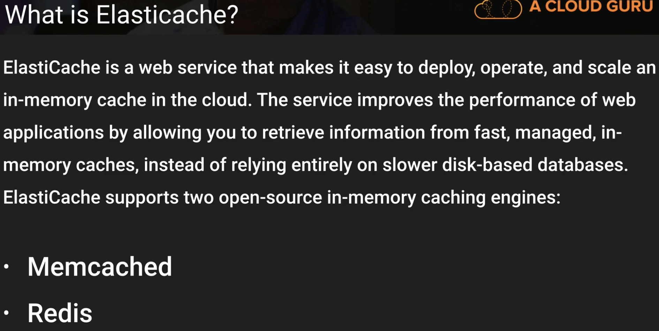

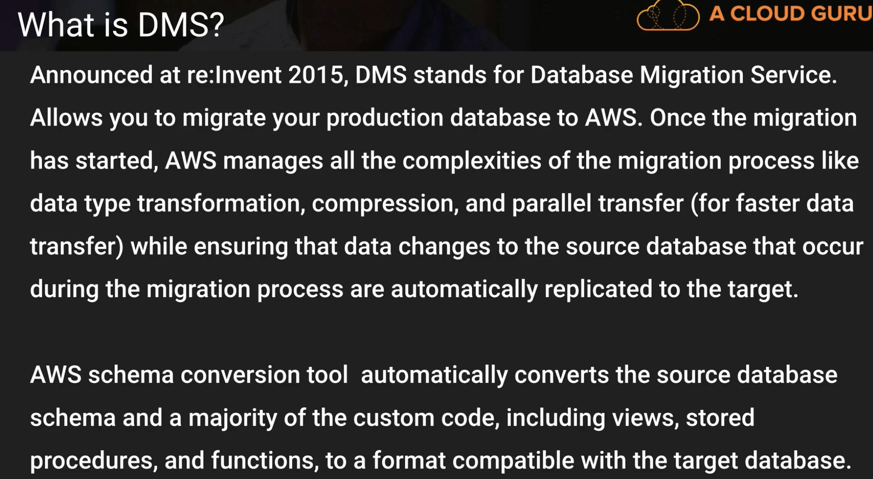

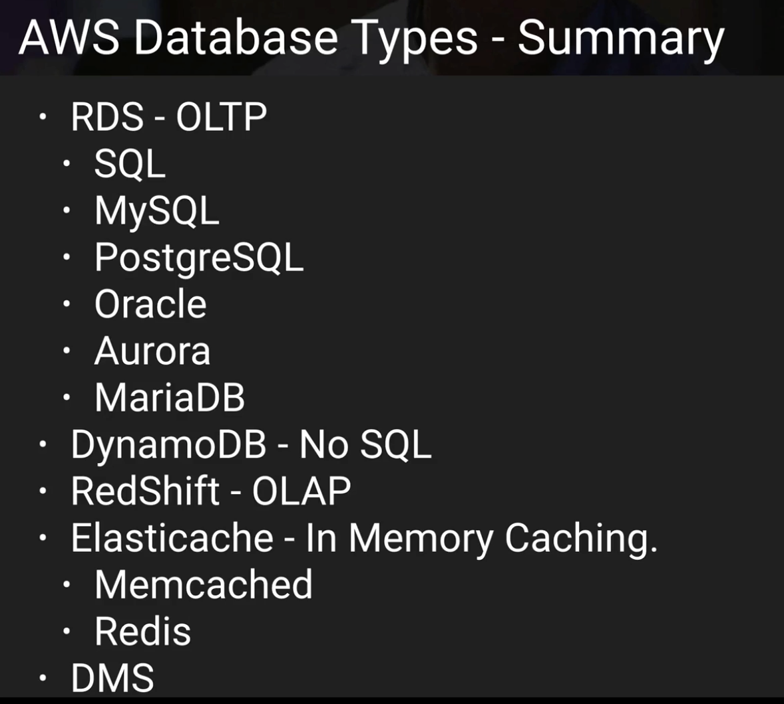

**DYNAMO DB:**

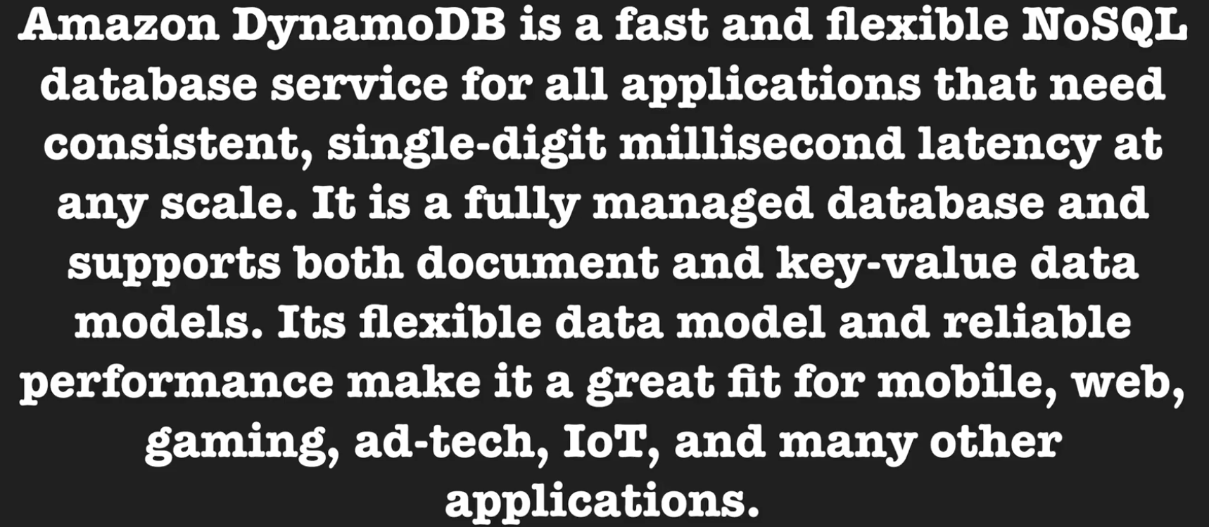

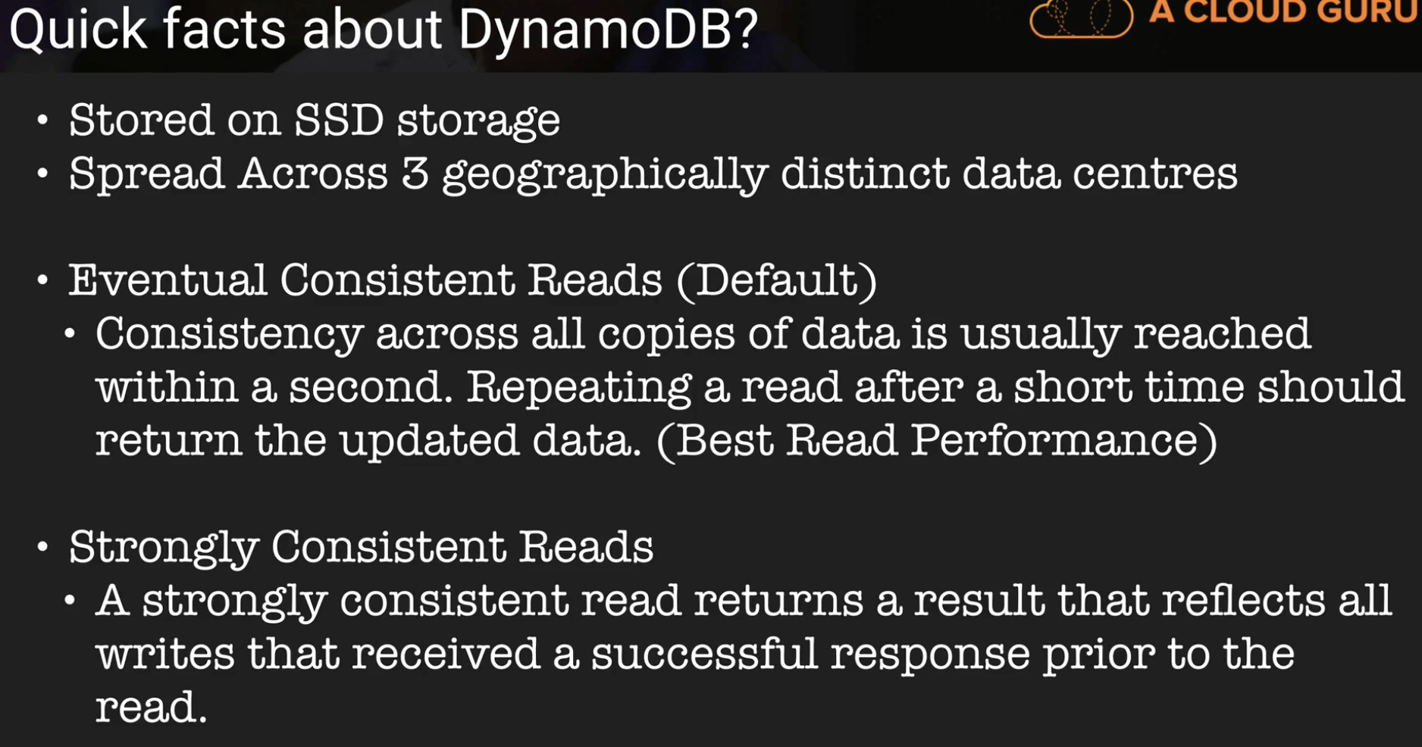

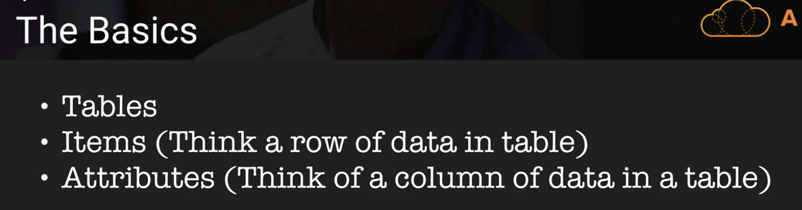

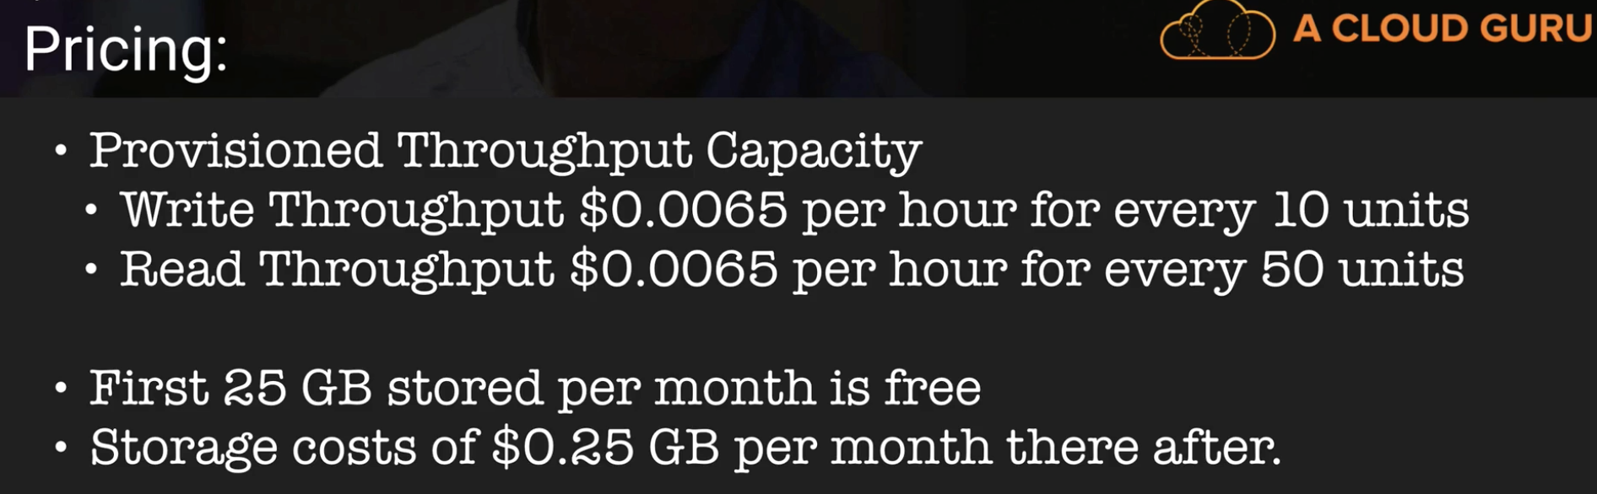

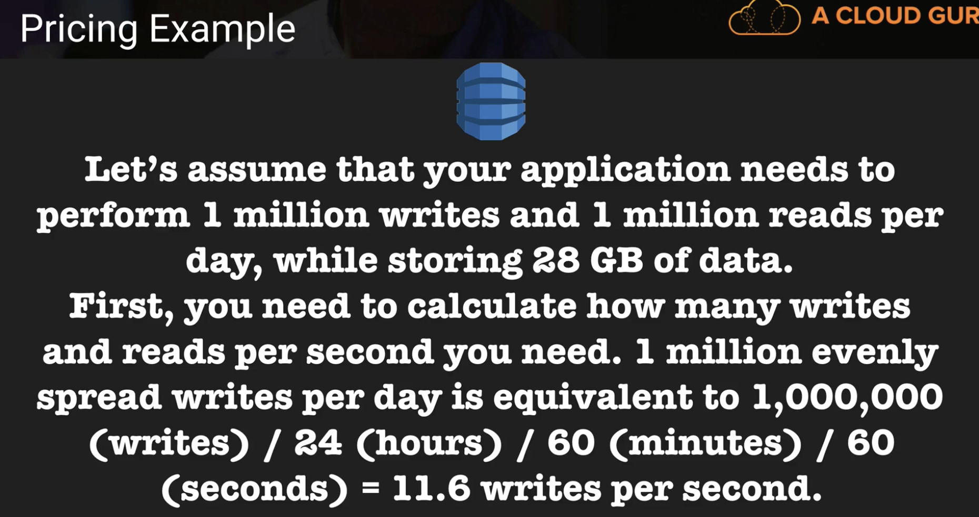

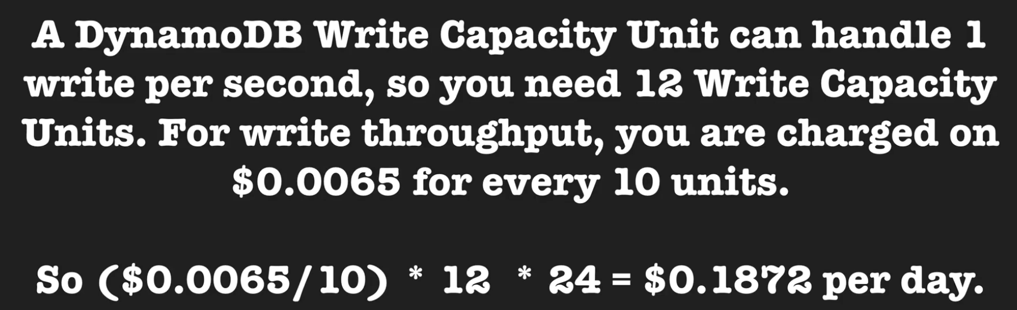

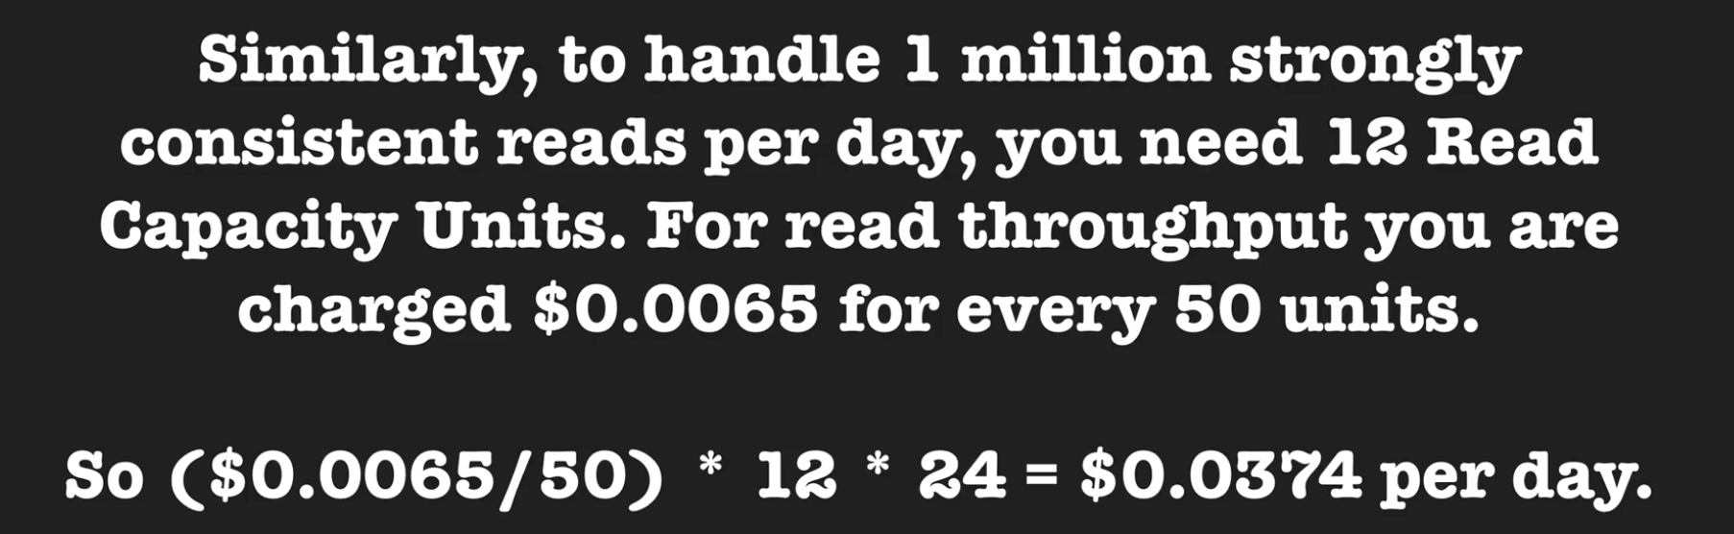

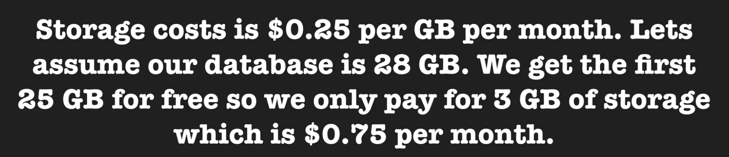

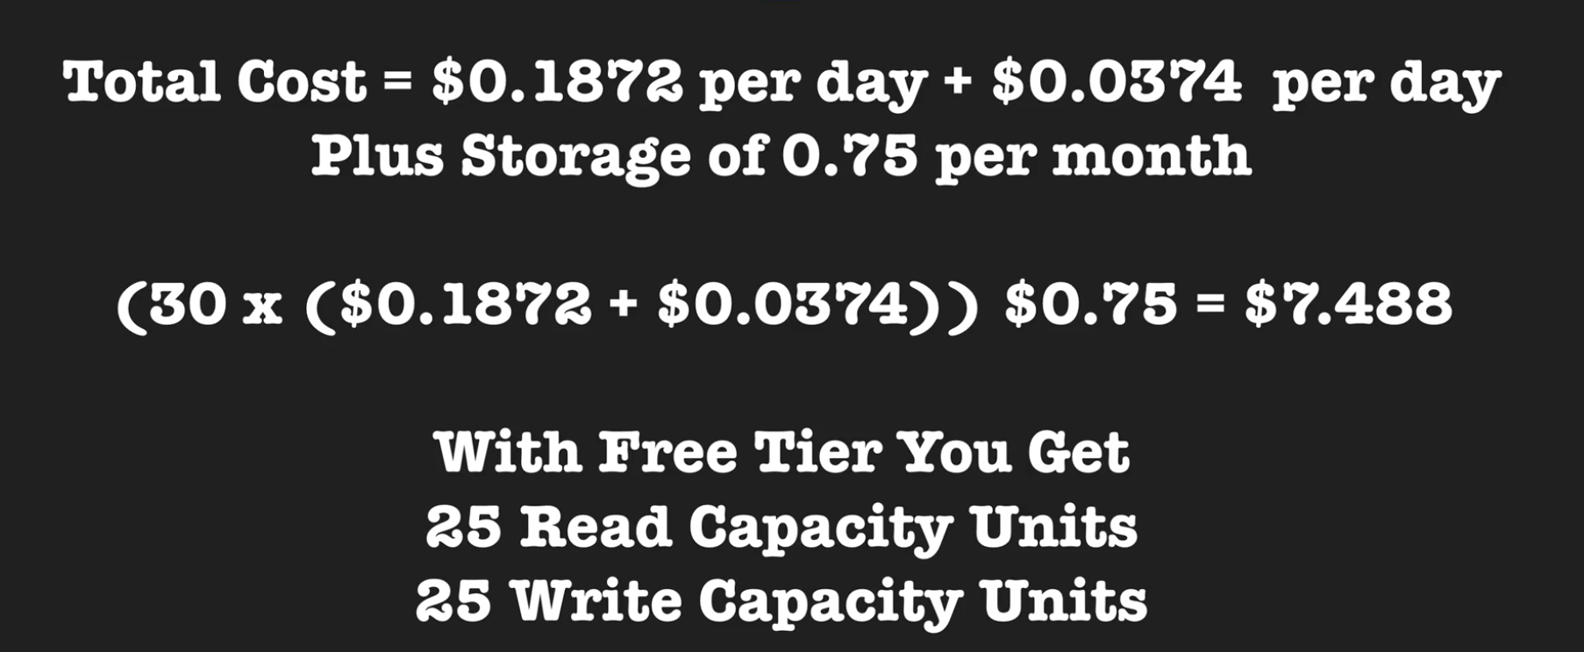

Here, 30 days multiply (read unit charge + write unit charge) plus 30 days storage cost in GB.

**Dynamo DB Indexes and Streams:**

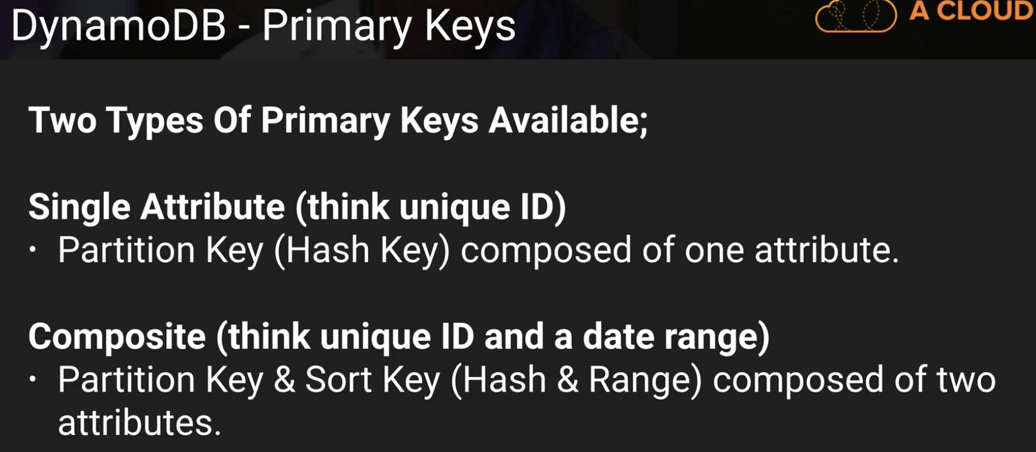

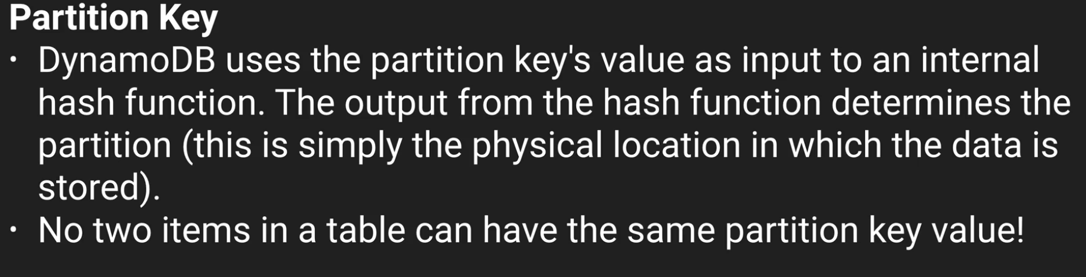

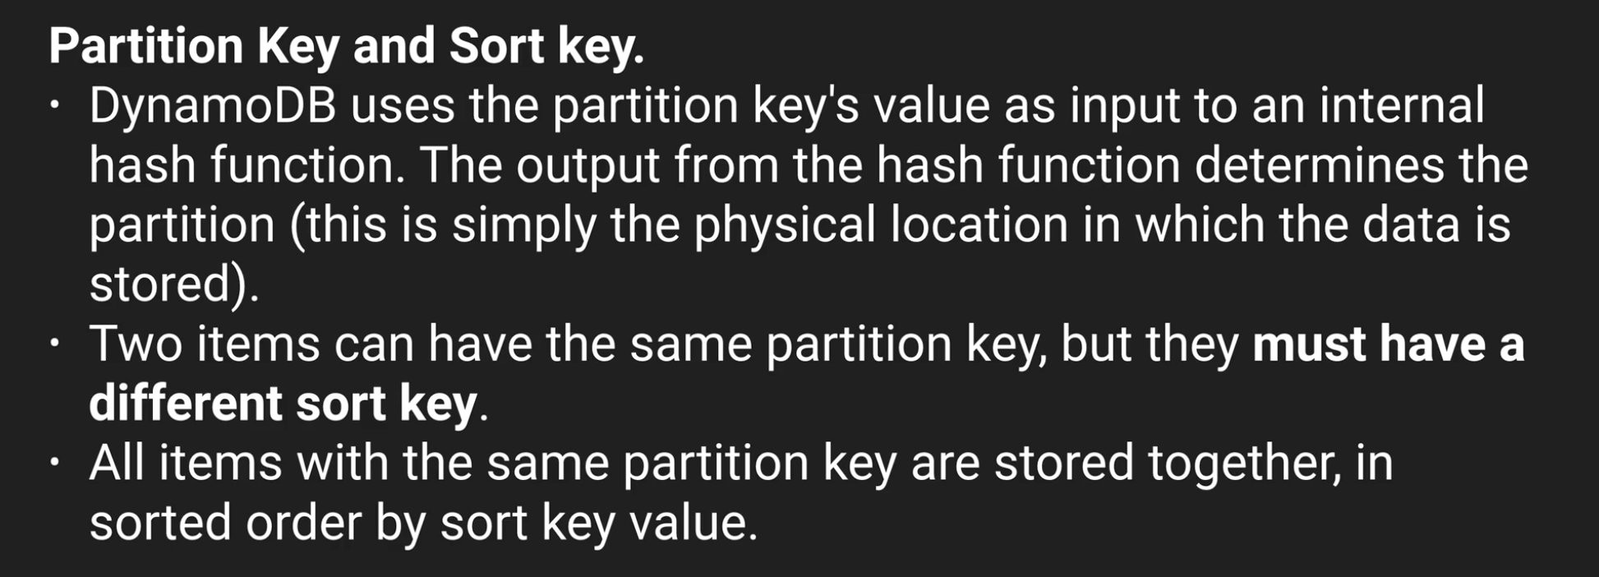

Confused with below slide ☹

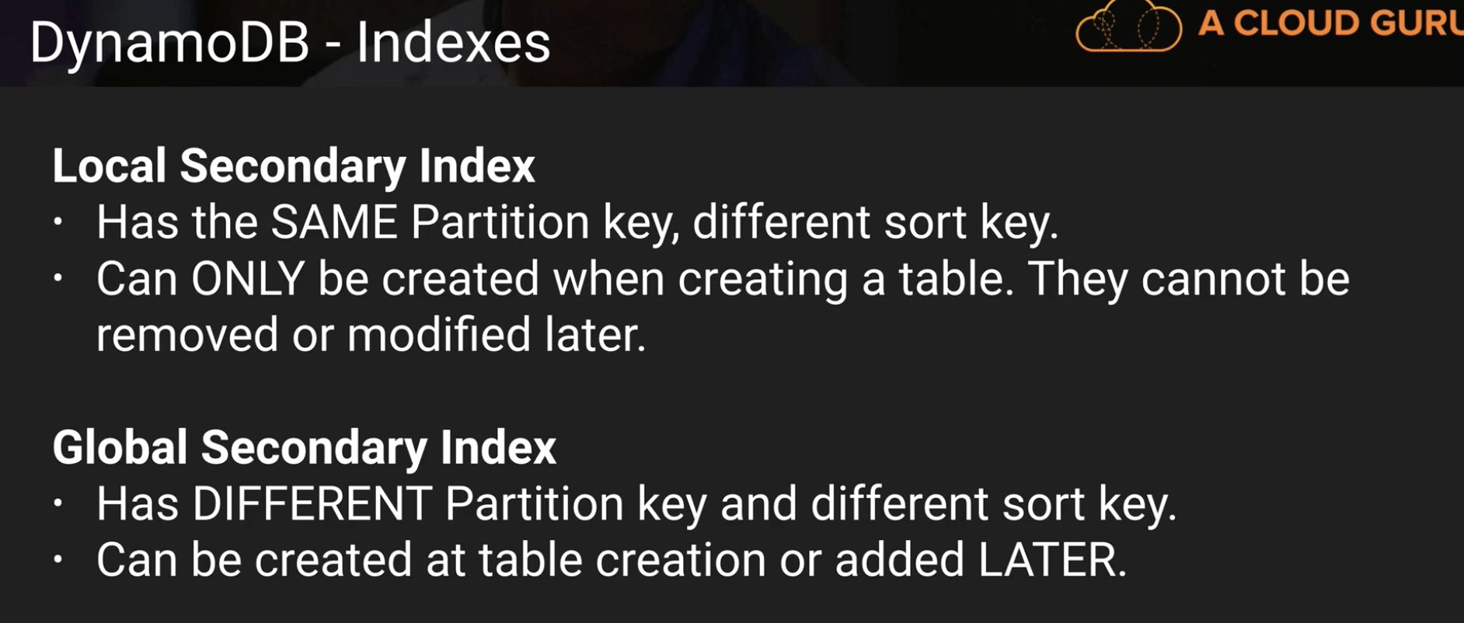

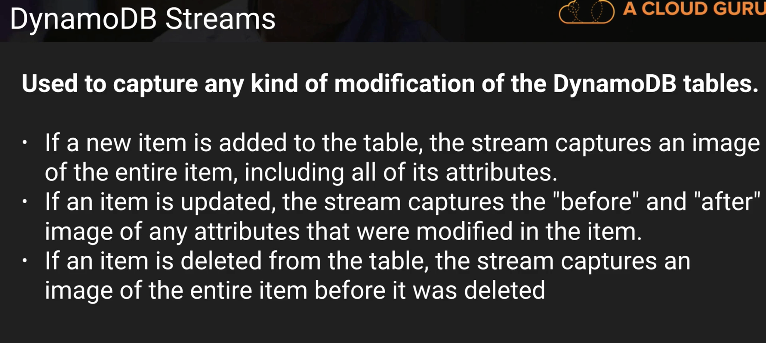

Above slide in a pictorial way:

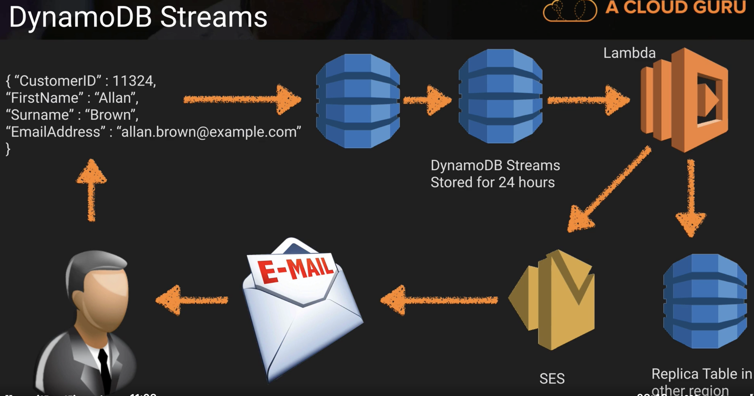

Per table you can have Local Secondary Indexes and Global indexes

Triggers -> sending welocome email to new users

Access control list in dynamo db -> you can add like facebook can only query some number of rows, etc..some rules

**Scan vs Query API Call:**

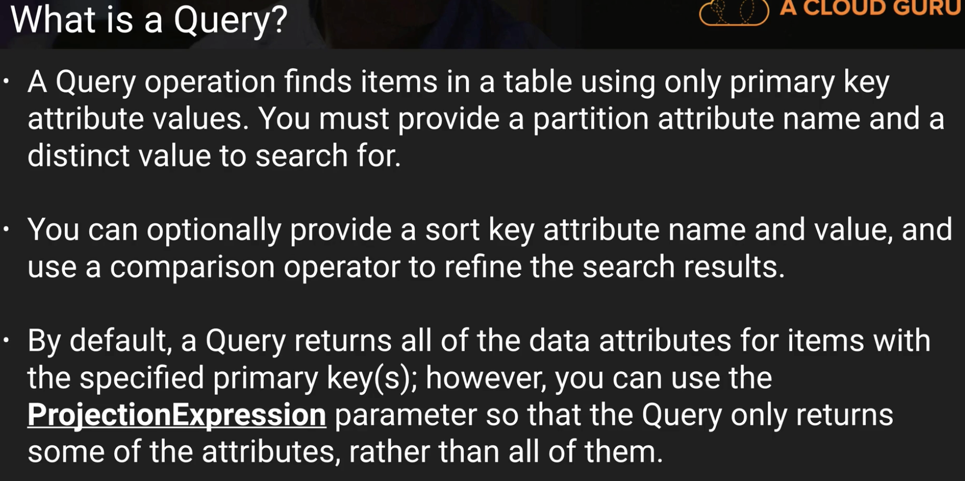

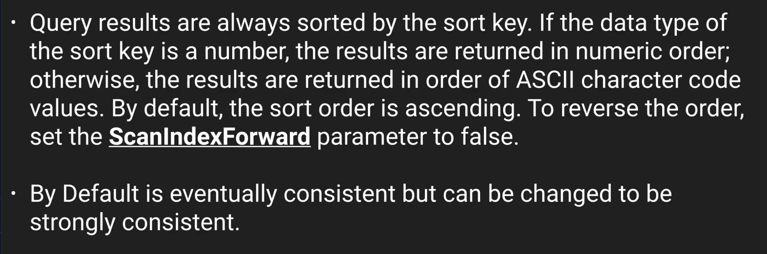

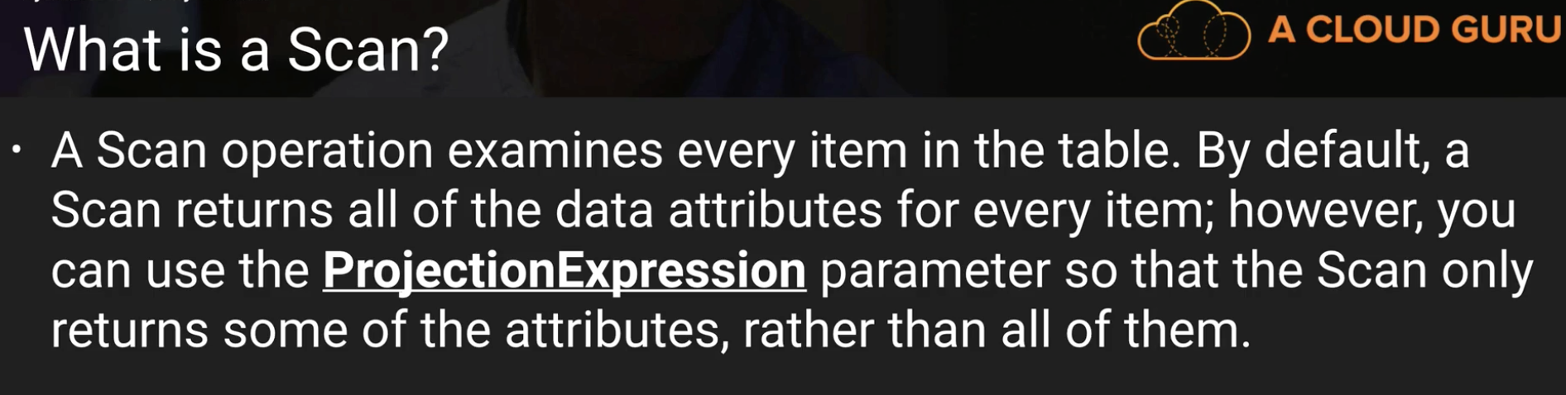

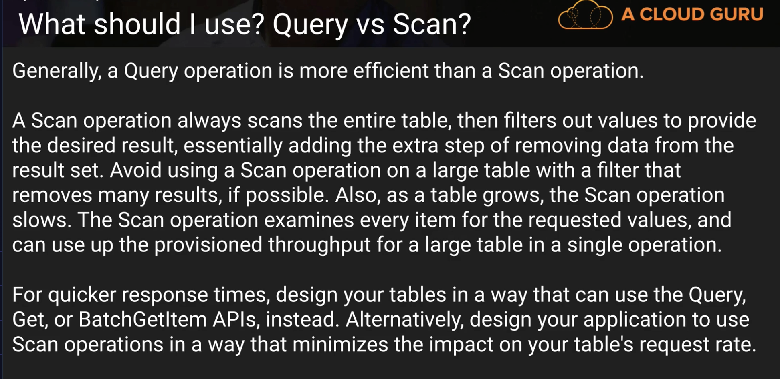

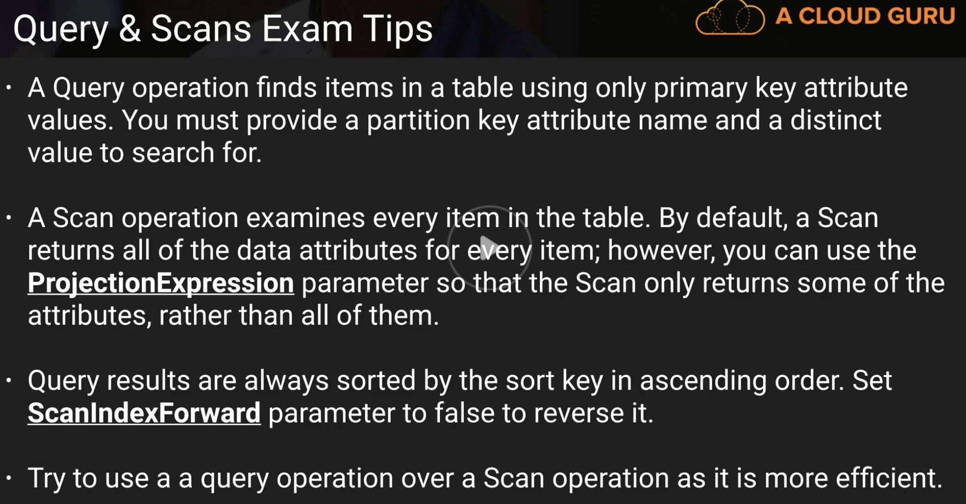

**Dynamo DB Provisioned Throughput: \*\***

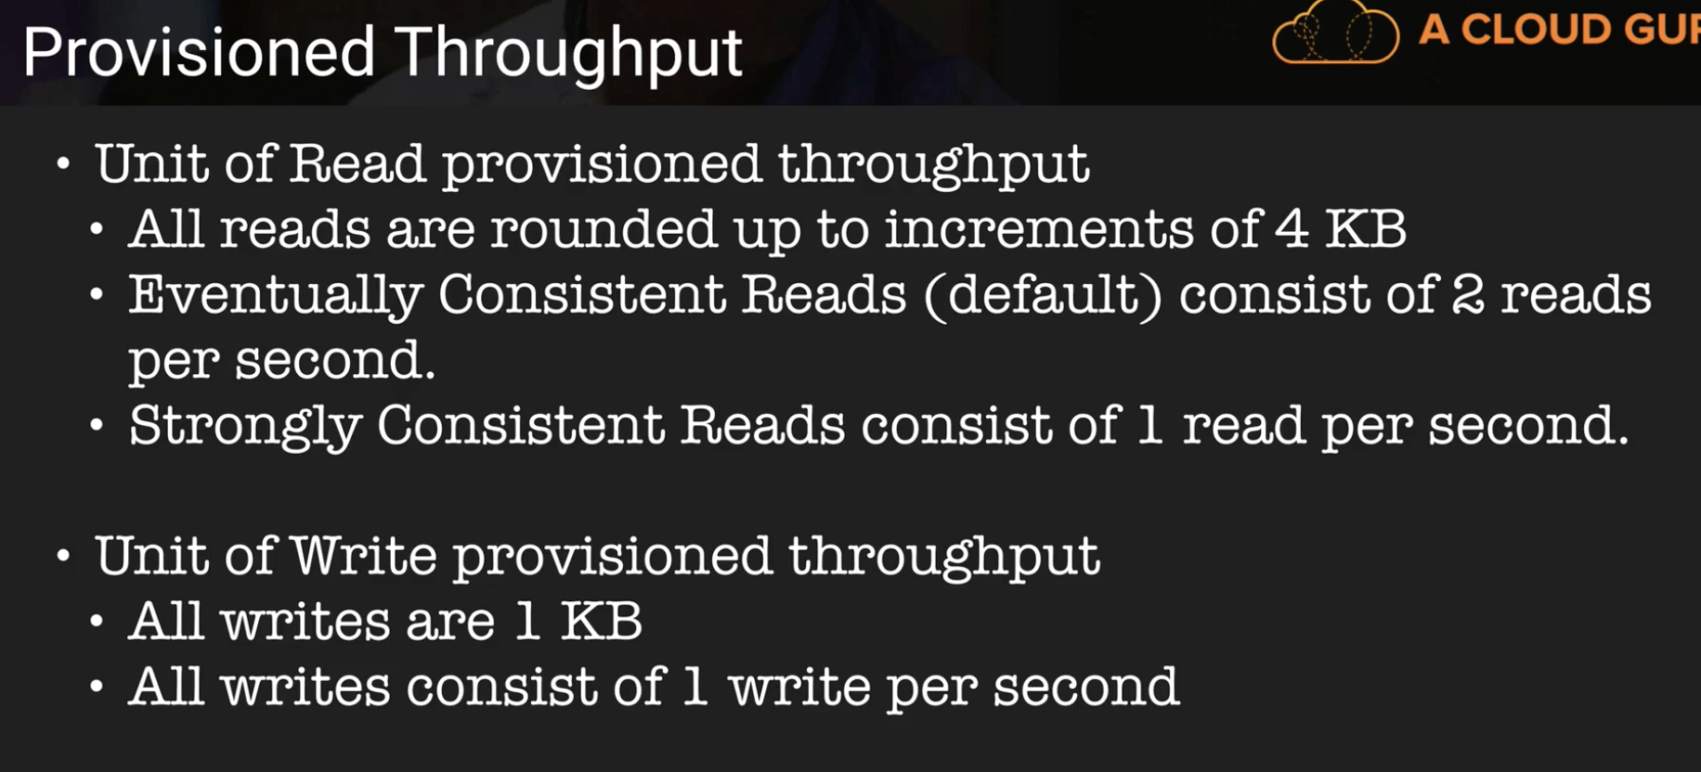

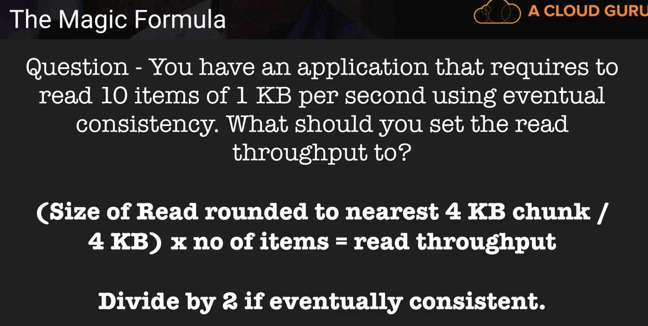

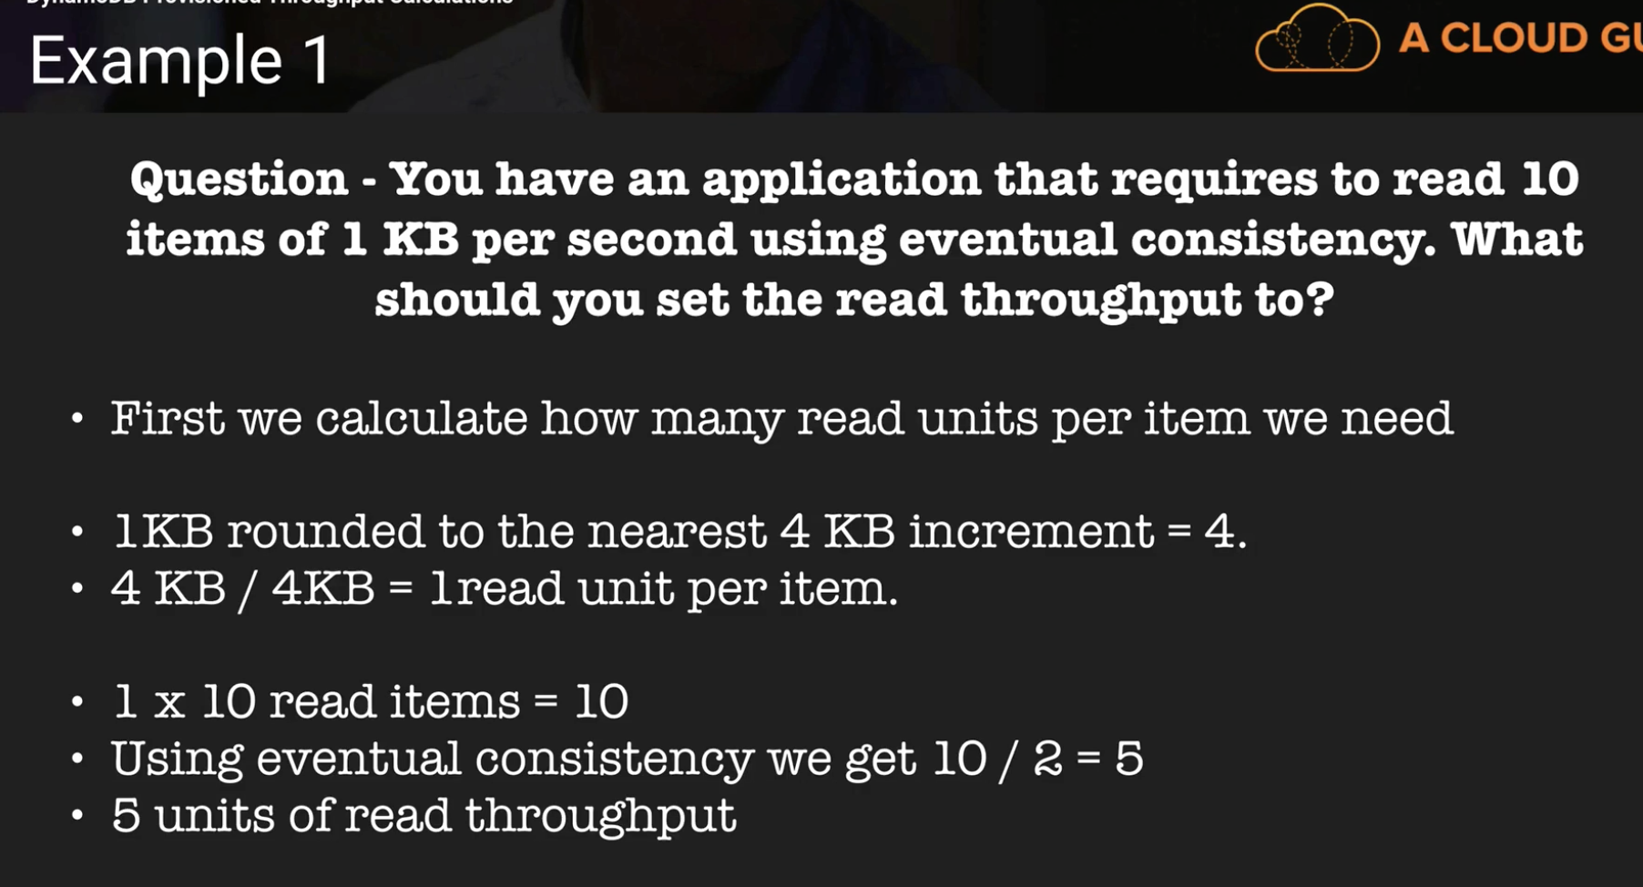

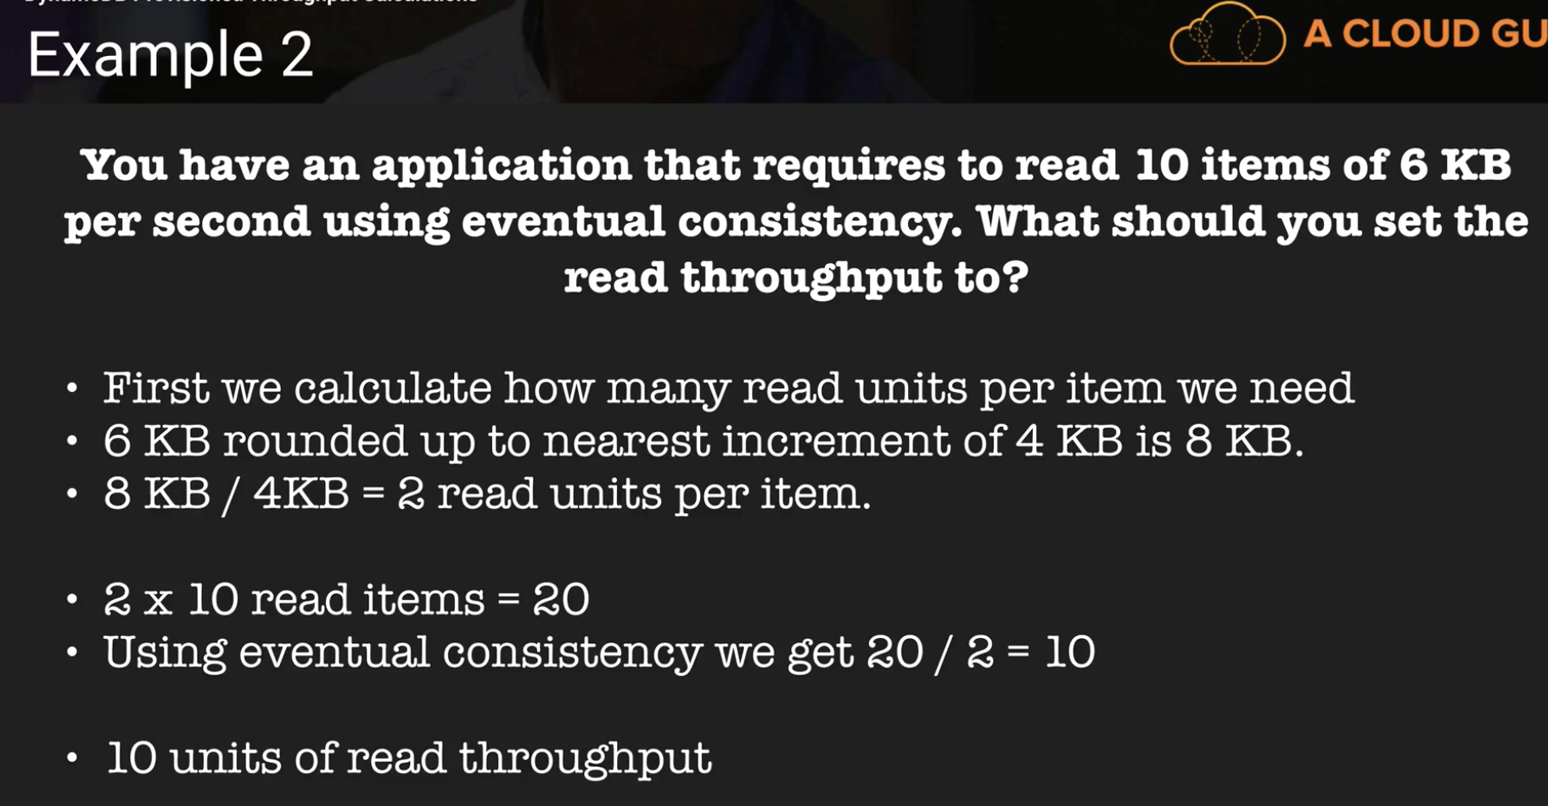

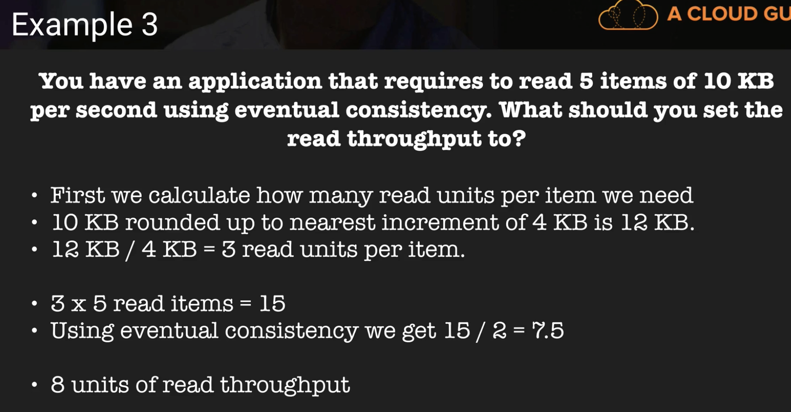

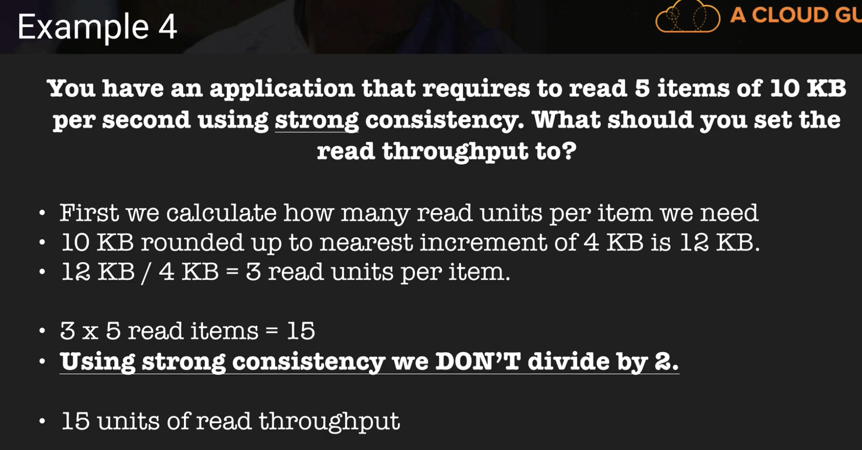

In all these questions, make sure you are given **per second, not per minute**

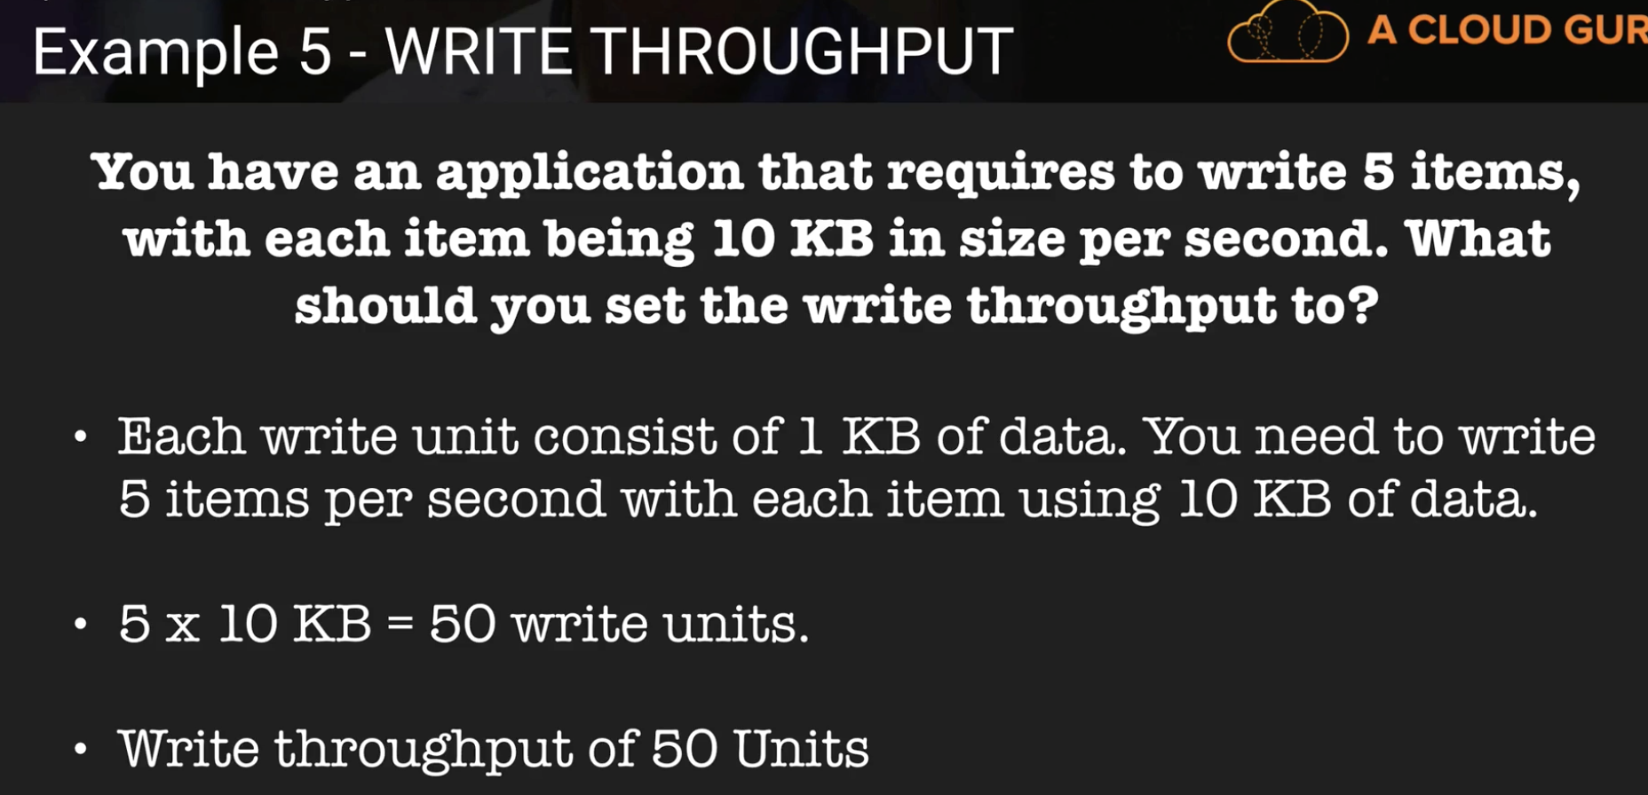

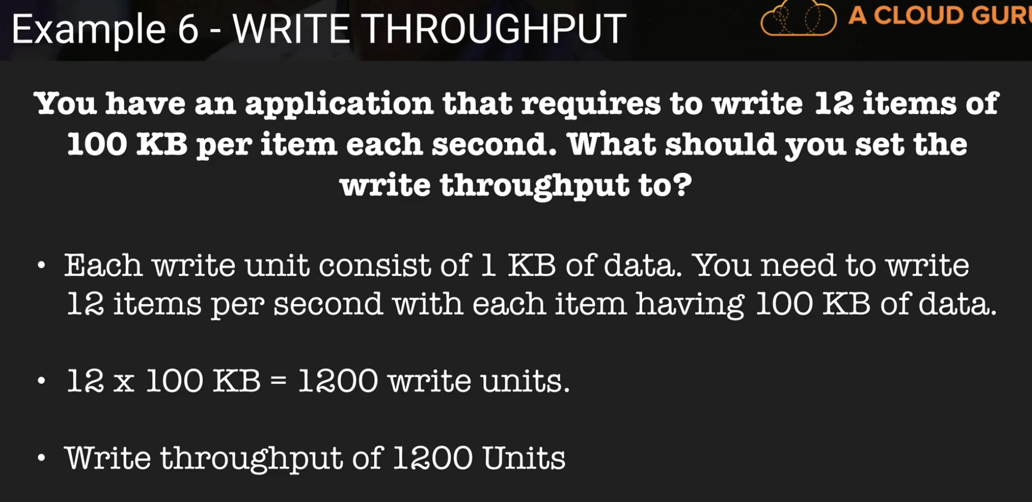

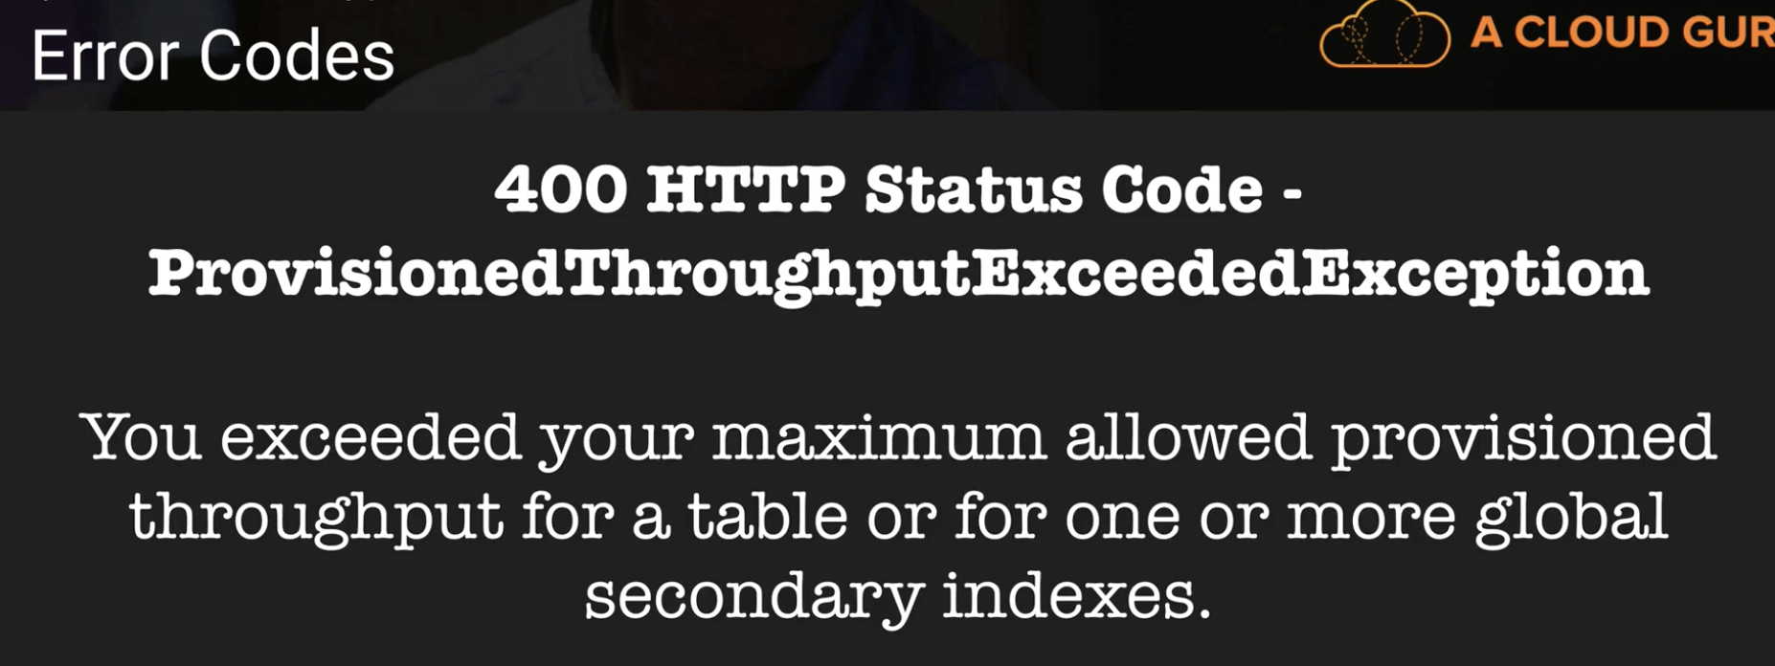

**Web Identity Providers:**

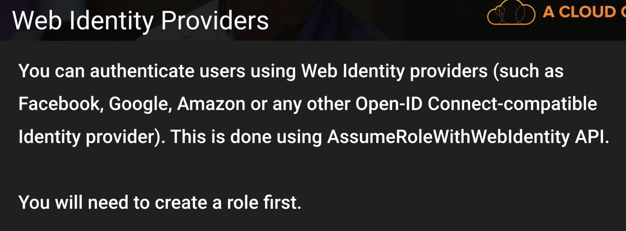

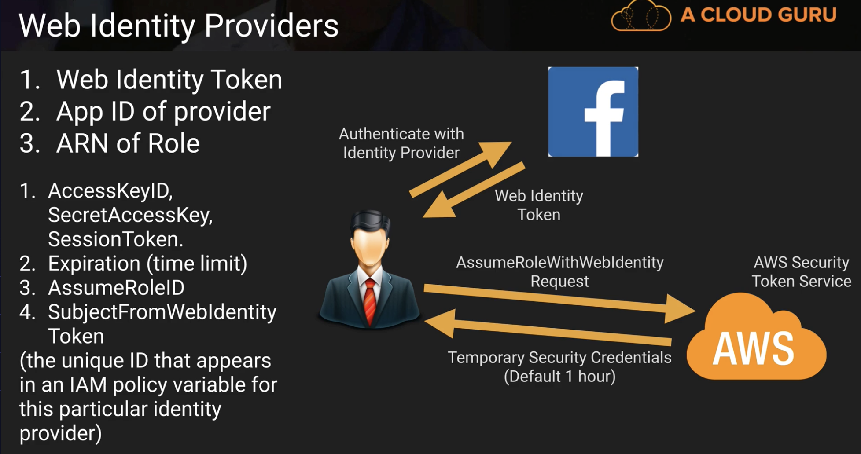

**You Just have to remember this from above slide:**

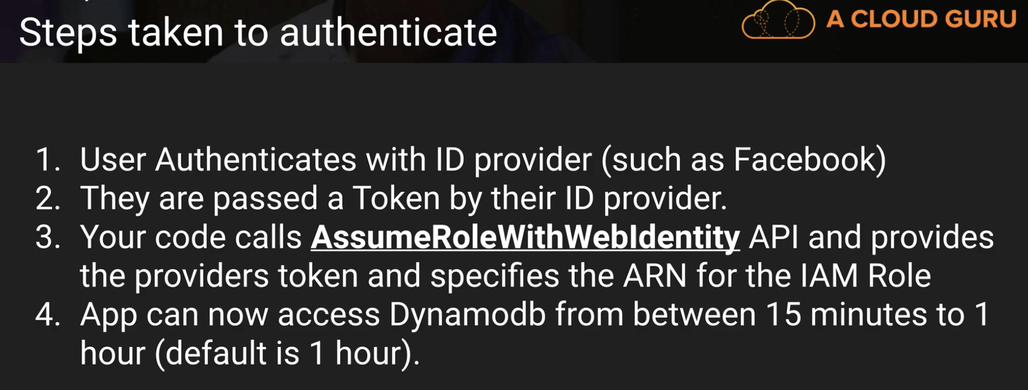

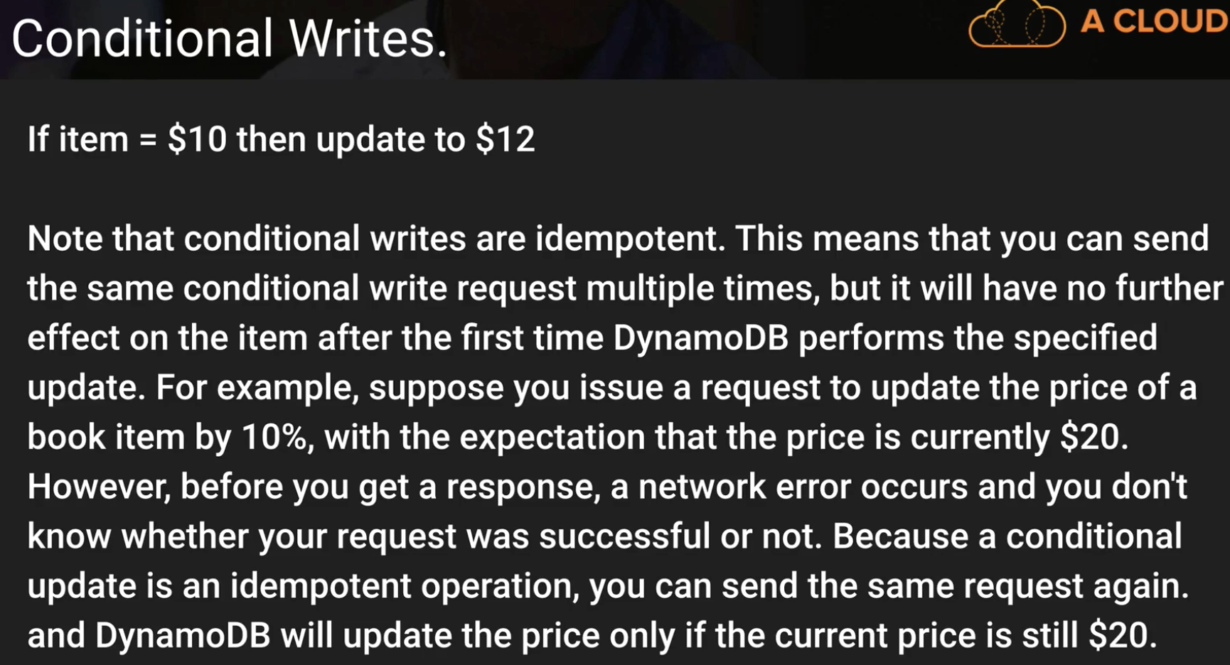

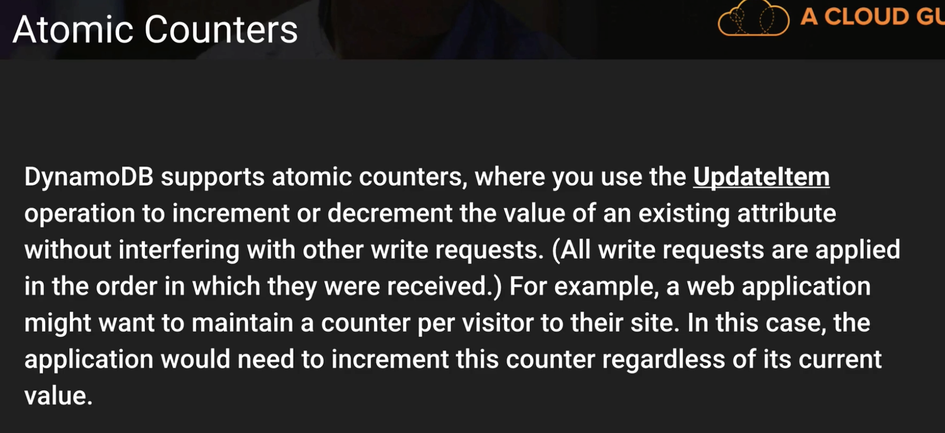

**In above slide, the example situation is important**

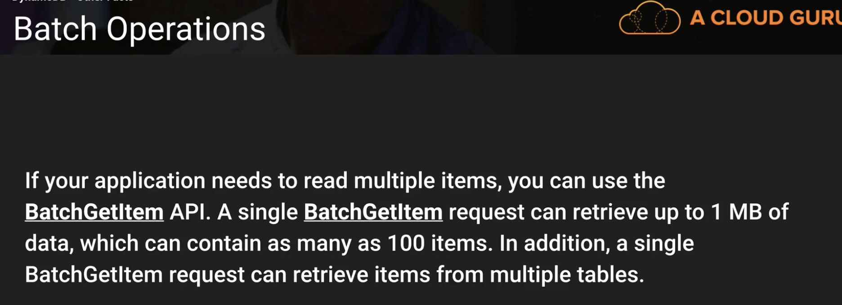

**DynamoDB Important:**

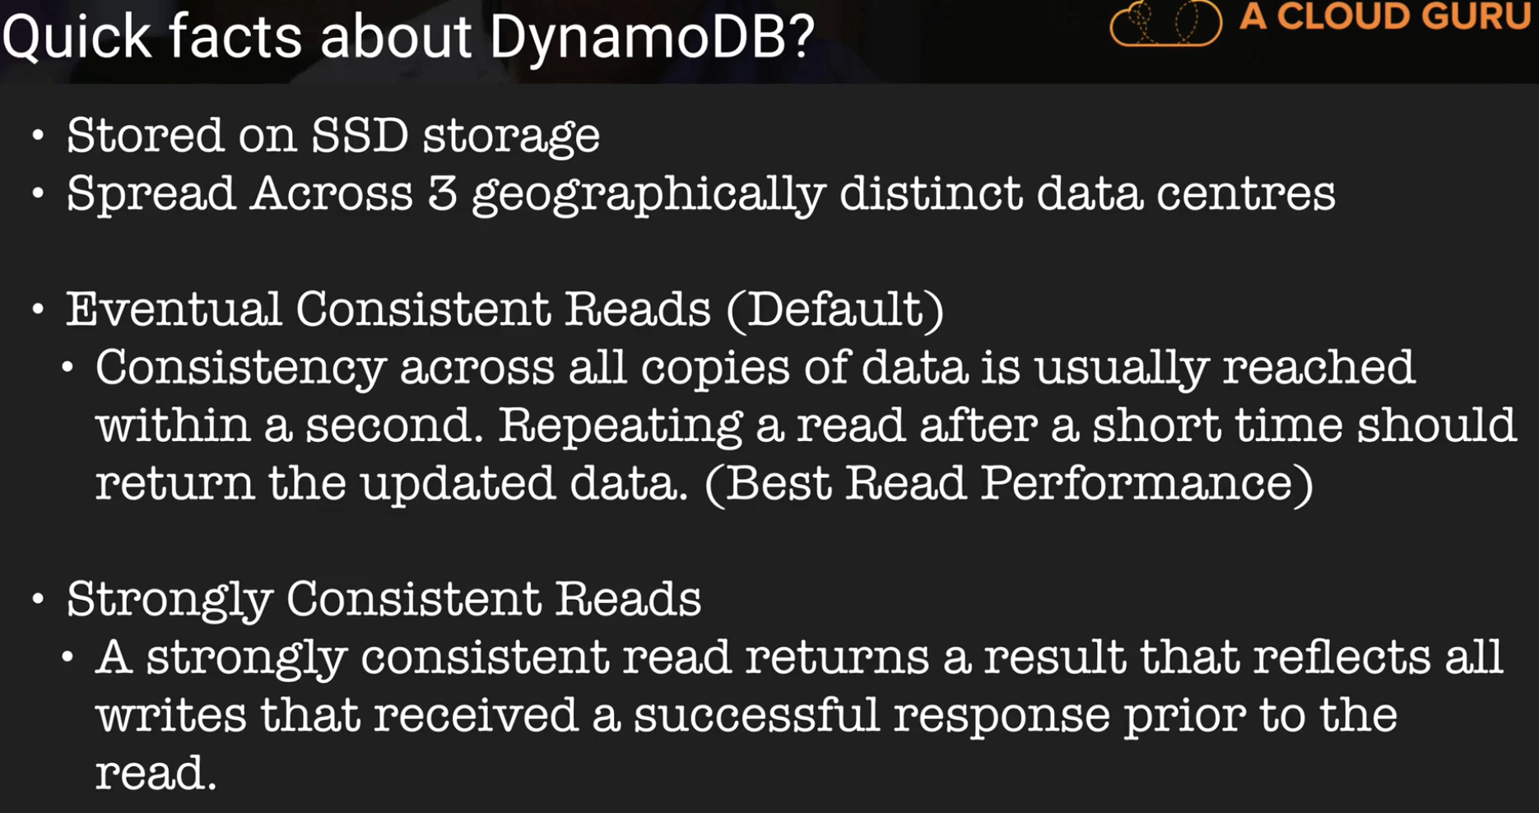

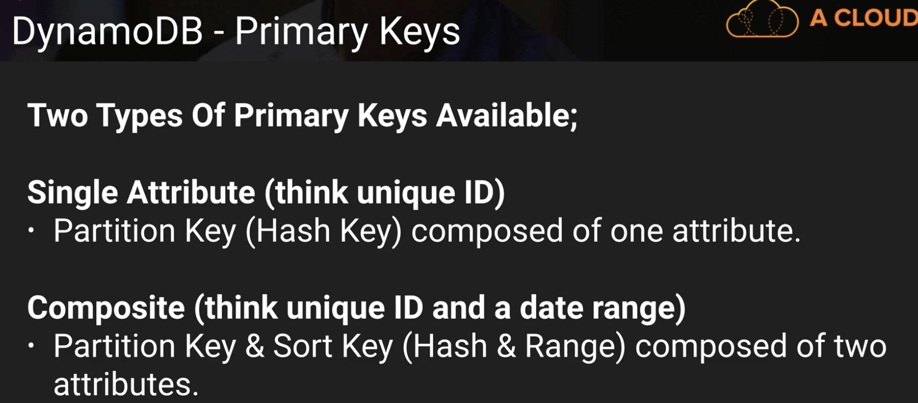

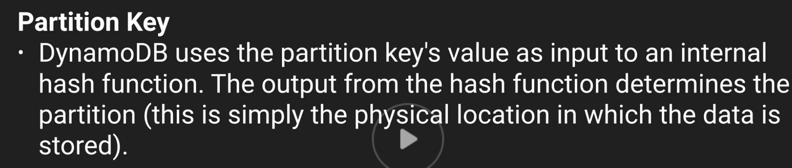

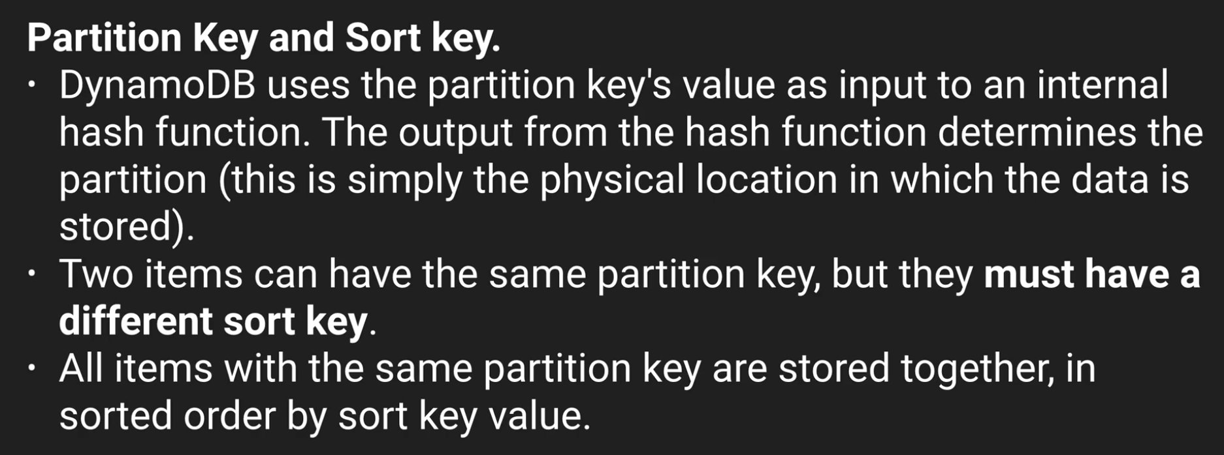

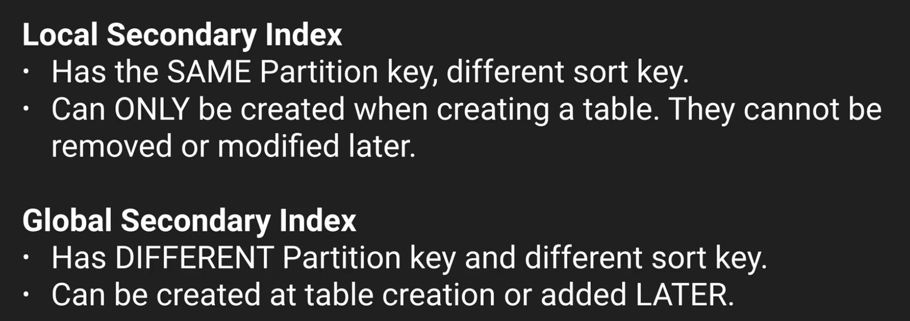

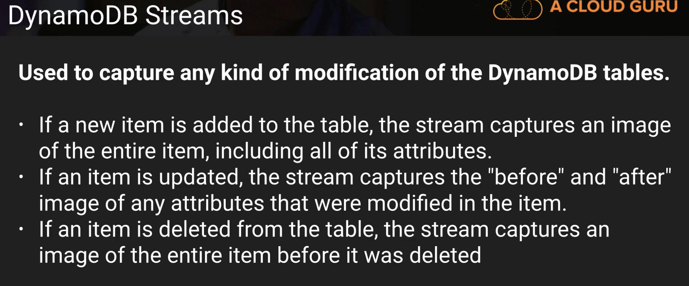

**DYNAMO DB FAQ IS VERY VERY IMP than other FAQs**

**IS DYANAMO DB FAQ Worth it?**

(answering my own question, sorry but I thought this was worth sharing):

I just read through the whole DynamoDB faq after going through the lectures here. It cost me about 2h in total but I must say it was very well worth it, especially since there are a lot of things that changed since this lecture was recorded, there's..

* **auto scaling** which was introduced June 2017
* **backup/restore** which was introduced November 2017
* **time to live** management, introduced February 2017
* **DynamoDB Acceleration (DAX)** which is a caching layer which became generally available June 2017
* **global tables** introduced November 2017
* **encryption at rest** introduced just 6 days ago in February 2018

So it seems the feature set has almost doubled in 2017 so even if those things are not asked in the exams it's certainly interesting to know that they exist.

Personally I found the sections about secondary local indexes a bit lengthy and if you skip something then skip those, as they are covered in the video lectures well enough.

Batchgetitem()

<https://docs.aws.amazon.com/amazondynamodb/latest/APIReference/API_BatchGetItem.html>

**Provisioned throughput limits can be changed by sending a ticket to AWS support**

**SQS Simple Queue Service: (3 to 4 Questions)**

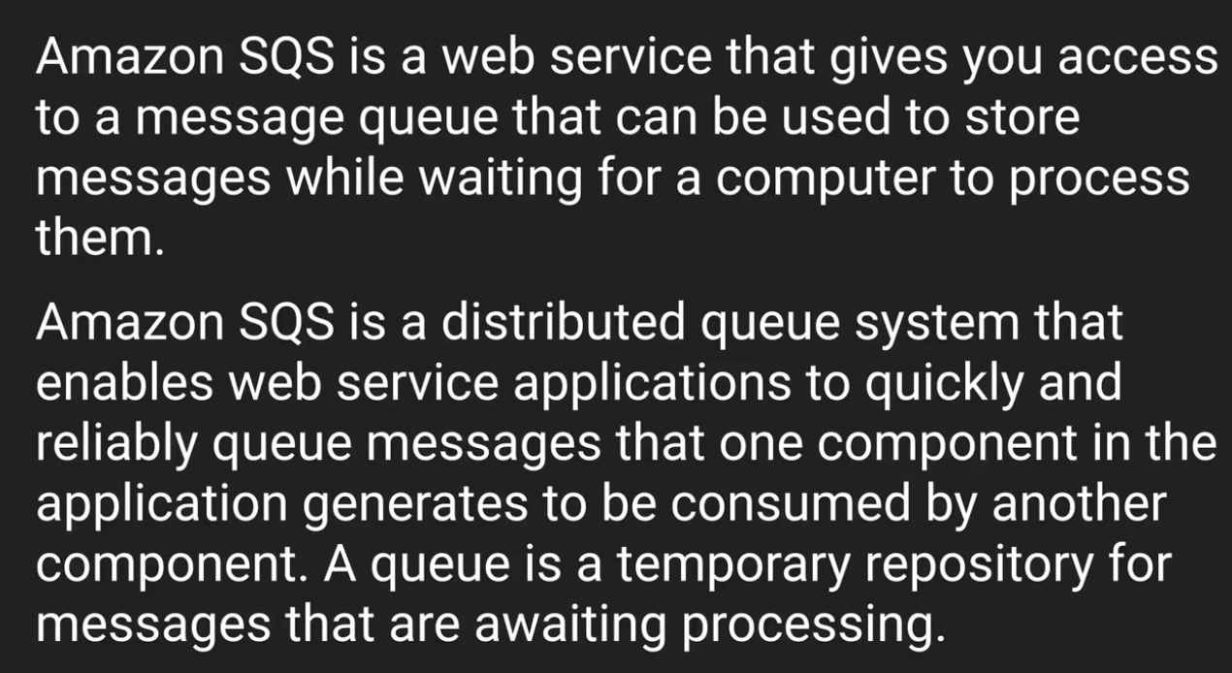

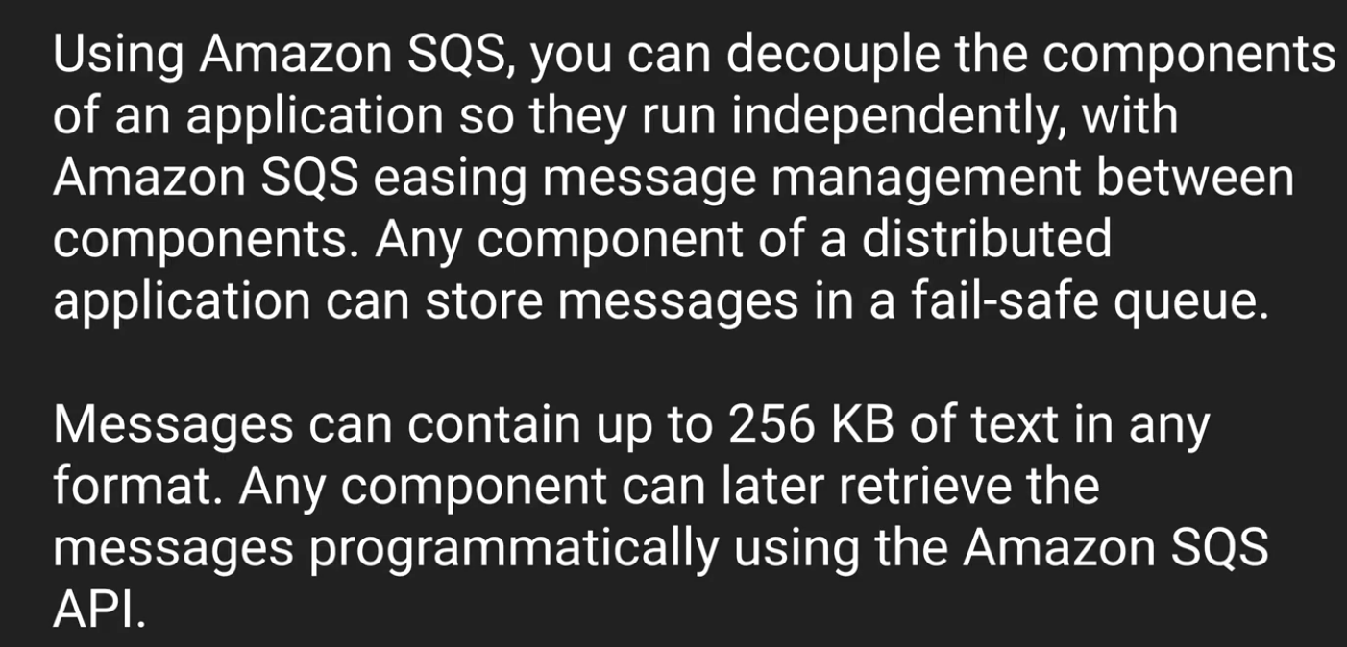 **Here 256KB is \***

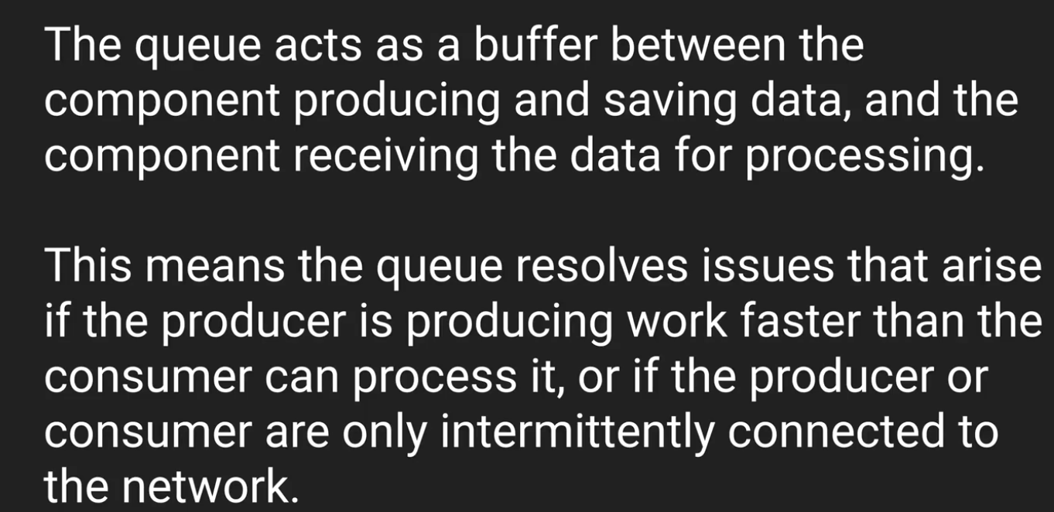

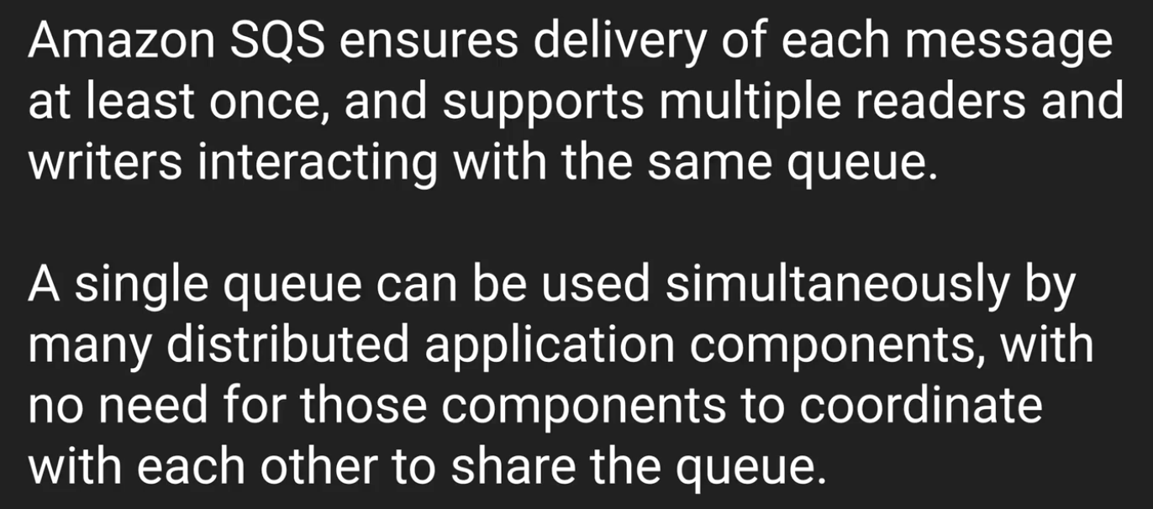

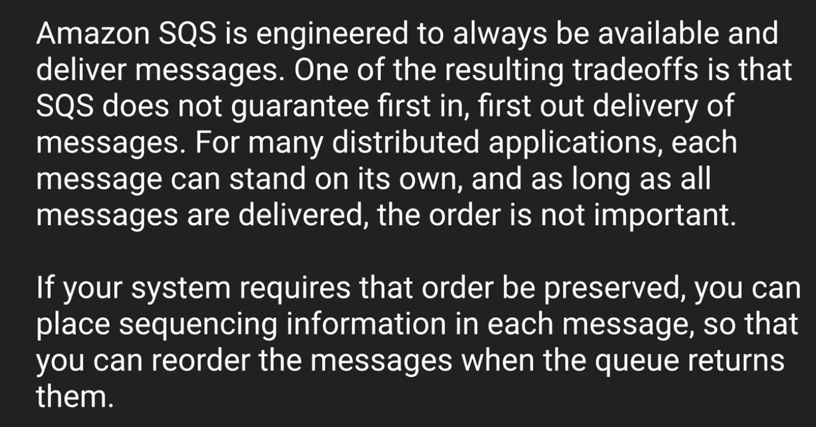

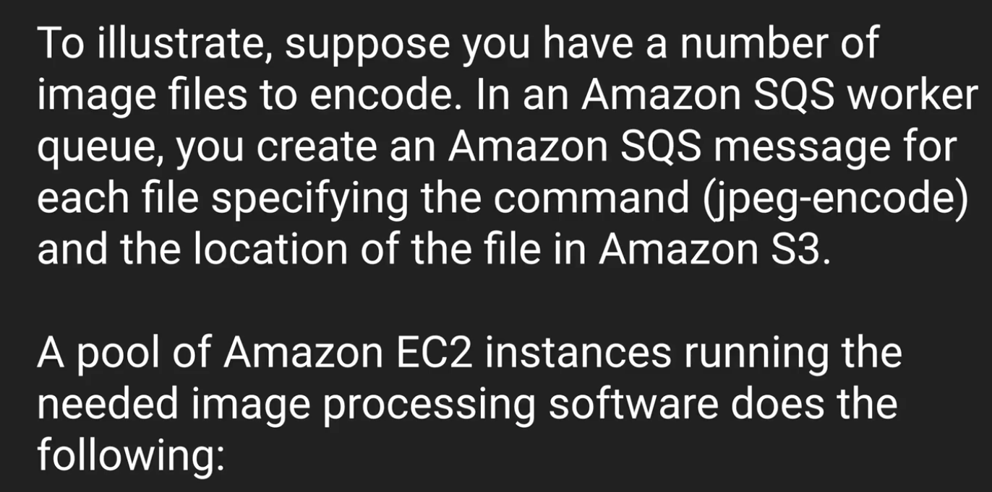

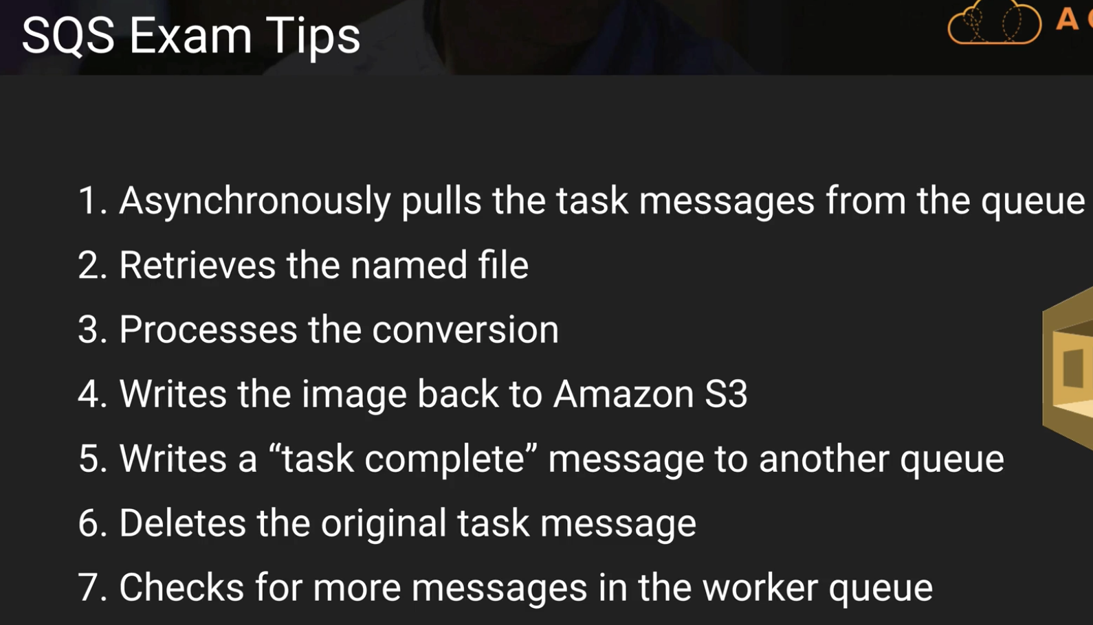

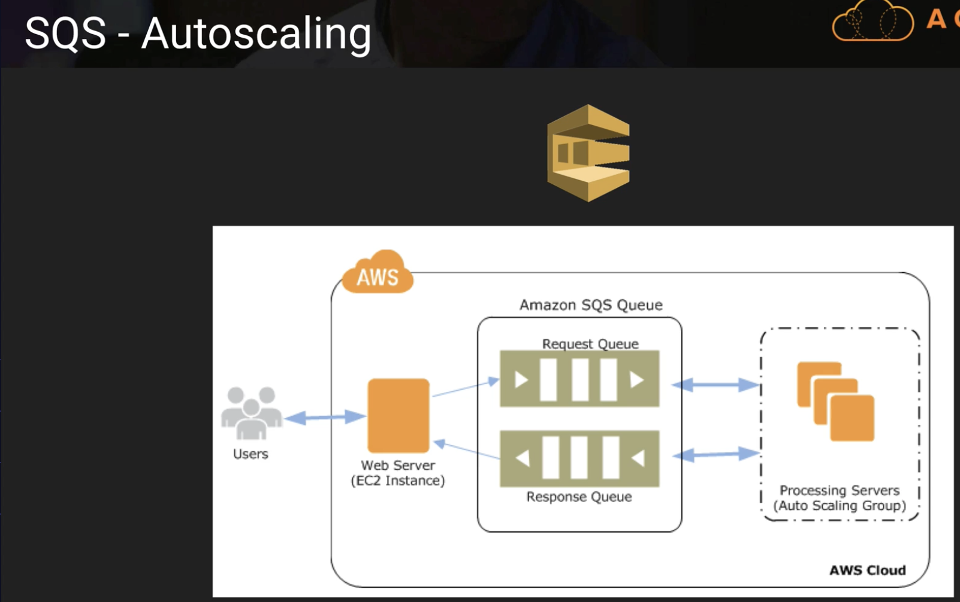

**In the below slide, SQS does offer FIFO – Mistake in Slide**

**Default Visibility time out – 30 sec**

**Maximum visibility time out – 12 hours**

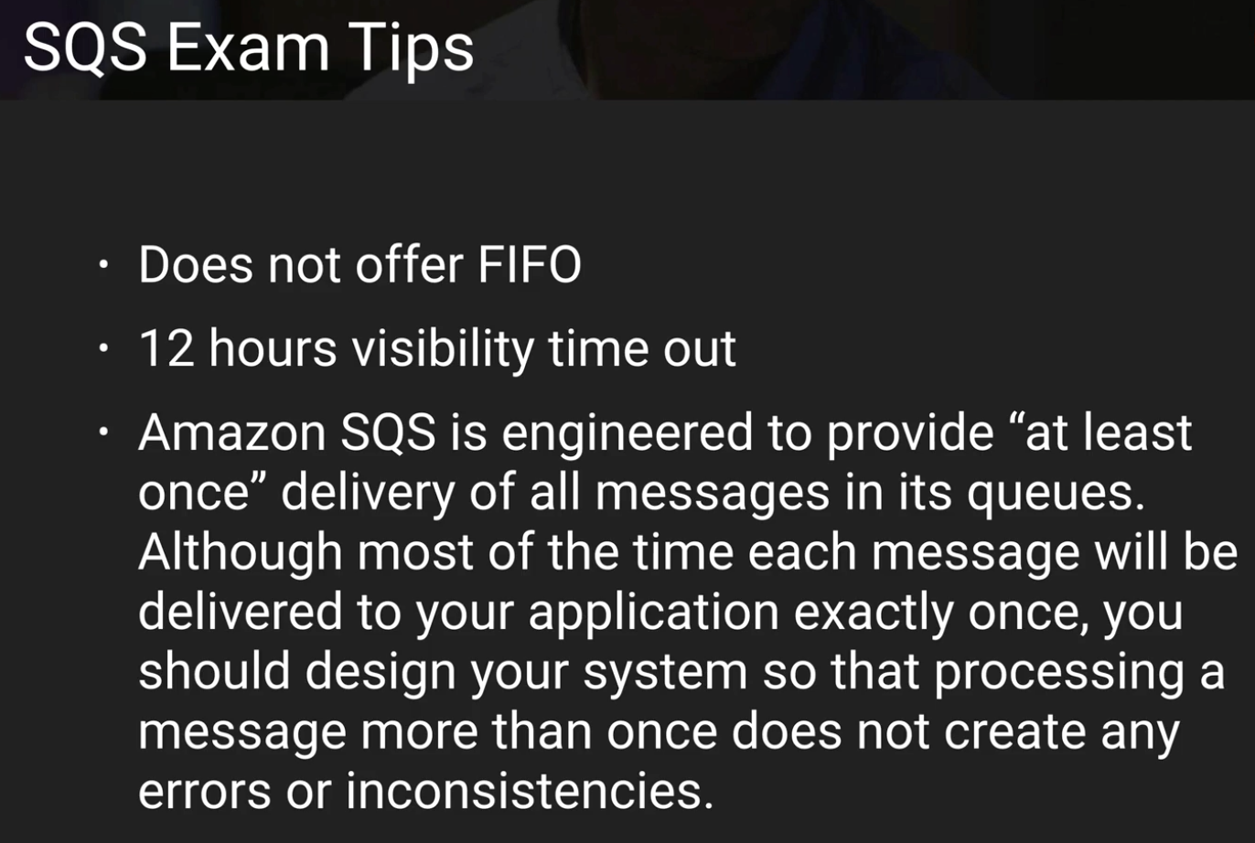

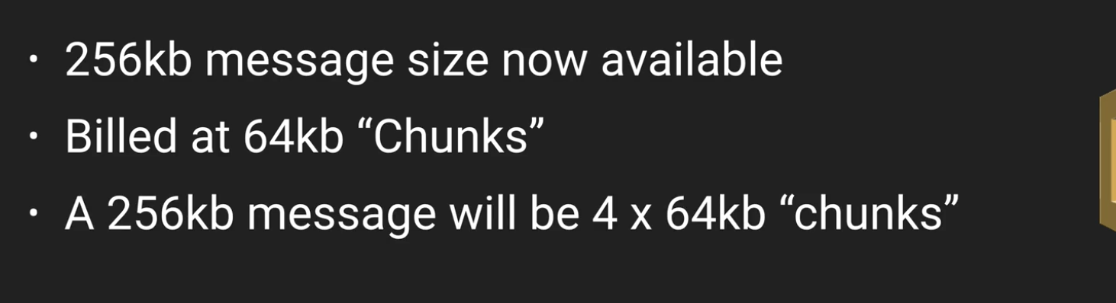

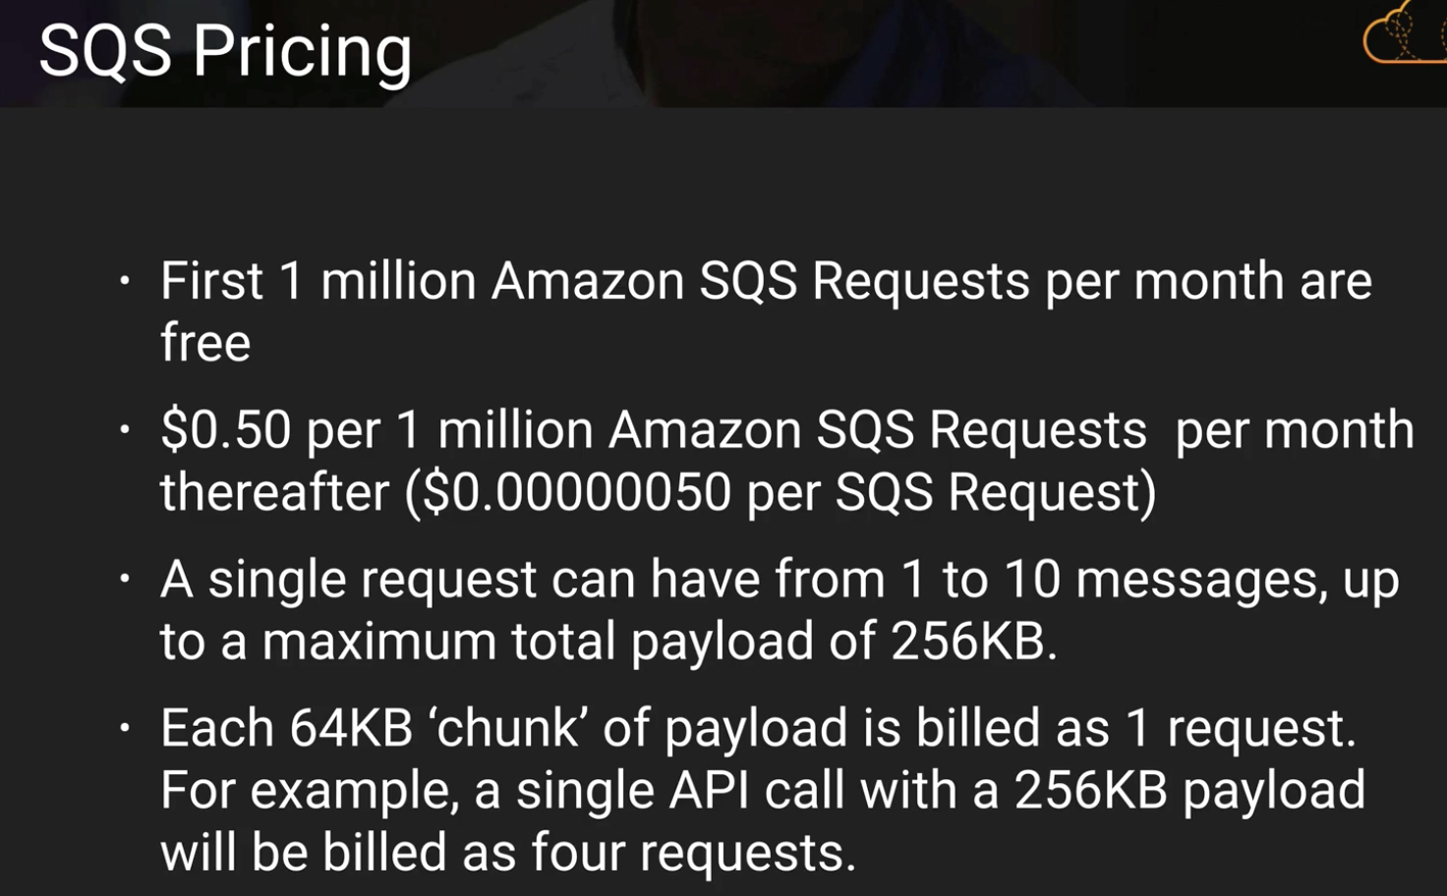

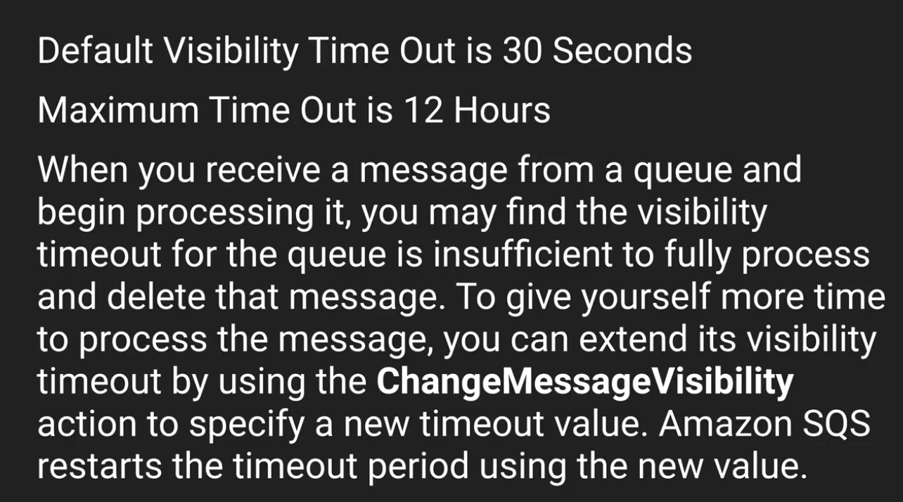 **ChangeMessageVisibility()**

**way to reduce polling when the queue is empty:**

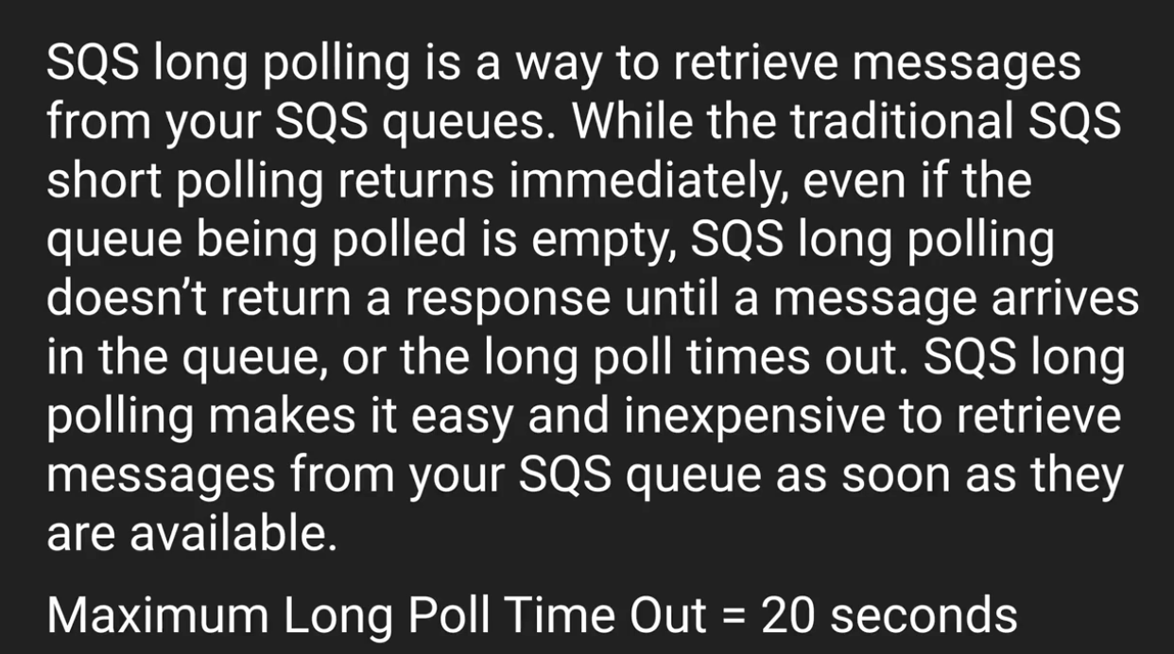

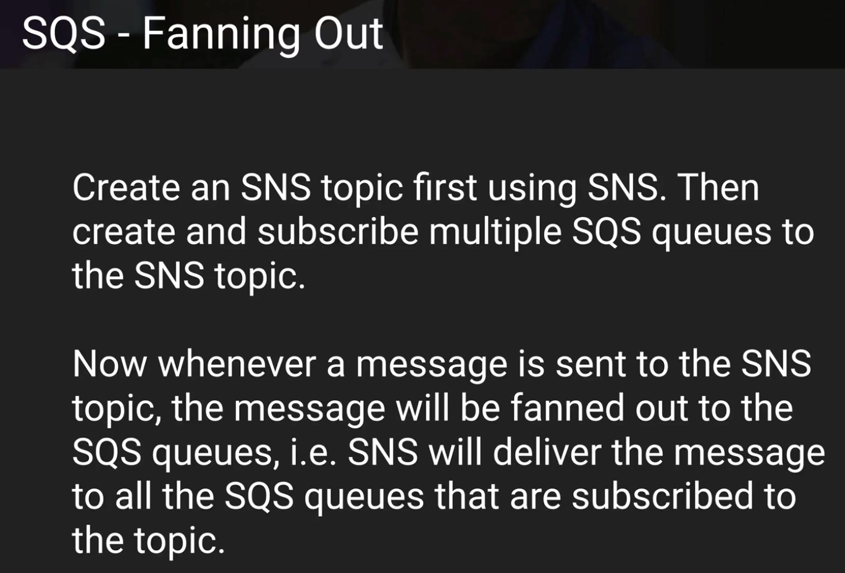

**You run a video-hosting website with two types of members: premium, fee-paying members; and free members. Each video that is uploaded is processed by a fleet of EC2 instances, which poll an SQS queue as videos are uploaded. However, you need to ensure that the videos uploaded by your premium, fee-paying members have a higher priority than those of your free members. How might you work with SQS to endure priority treatment of the premium members' videos?**

**Create two SQS queues — one for premium members, and one for free members. Program your EC2 fleet to poll the premium queue first and, if empty, to then poll your free members SQS queue.**

**Maximum retention period for a SQS message is :**

**14 days. Don’t get confused with visibility time out.**

**An SQS message can be delivered multiple times. – True**

**Which Amazon service can you use in conjunction with SQS to "fan out" SQS messages to multiple queues. - SNS**

**Simple Notification Service:**

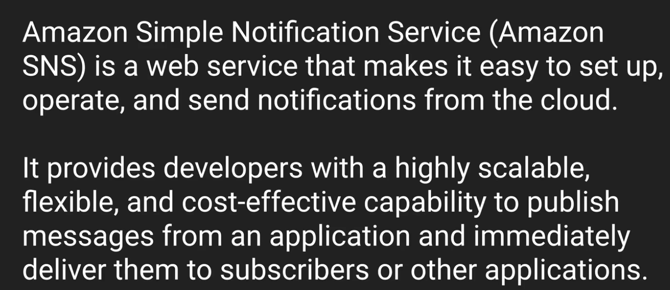

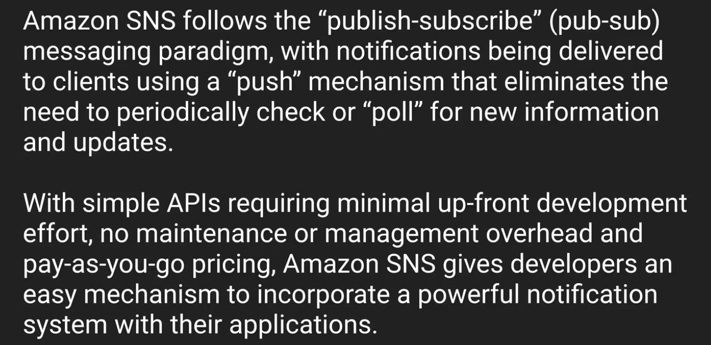

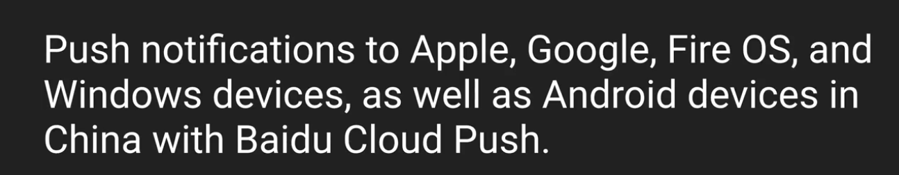

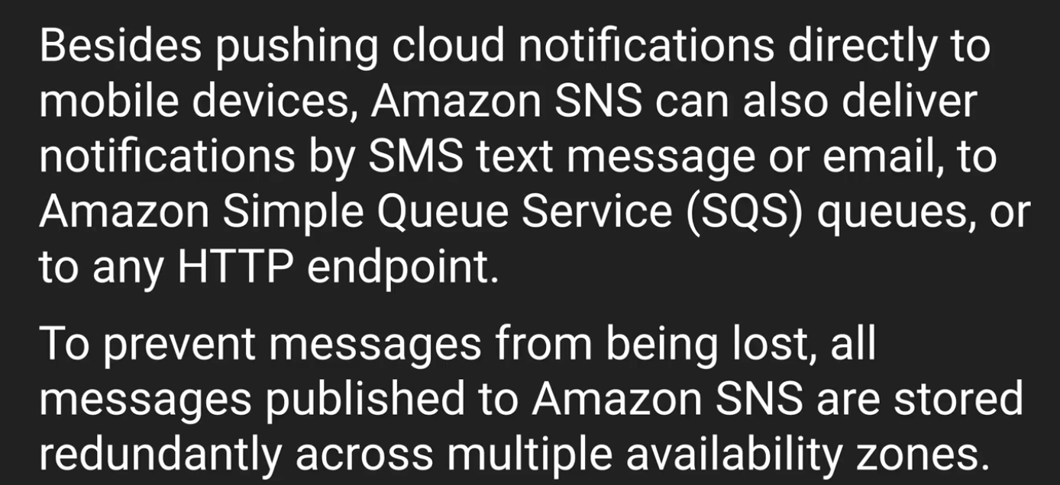

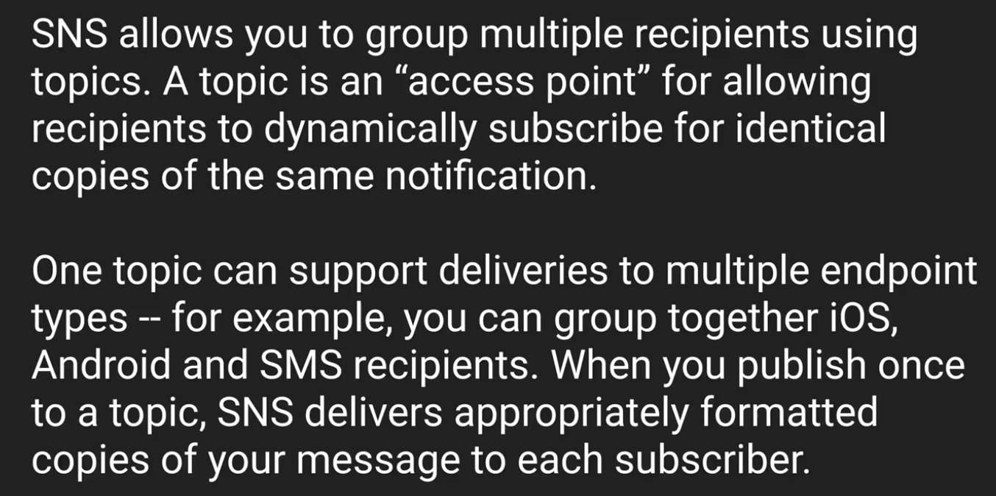

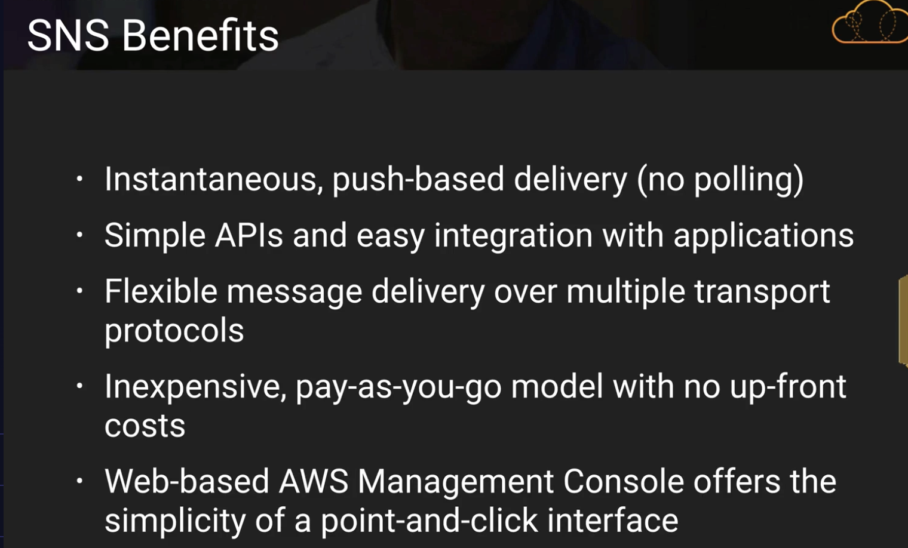

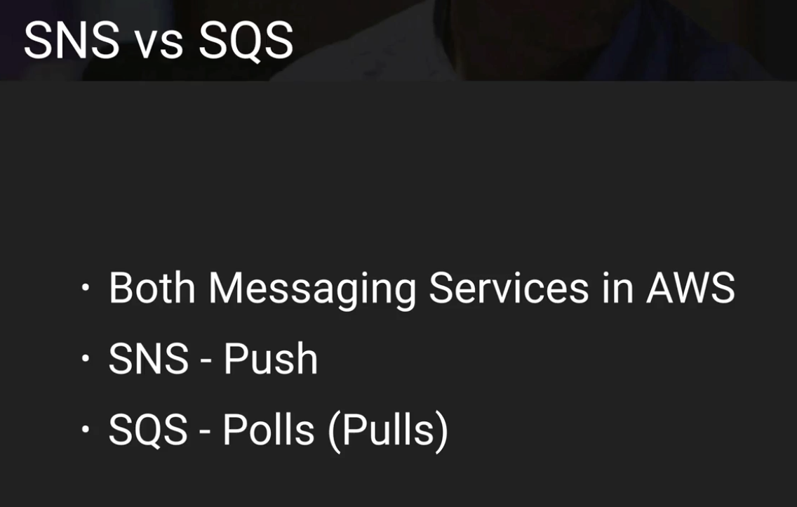

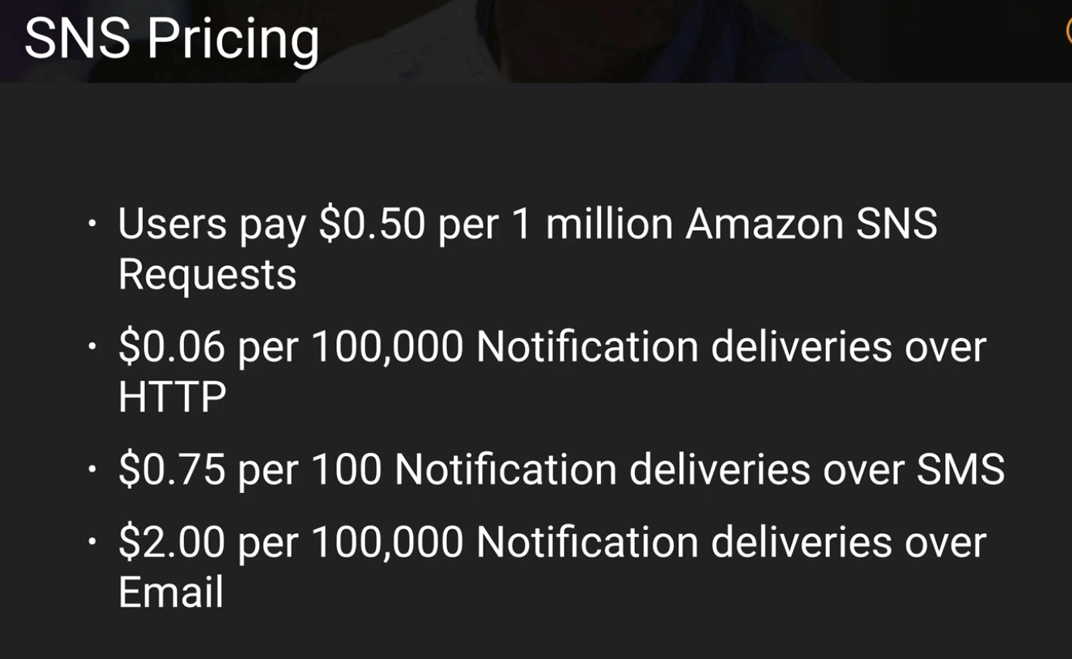

**data format of SNS is JSON**

**SNS Summary:**

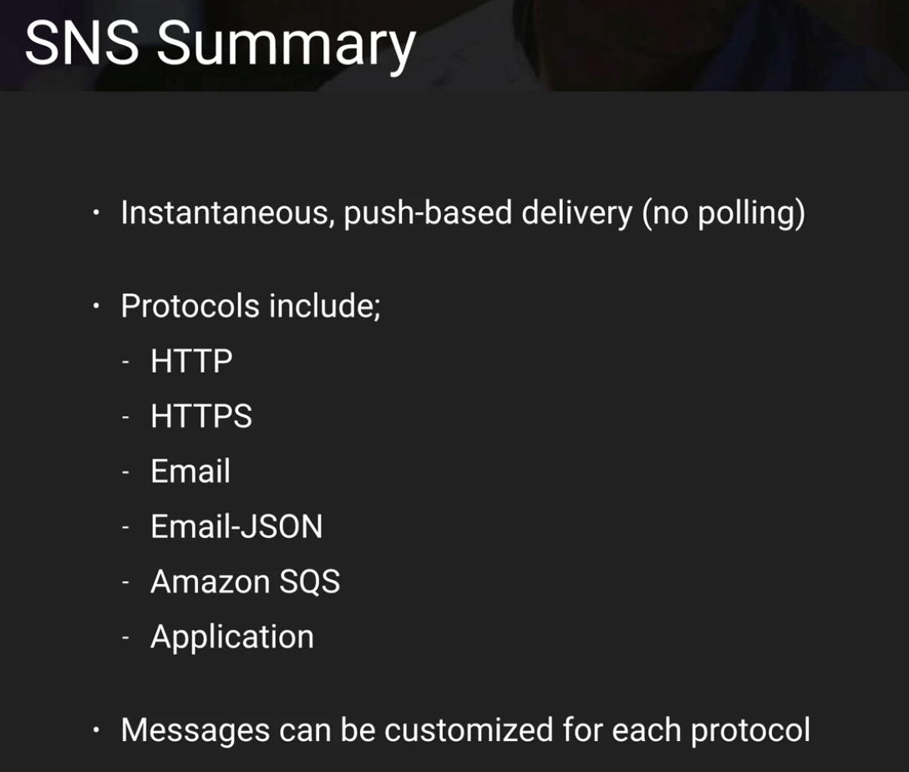

You have a list of email addresses to which you need to push emails on a periodic basis. What do you subscribe them to? – A TOPIC

SNS messages cannot be customized by protocol type. - False

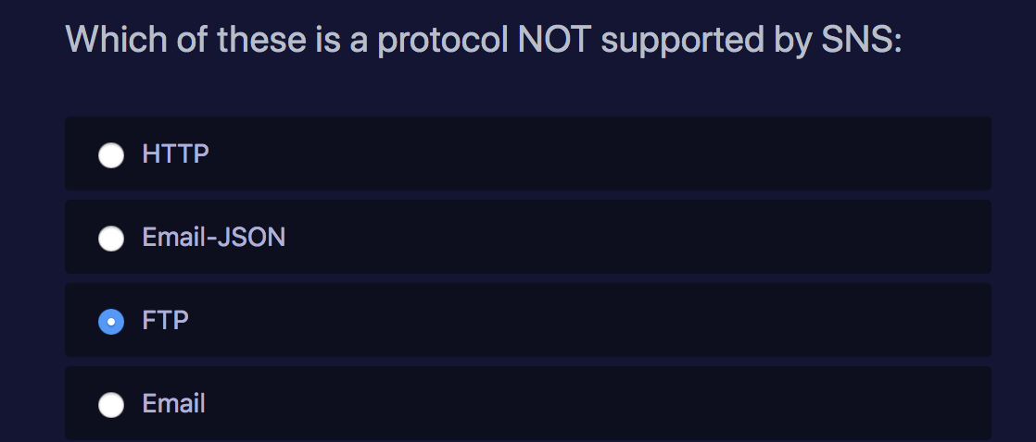

**Simple Work-Flow Service: (1 or 2 Questions) (tough questions)**

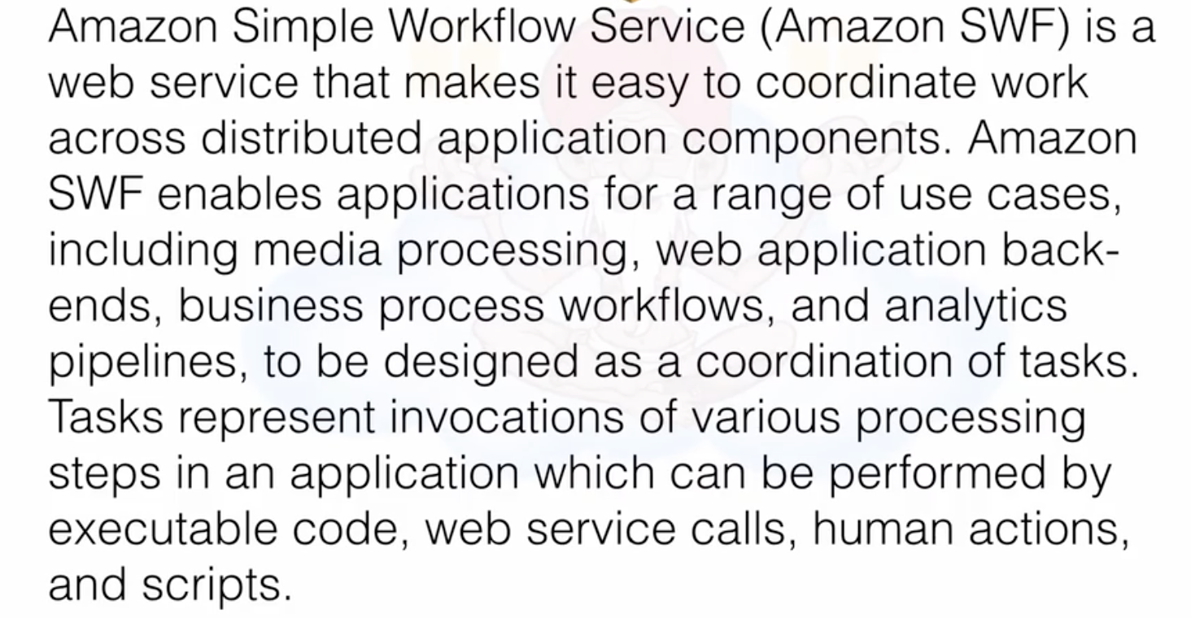

**Example:**

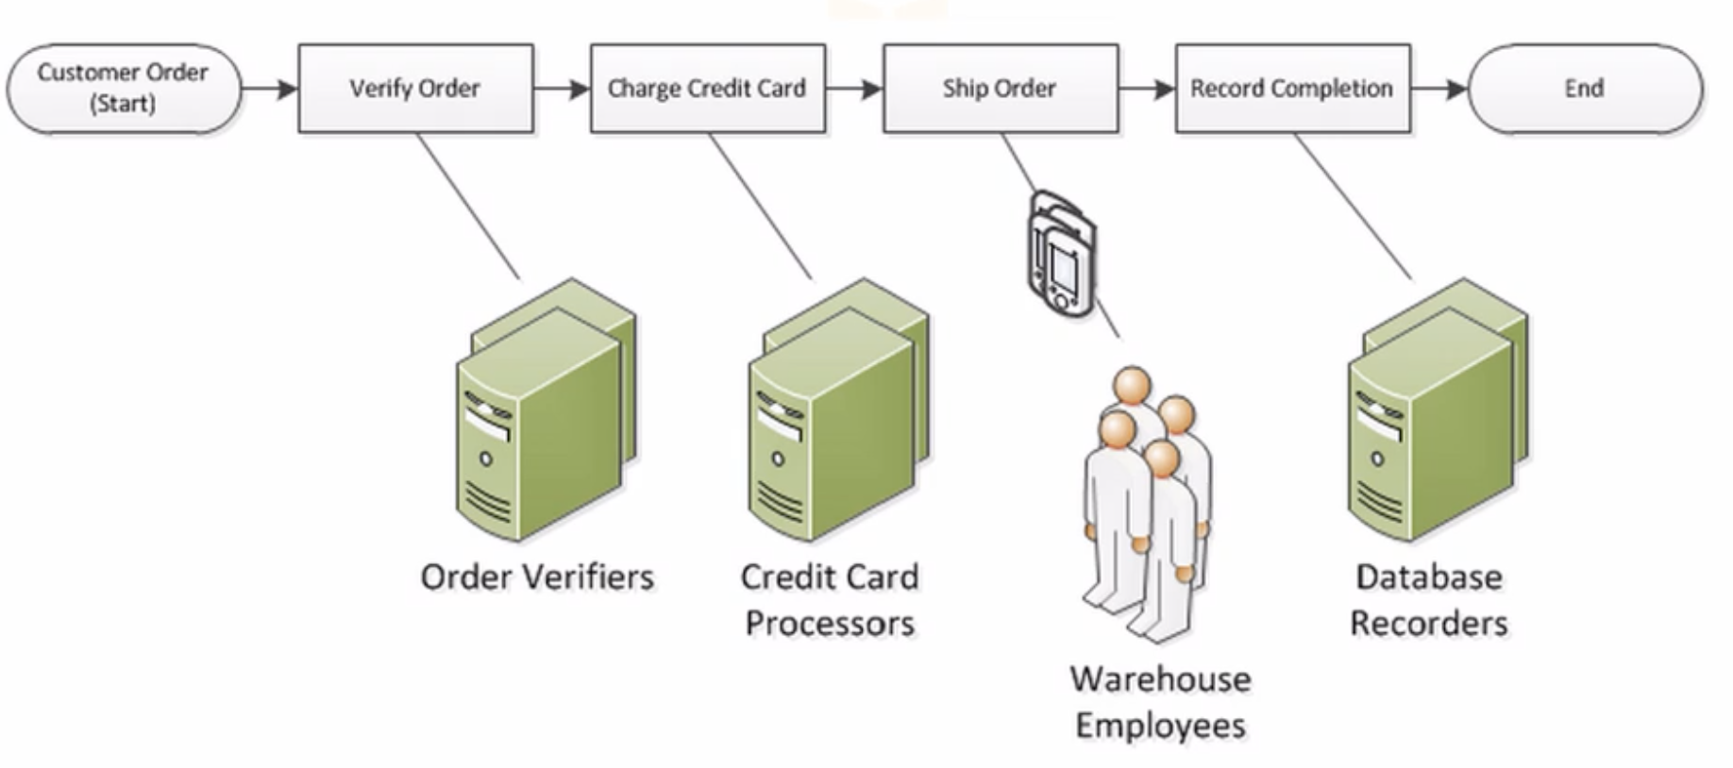

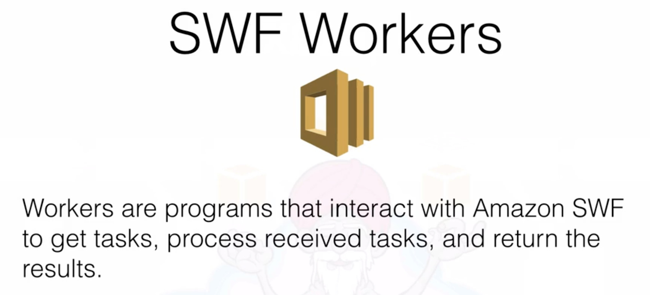

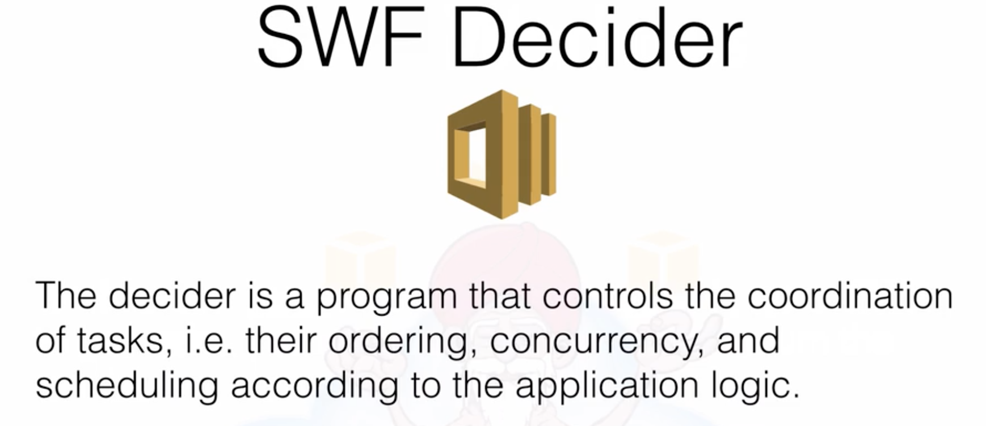

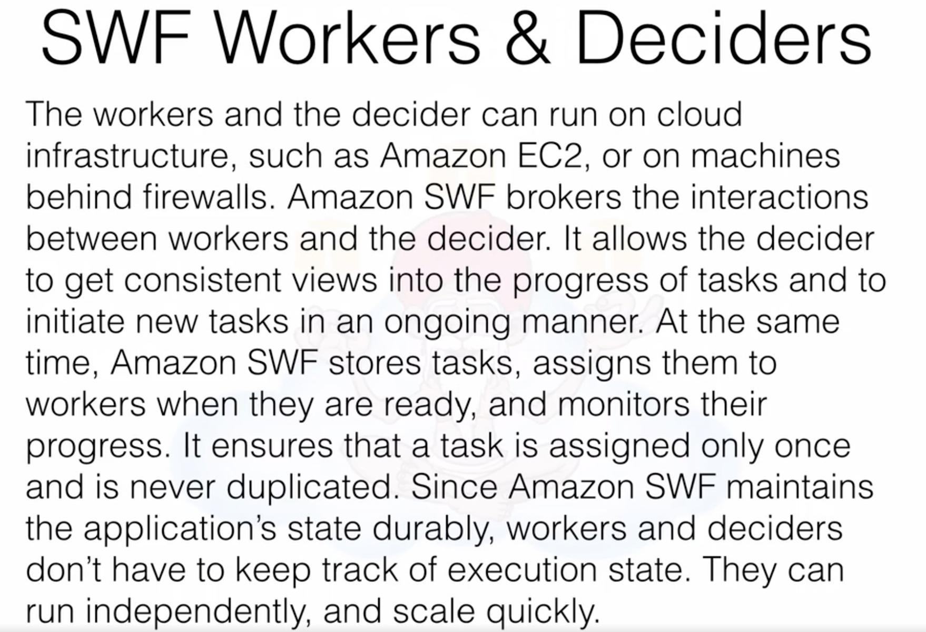

SWS – a task is only assigned once.

SQS – a task can be assigned multiple times (sometimes -if timed out)

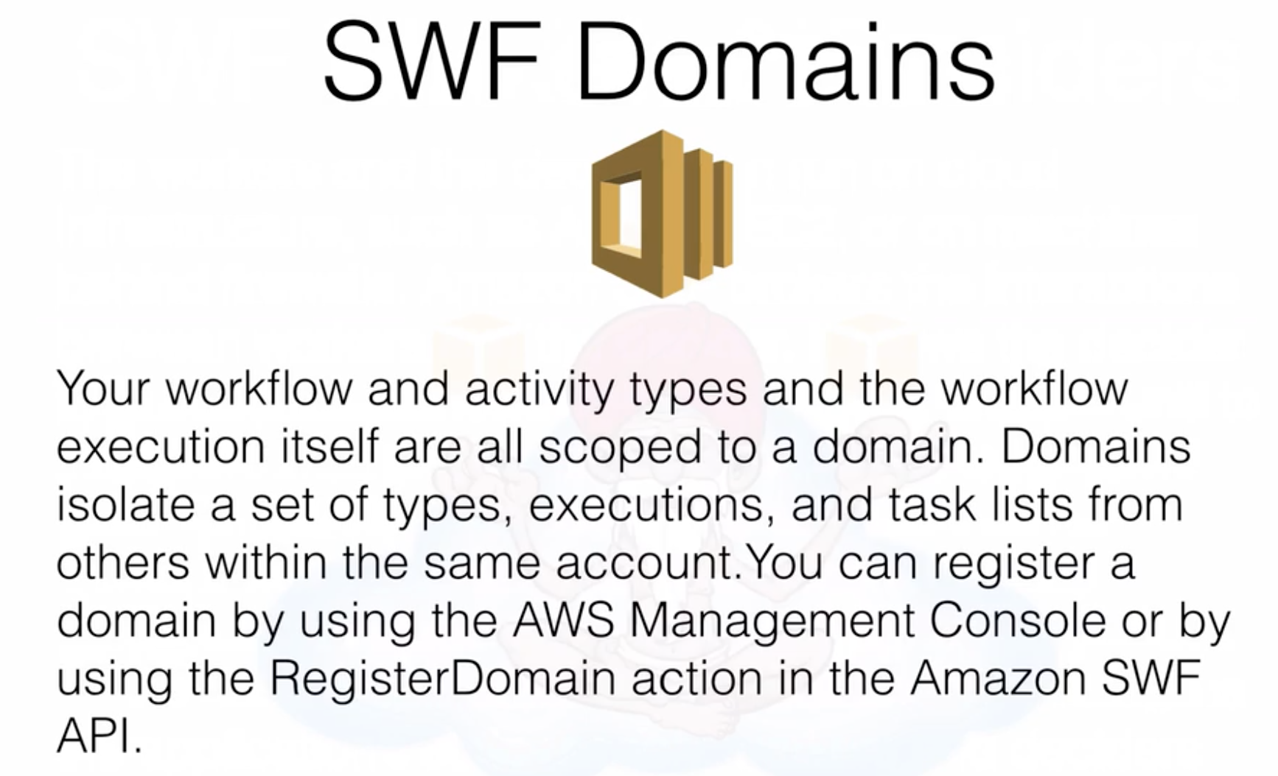

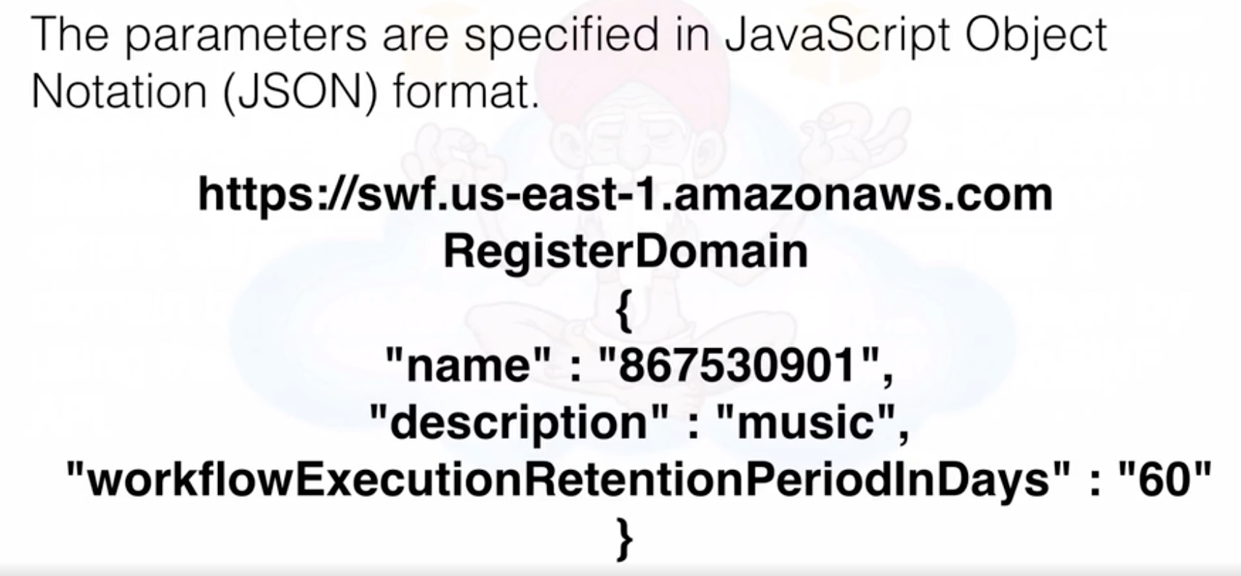

Compare between SQS and SWS: SQS max timeout is **12 hours while**

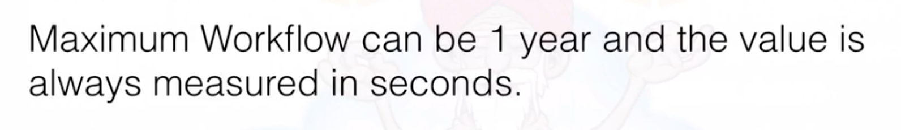

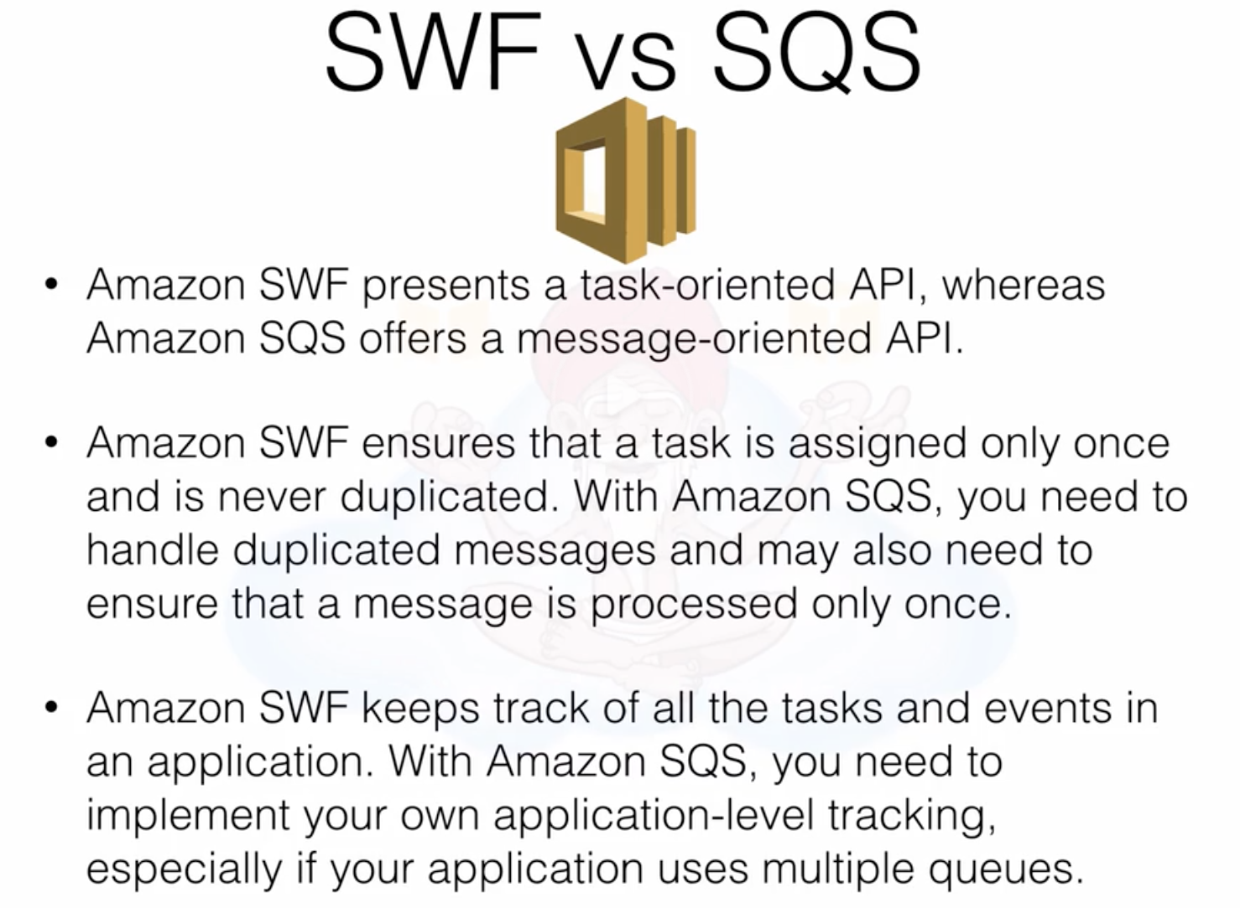

**Important Questions:**

**SWF consists of a domain, workers, and deciders. – True**

**what is a decider? - The decider is a program that controls the coordination of tasks, i.e. their ordering, concurrency, and scheduling according to the application logic.**

**Amazon SWF is useful for automating workflows that include long-running human tasks (e.g. approvals, reviews, investigations, etc.) Amazon SWF reliably tracks the status of processing steps that run up to several days or months. – True**

**what is a worker? - Workers are programs that interact with Amazon SWF to get tasks, process received tasks, and return the results.**

**Maintaining your application's execution state (e.g. which steps have completed, which ones are running, etc.) is a perfect use case for SWF. – TRUE**

**Elastic Beanstalk (4 to 5 Questions)**

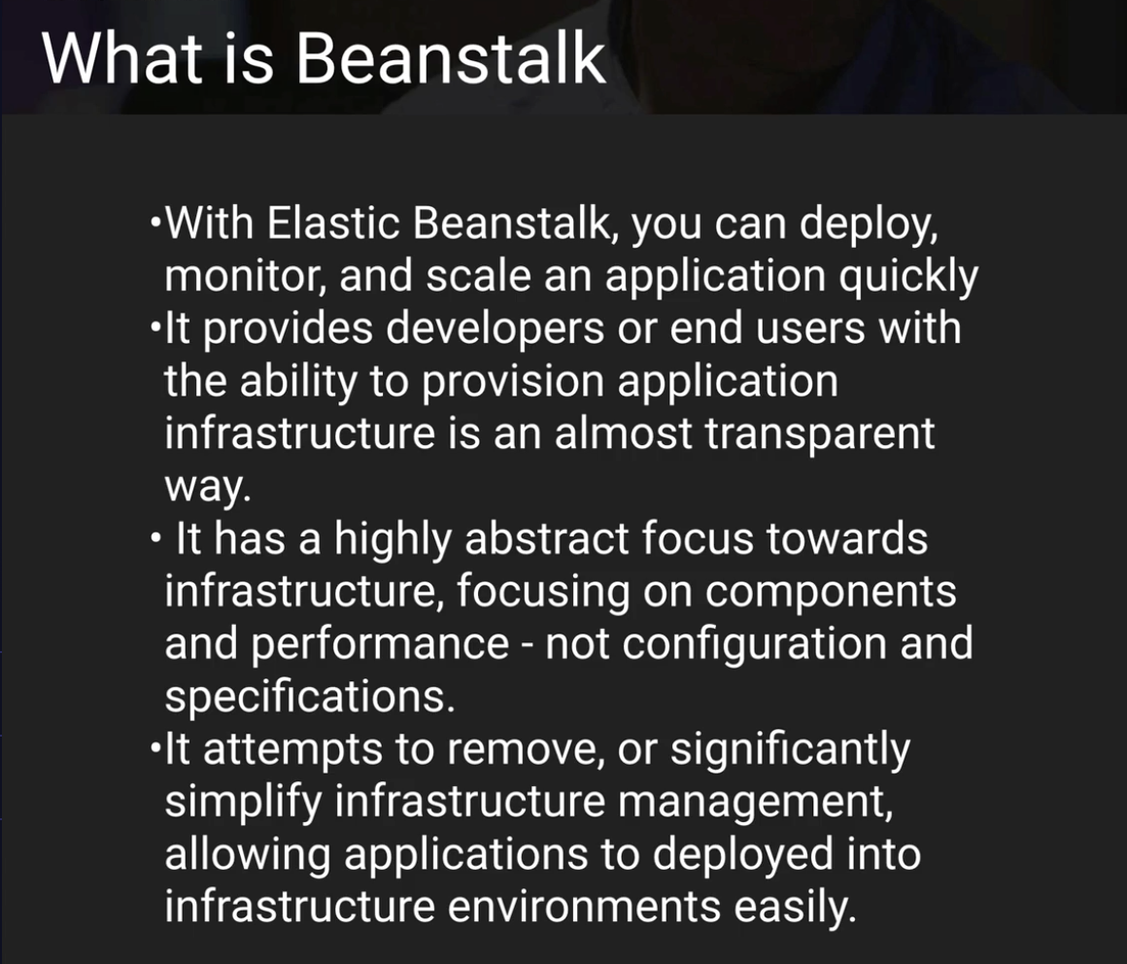

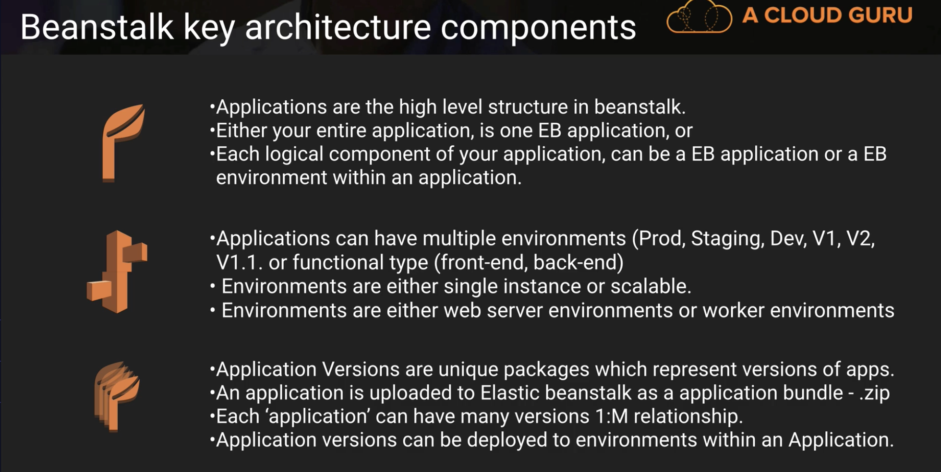

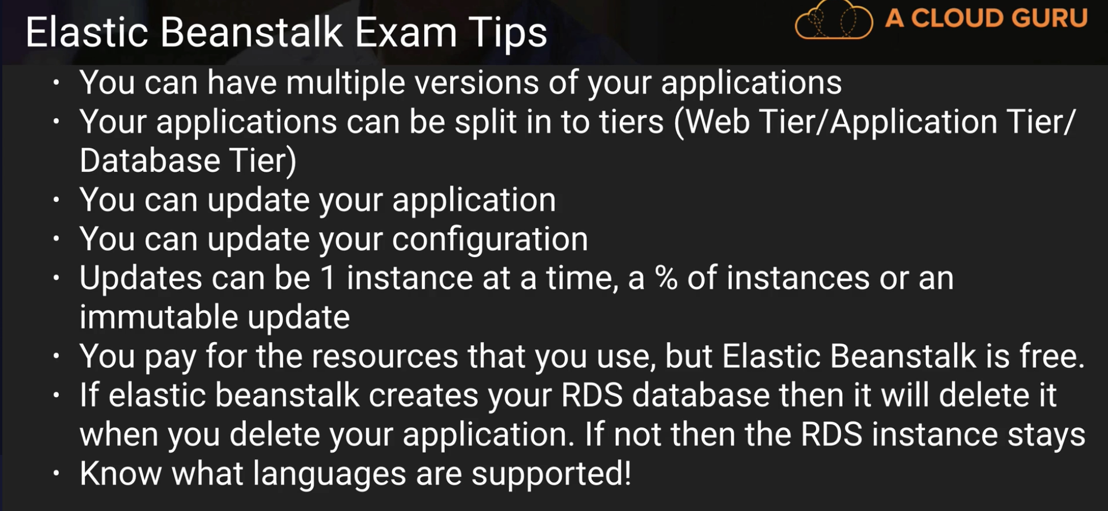

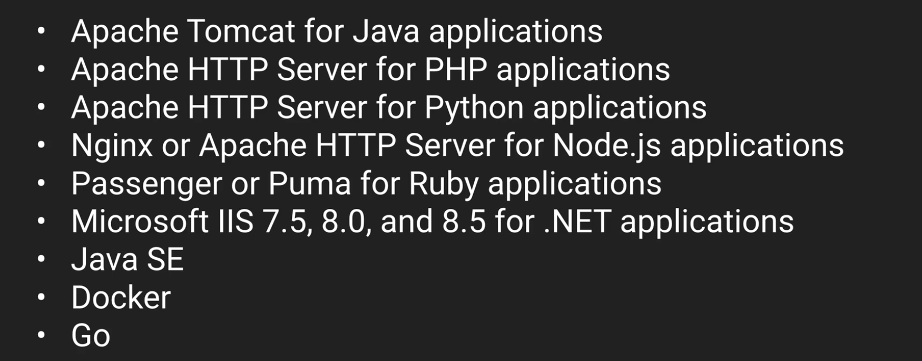

**Supporting env:**

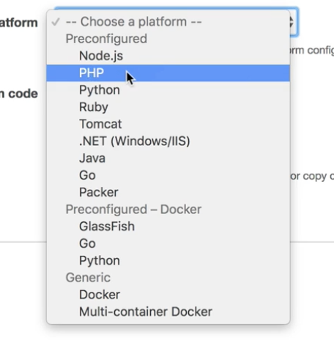

**Imp:**

**Elastic Beanstalk service itself is free. But resources tagged to it are not.**

**Elastic Beanstalk is object based storage – False**

**Cloud Formation (1 or 2 Questions)**

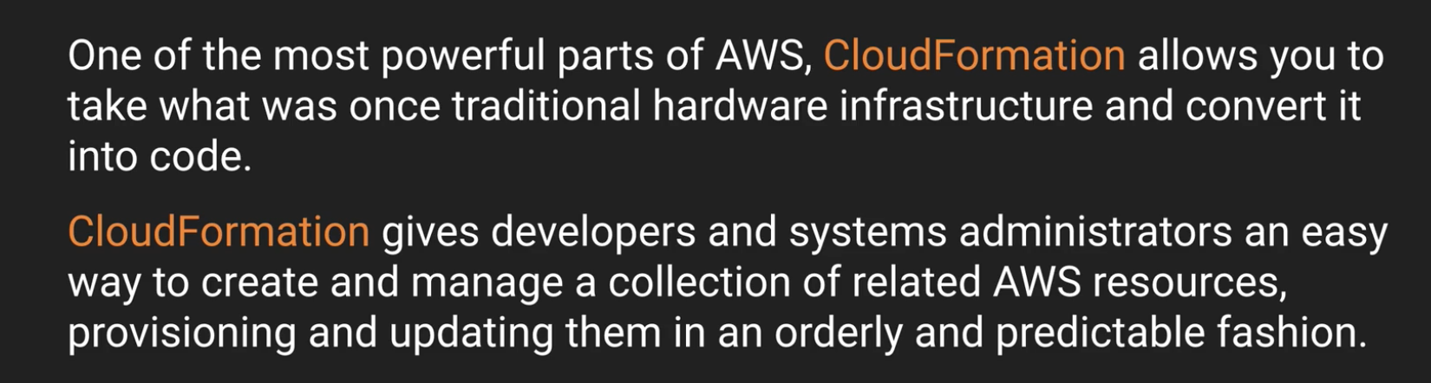

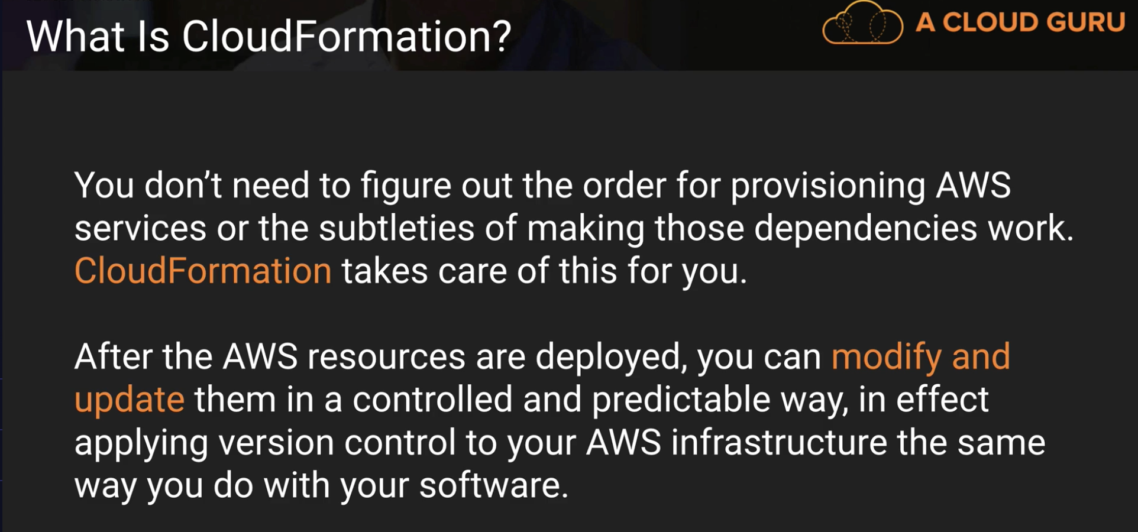

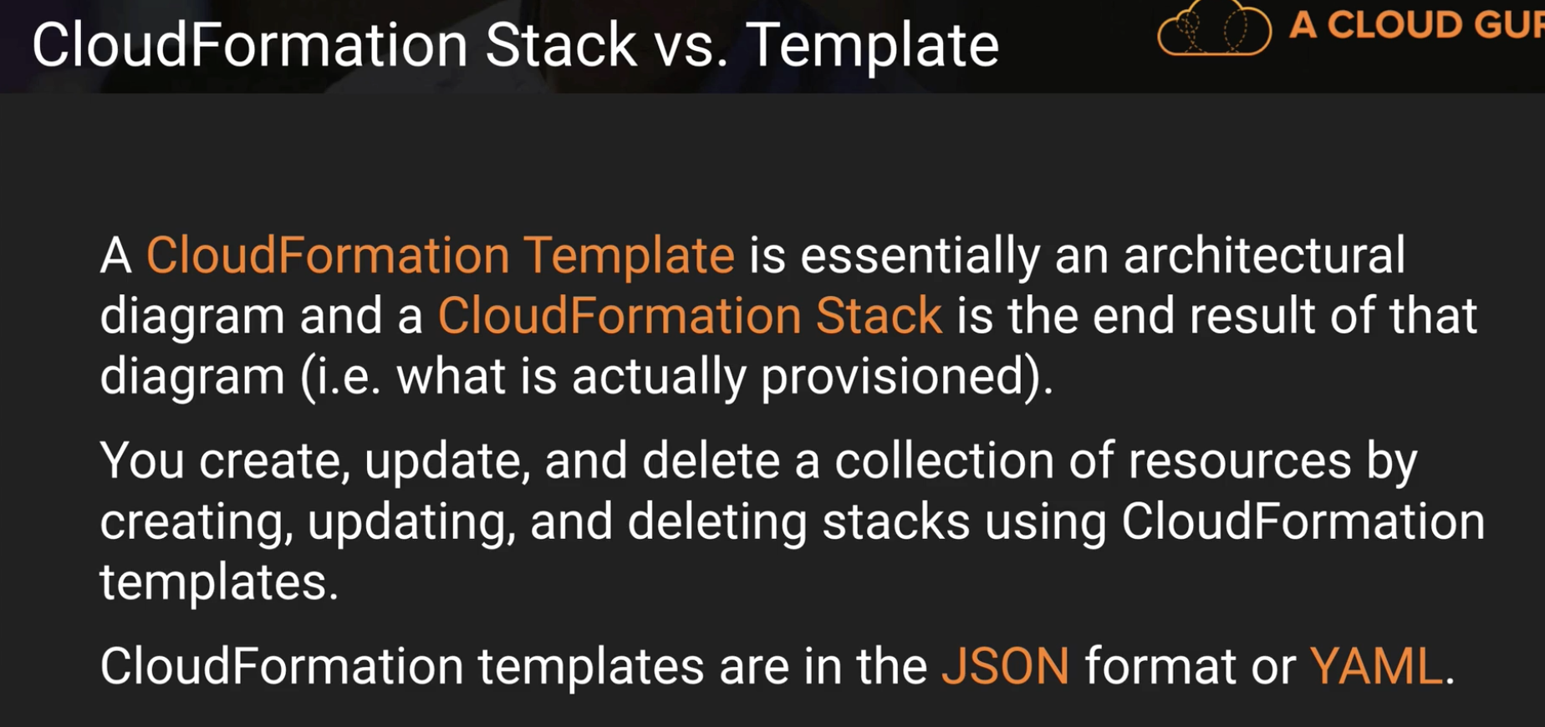

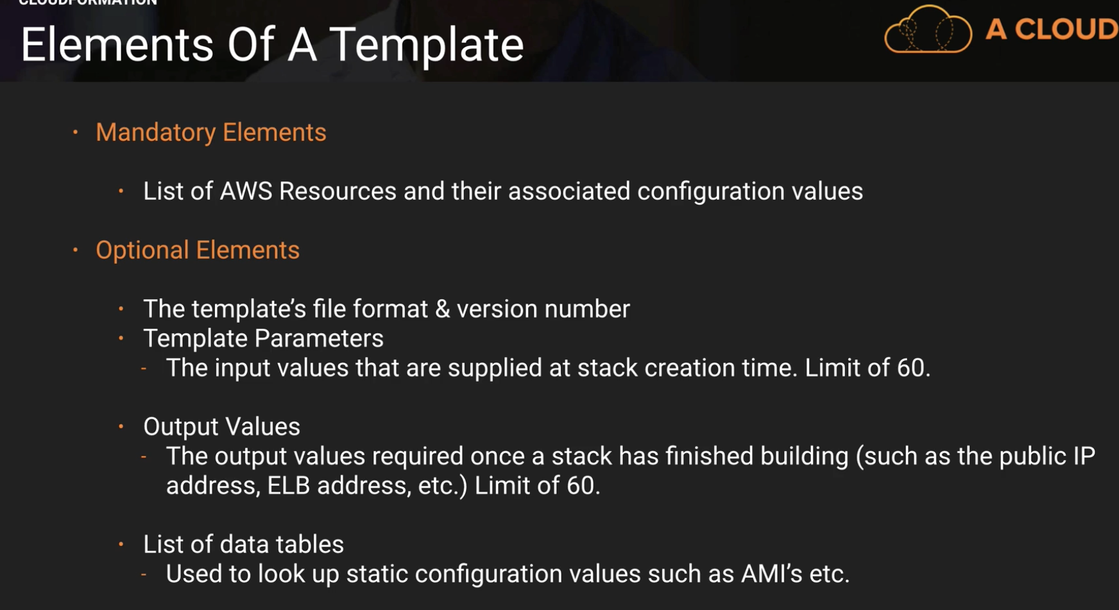

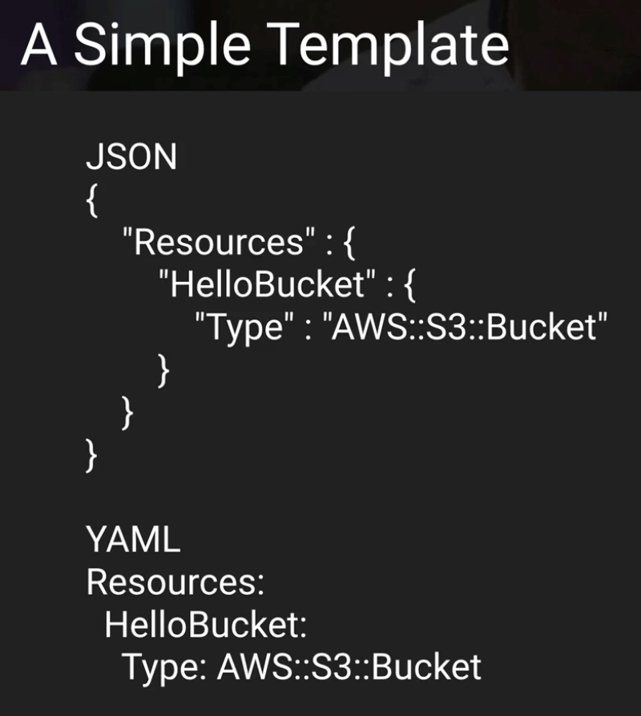

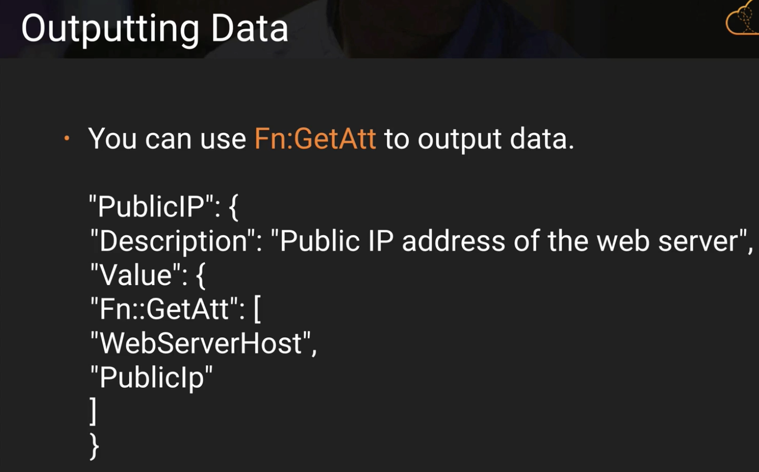 **(Fn:GetAtt)**

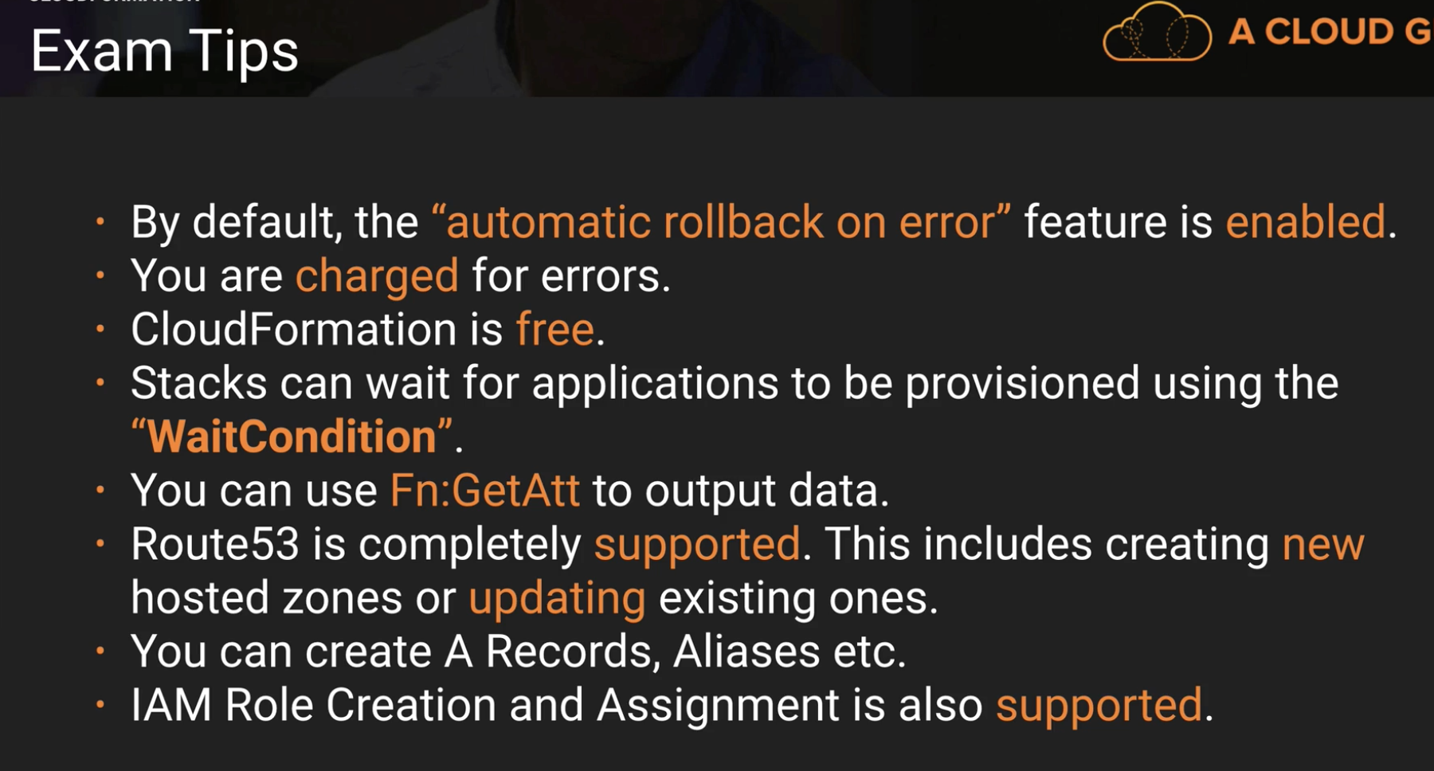

*Situation question: which one to use better in between Elastic beanstalk vs Cloud formation

**You are creating a virtual data centre using cloud formation and you need to output the DNS name of your load balancer. What command would you use to achieve this? - FN::GetAtt**

**By default, what happens if Cloud Formation encounters an error?**

**It will terminate and rollback all resources created on failure.**

**Cloud Formation itself is free, however the resources it provisions will be charged at the usual rates. – TRUE**

**The default scripting notation for Cloud Formation is JSON (can use YAML too)**

**AWS Shared Responsibility Model:**

1. **Amazon EC2, Amazon EBS, and Amazon VPC**

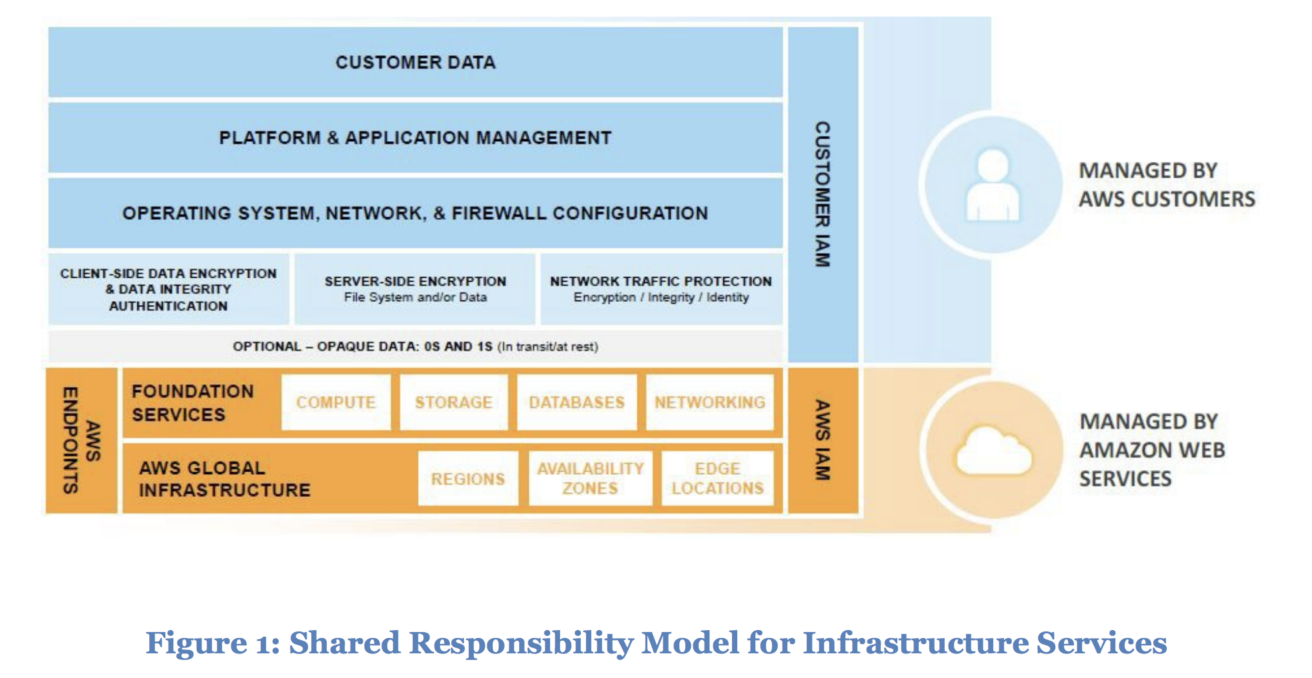

**2) Eg :Amazon RDS**

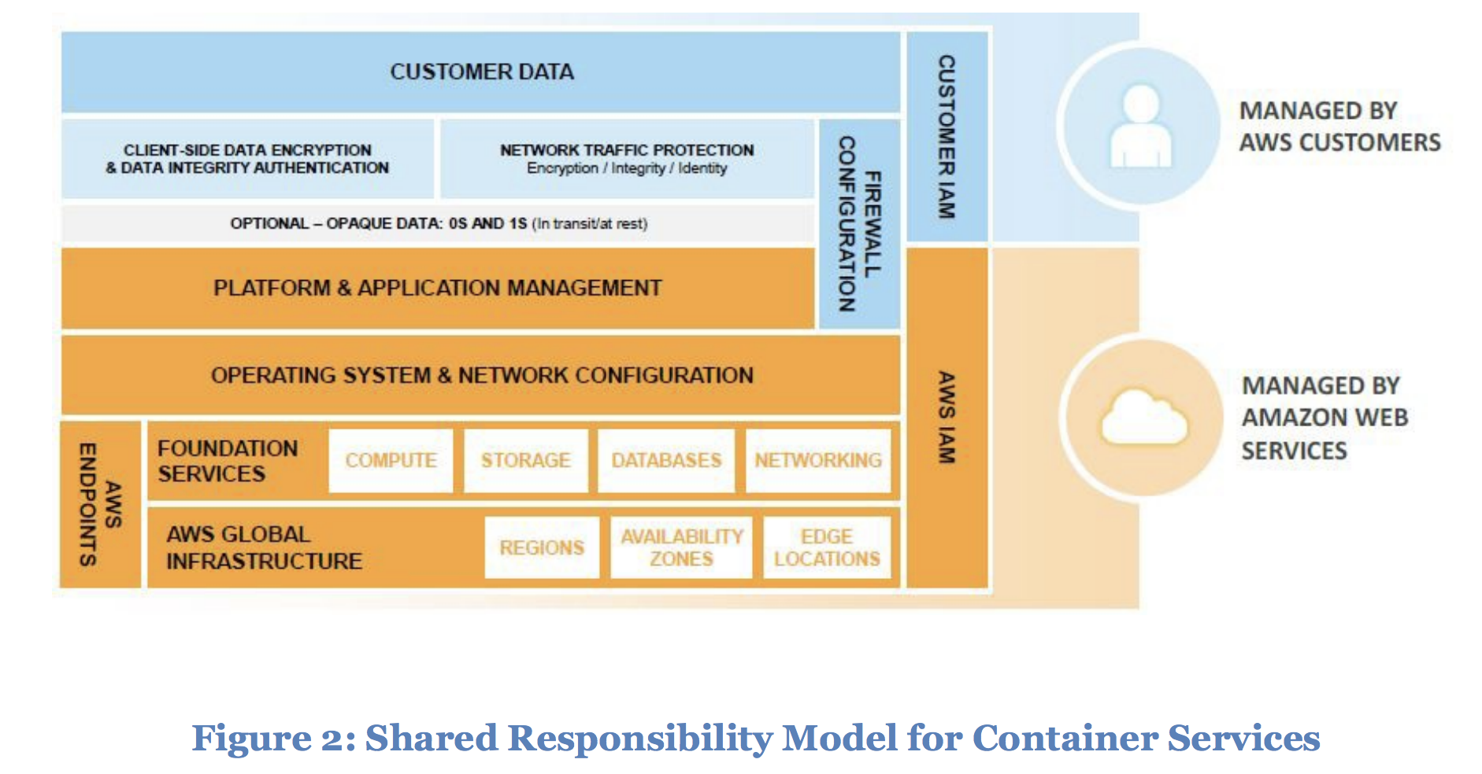

**3)**

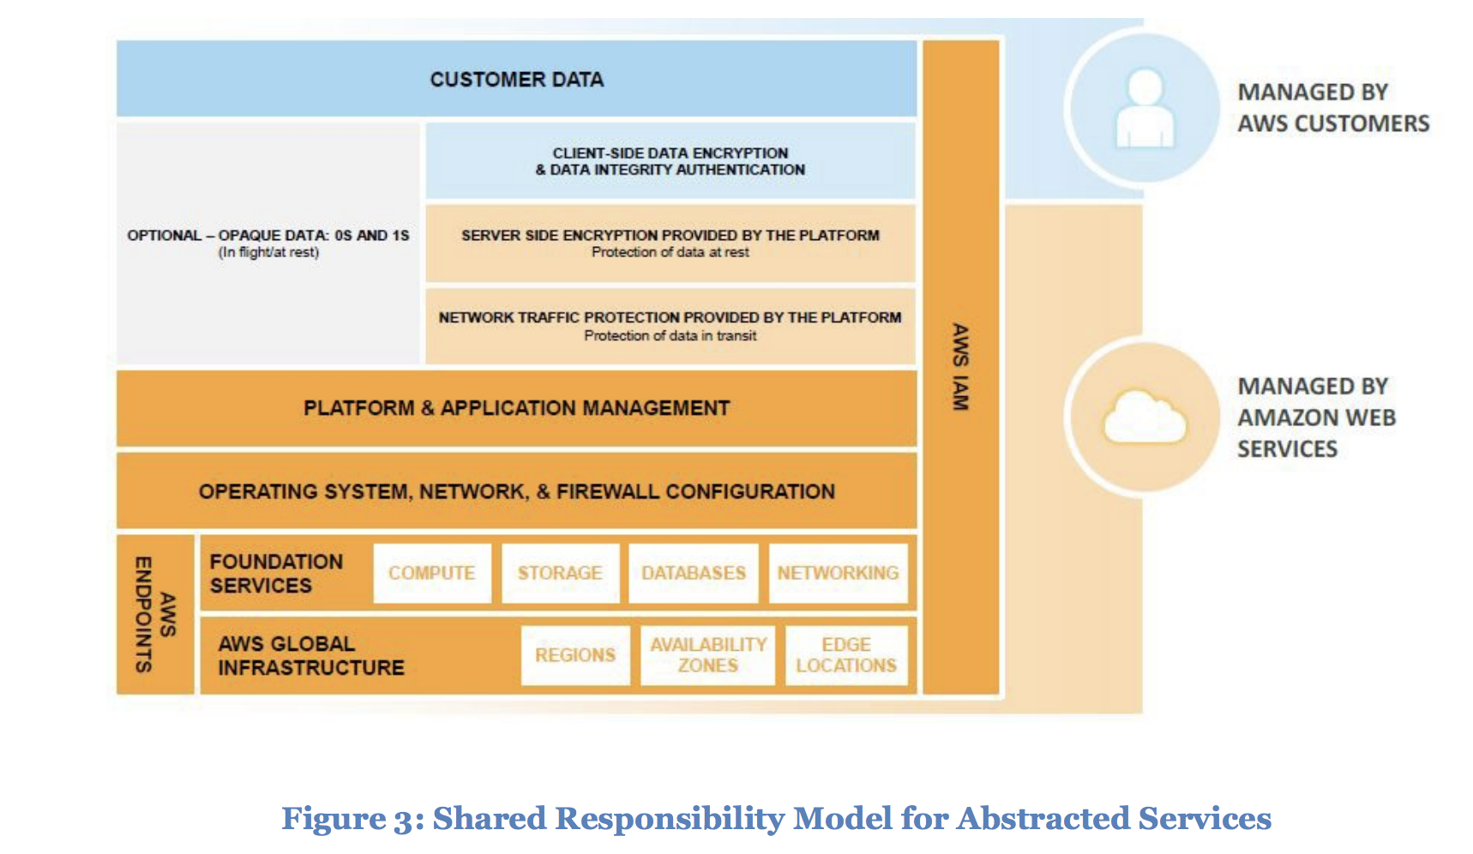

More details:

<https://d1.awsstatic.com/whitepapers/Security/AWS_Security_Best_Practices.pdf>

**Quiz:**

**You are required to patch OS and Applications in RDS? – False**

**In the shared responsibility model, what is AWS's responsibility?**

**Restricting access to the data centers, proper destruction of decommissioned disks, patching of firmware for the hardware on which your AWS resources reside.**

**Route 53/DNS**

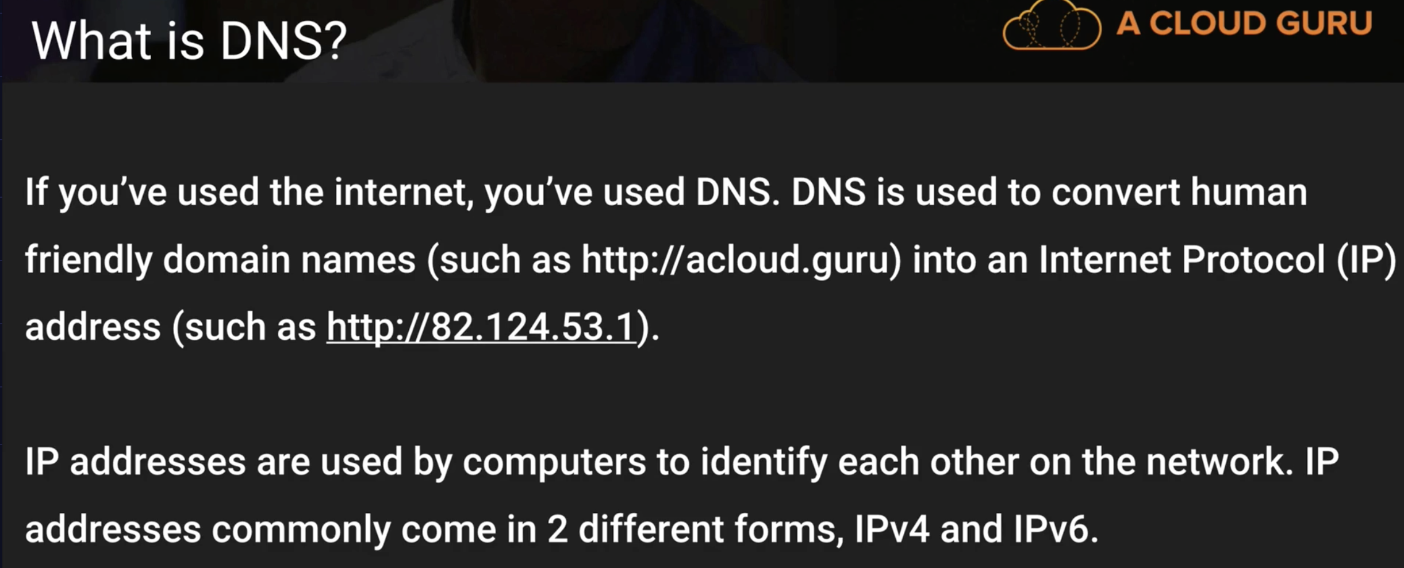

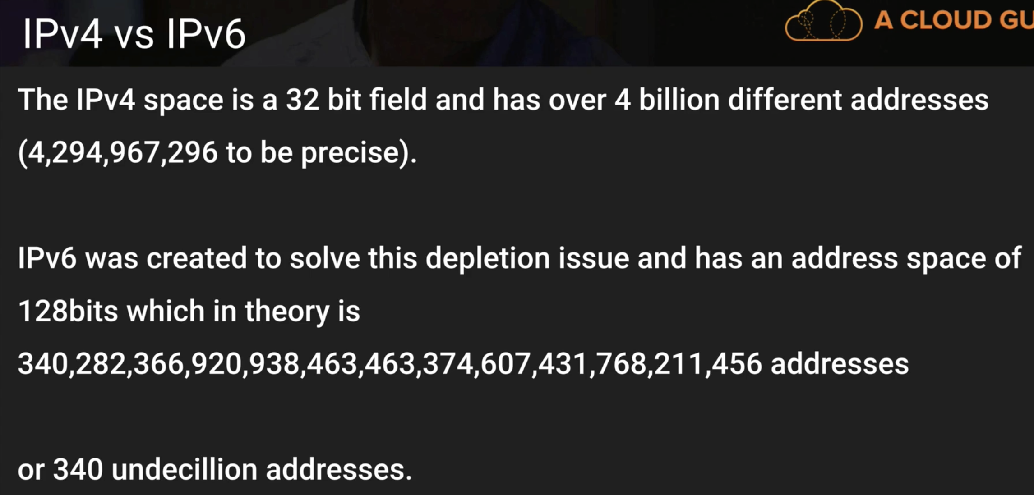

You can use IPv6 in AWS services now.

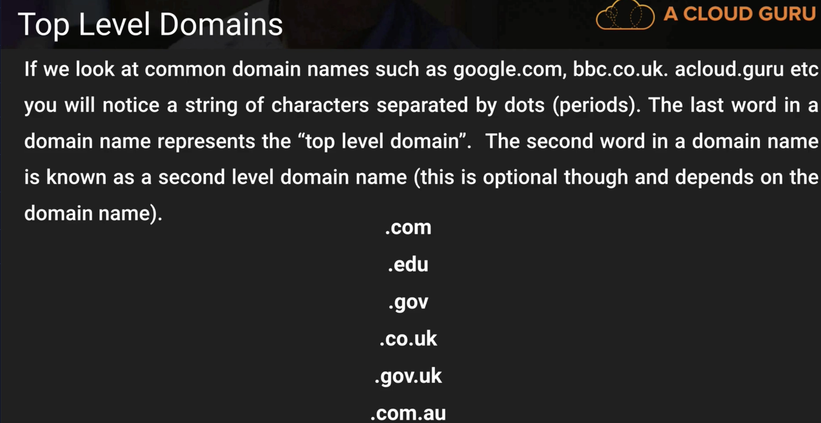

Amazon is now Domain Name Registrar. Previously you would have to go to GoDaddy.com,etc.

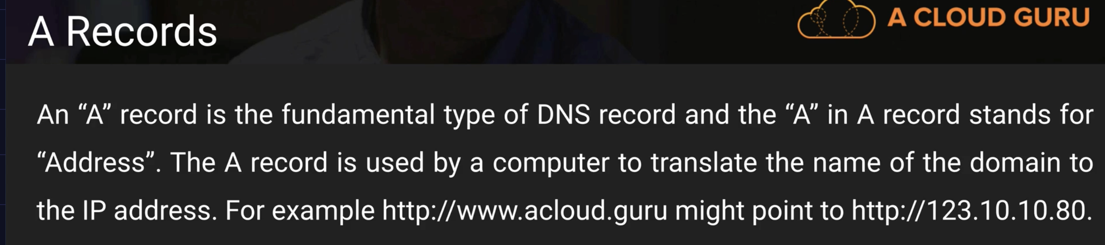

In AWS, Elastic Load balancers have only DNS Name. Amazon handles IPv4 or IPv6

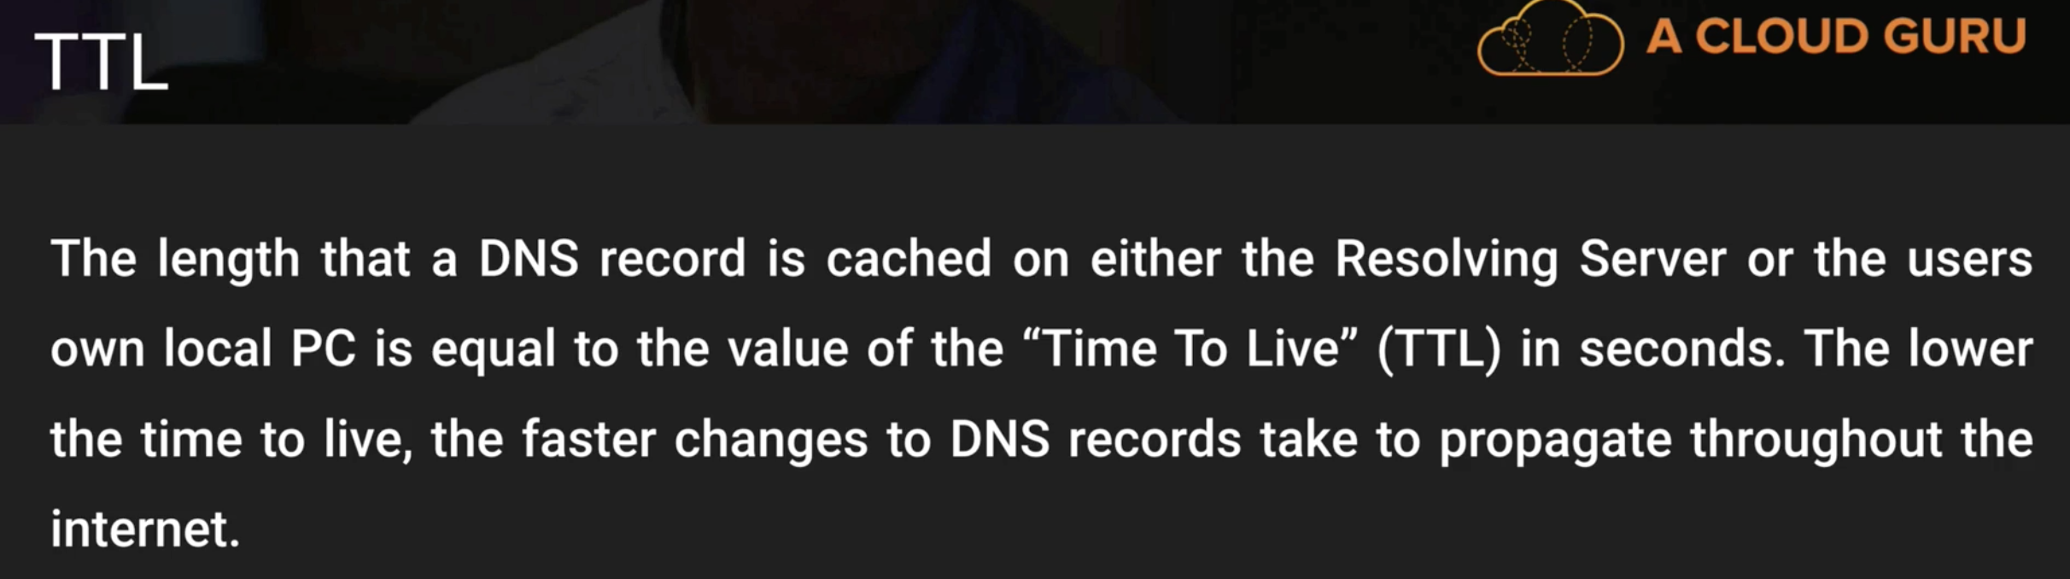

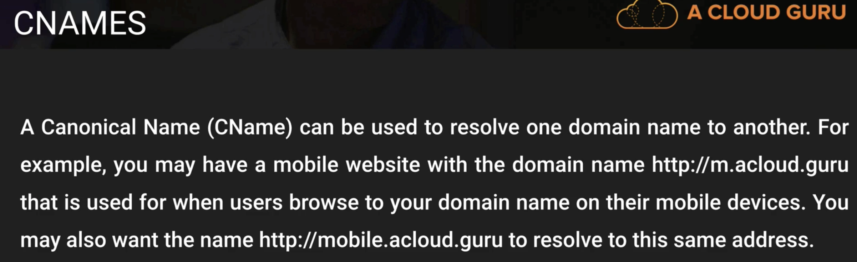

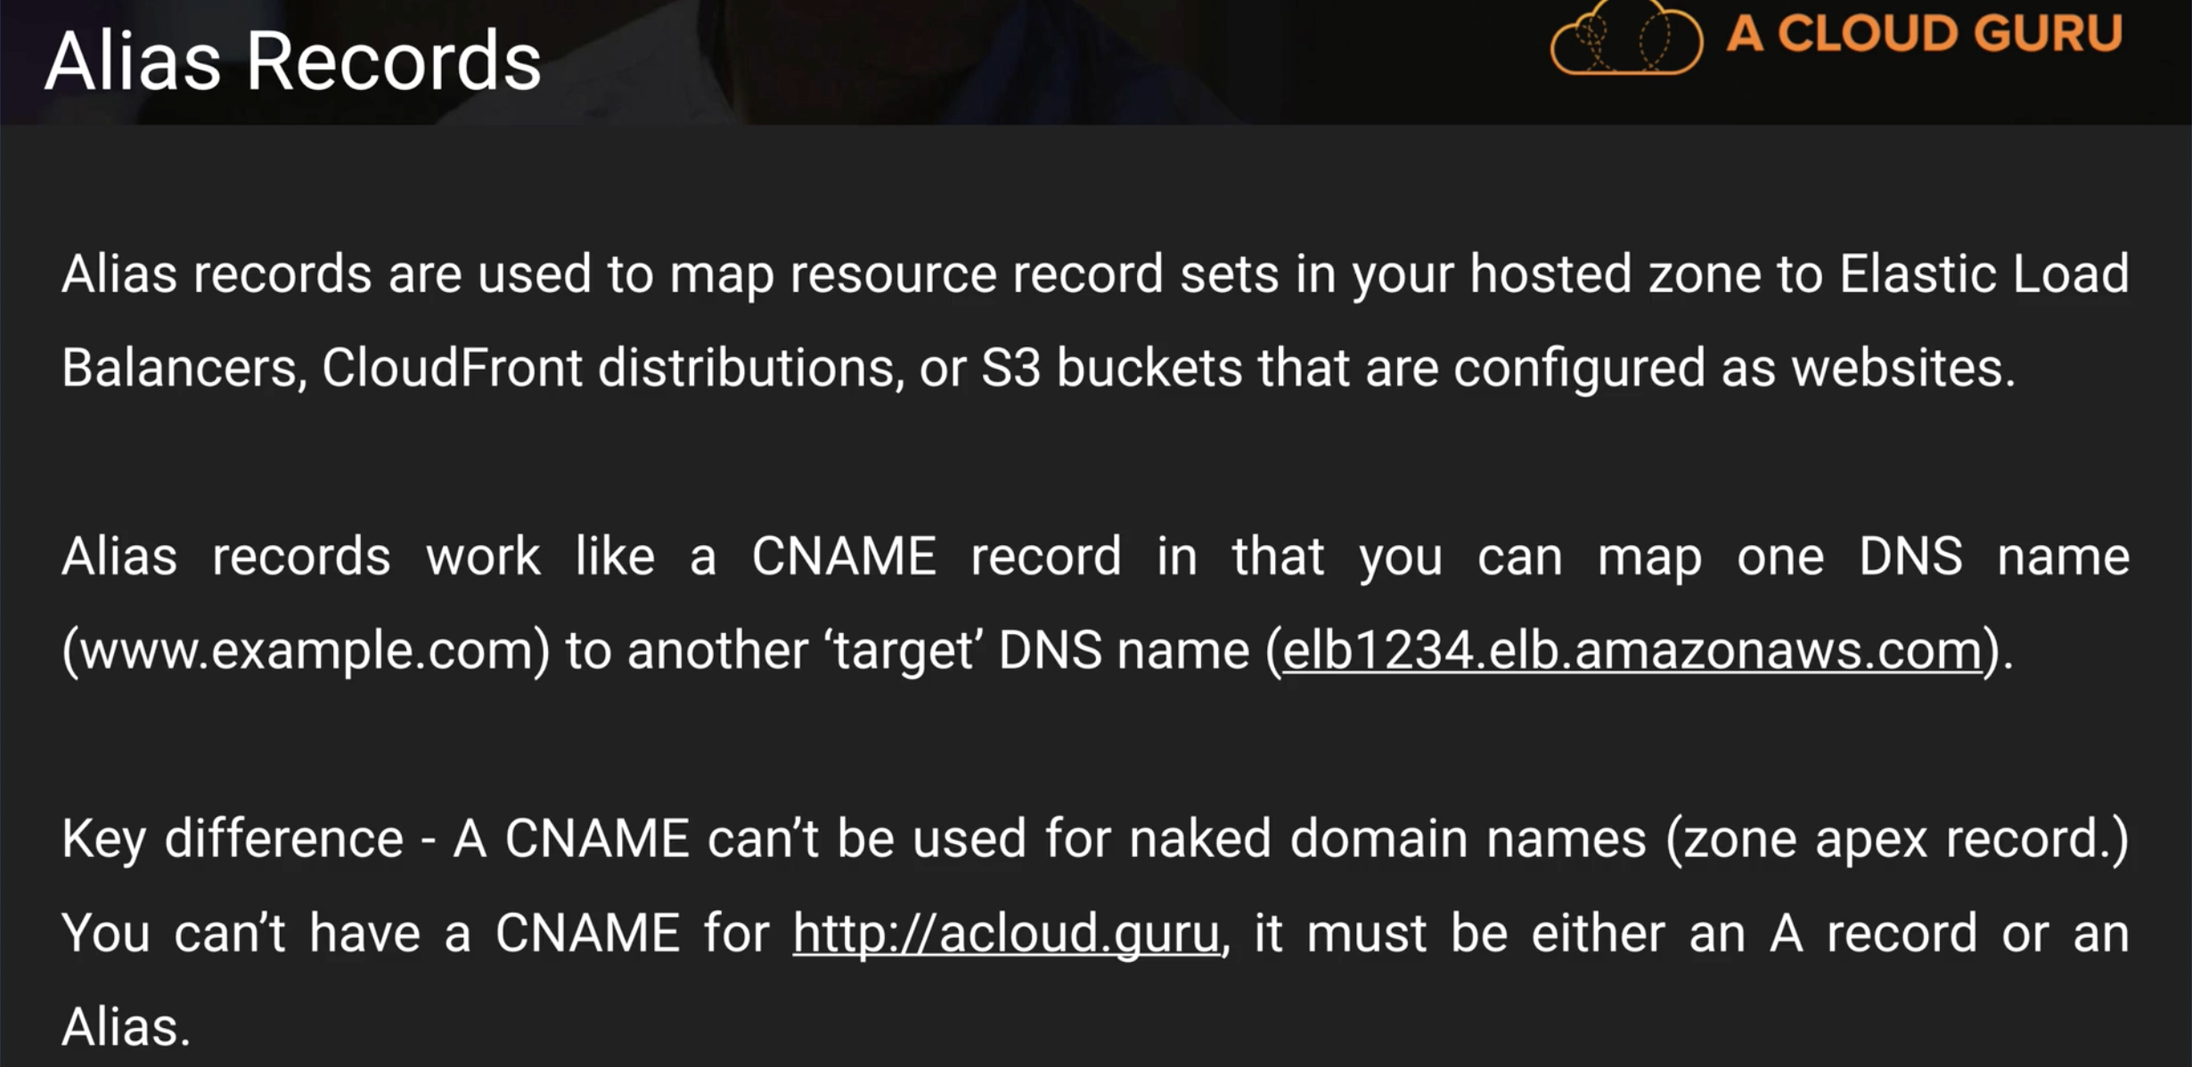

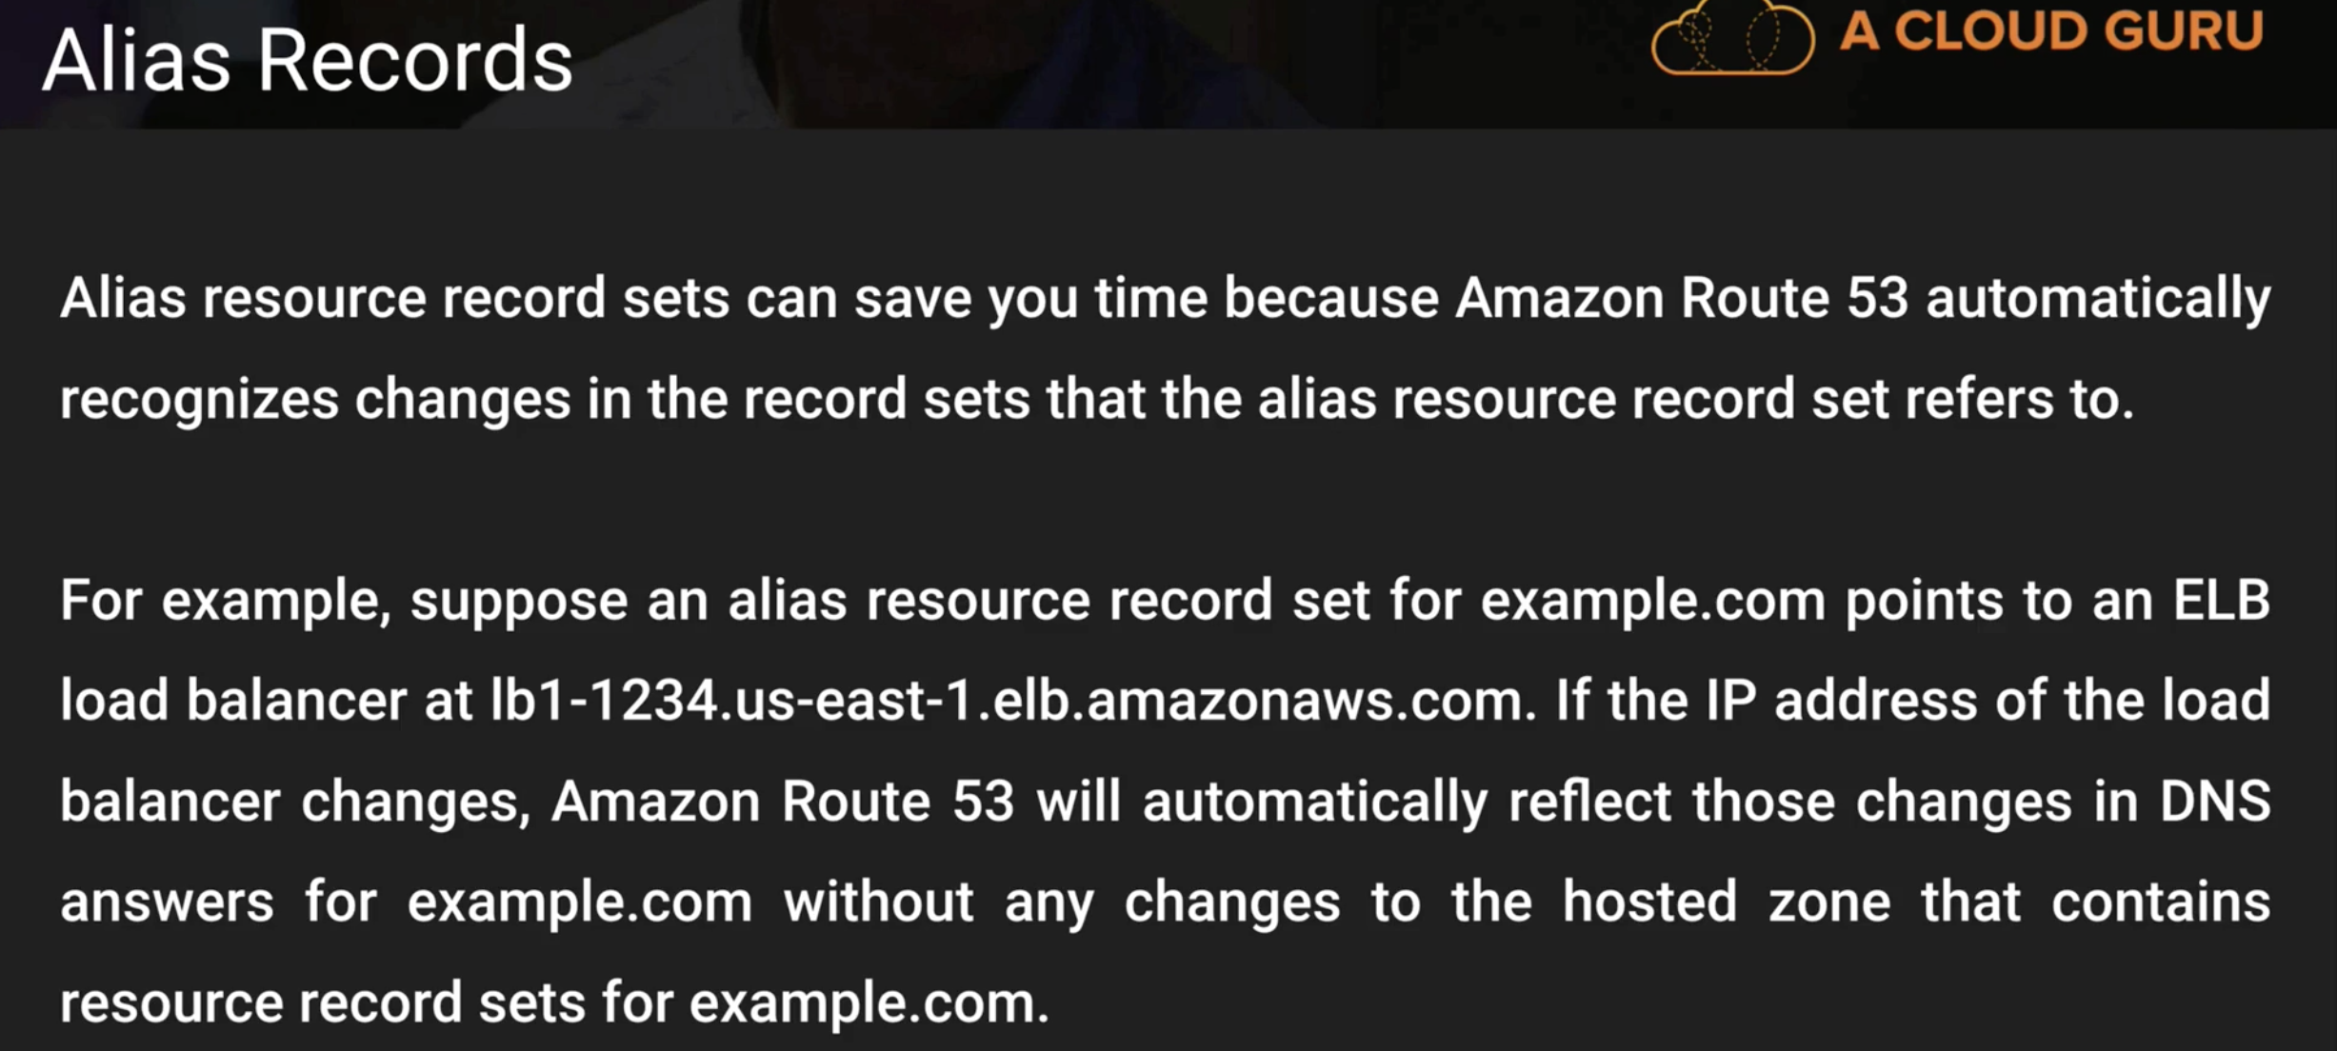

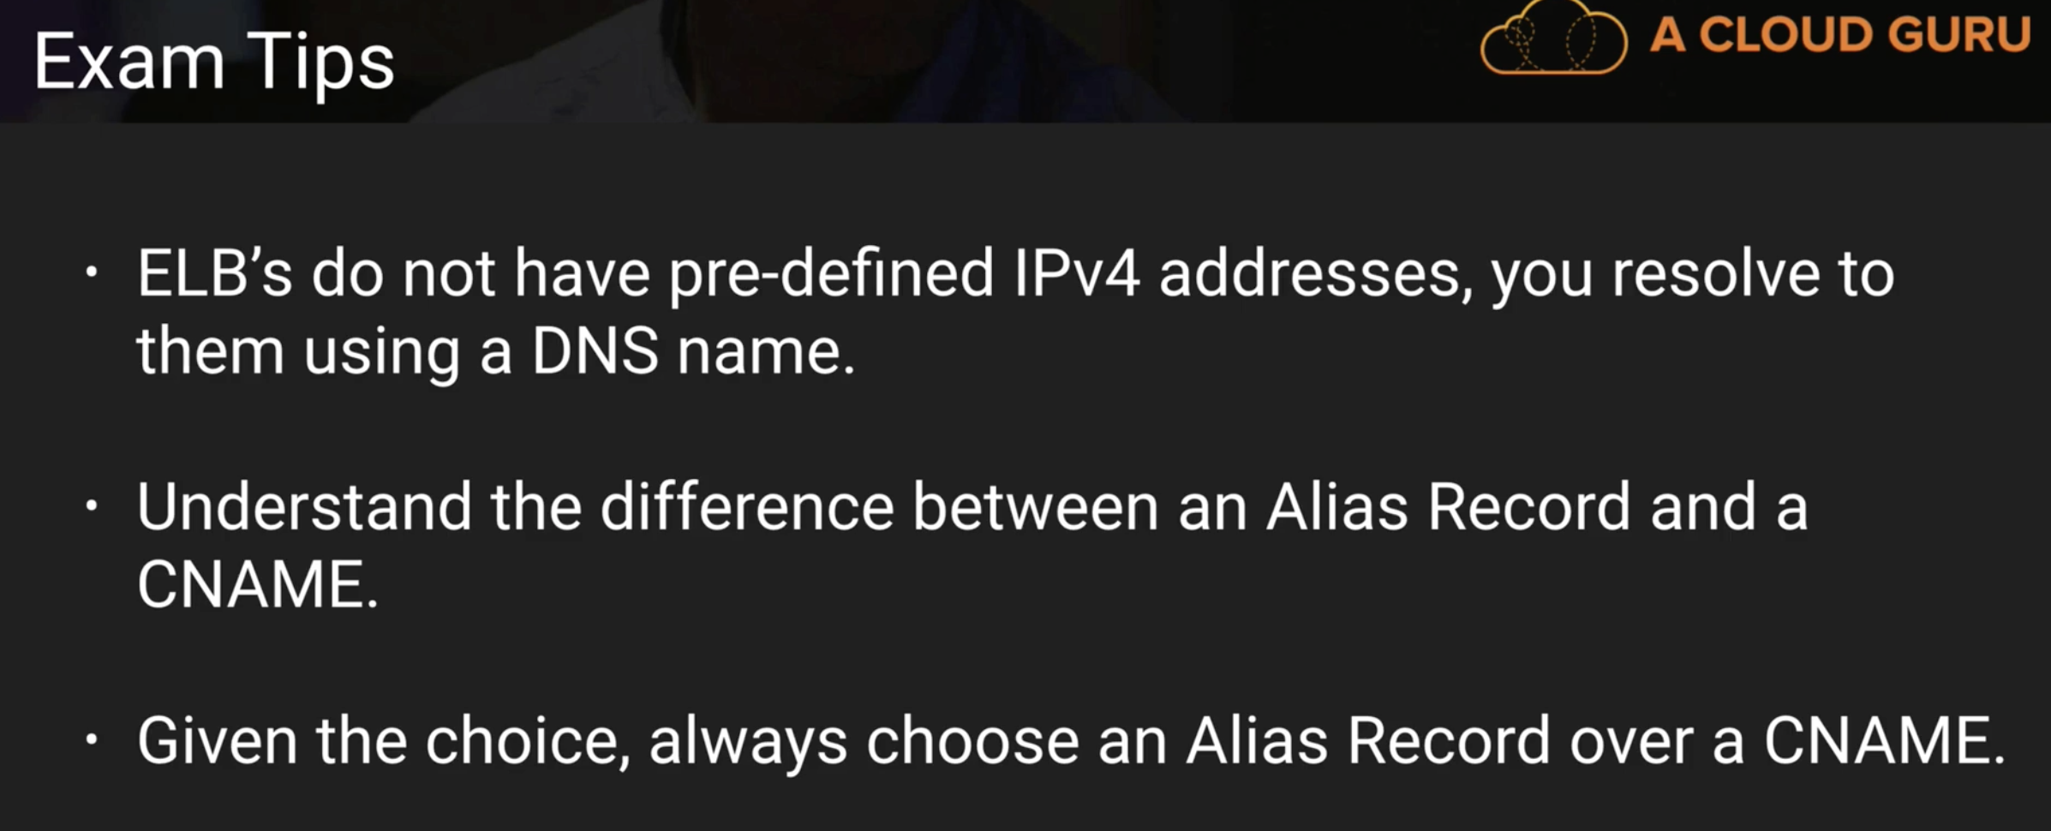

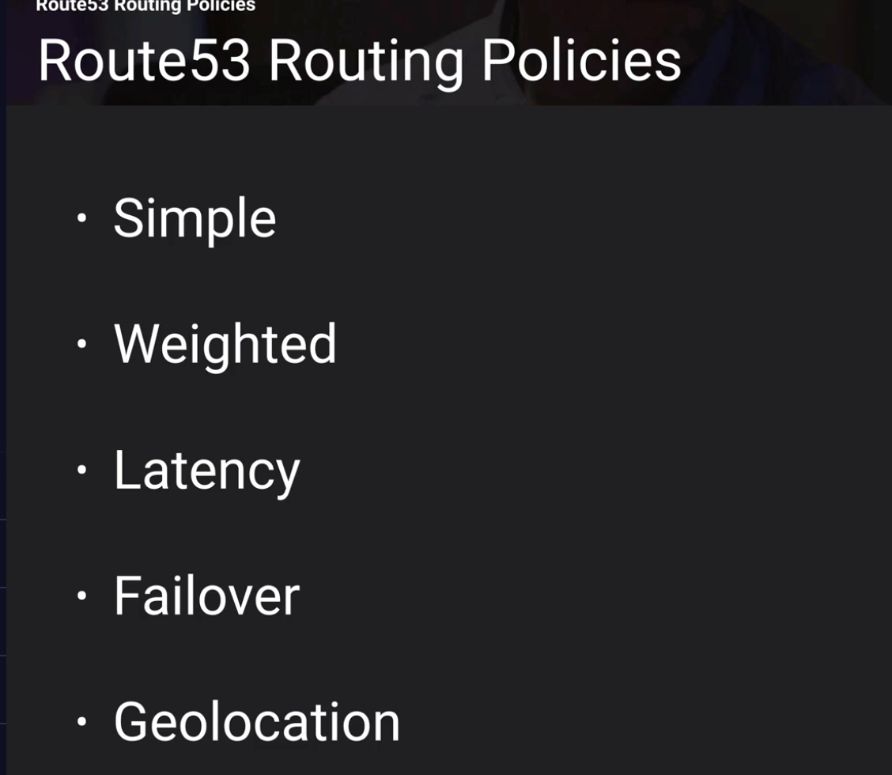

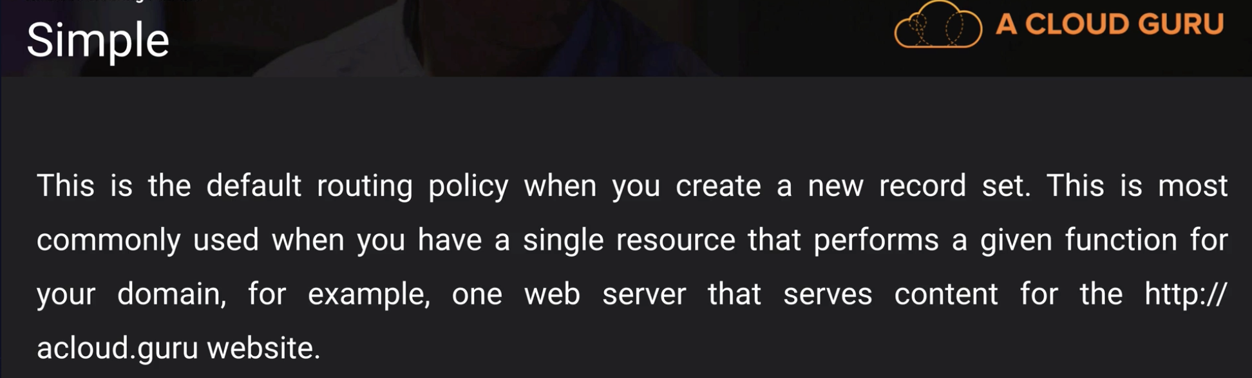

when you create a domain name, there are two default records in it. NameServer and SOA

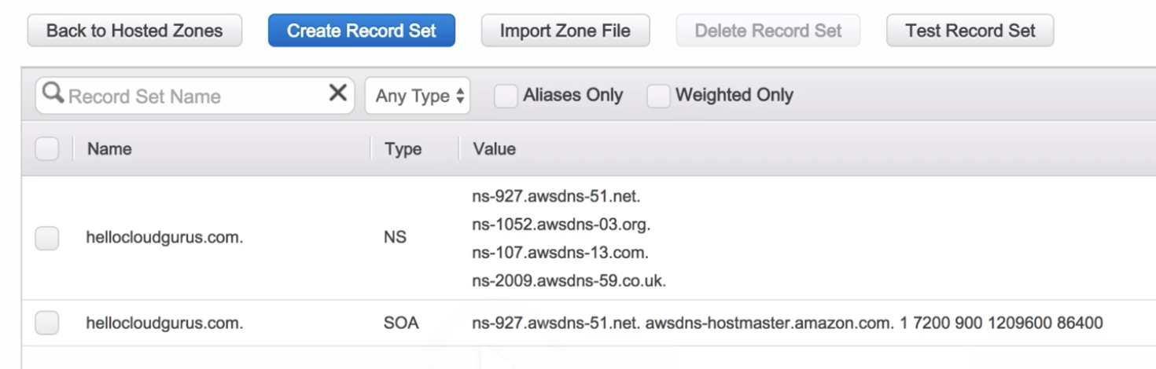

alias recordname 🡪 naked domain name (naked – no www **e.g.: hellocloudguru.com**)

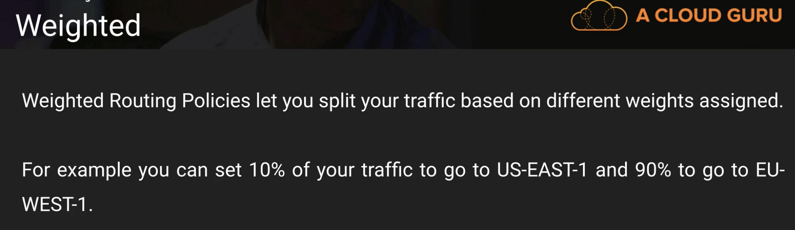

**Note: Route 53 is a global service like IAM**

Exam: can be given as a scenario

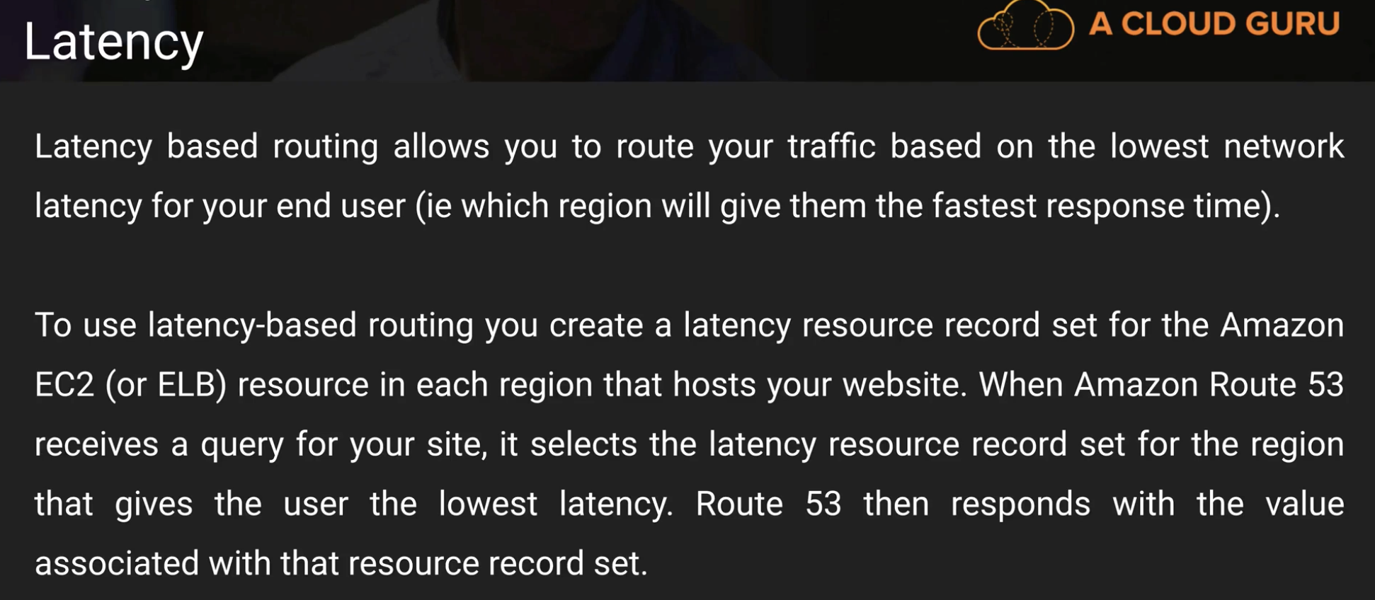

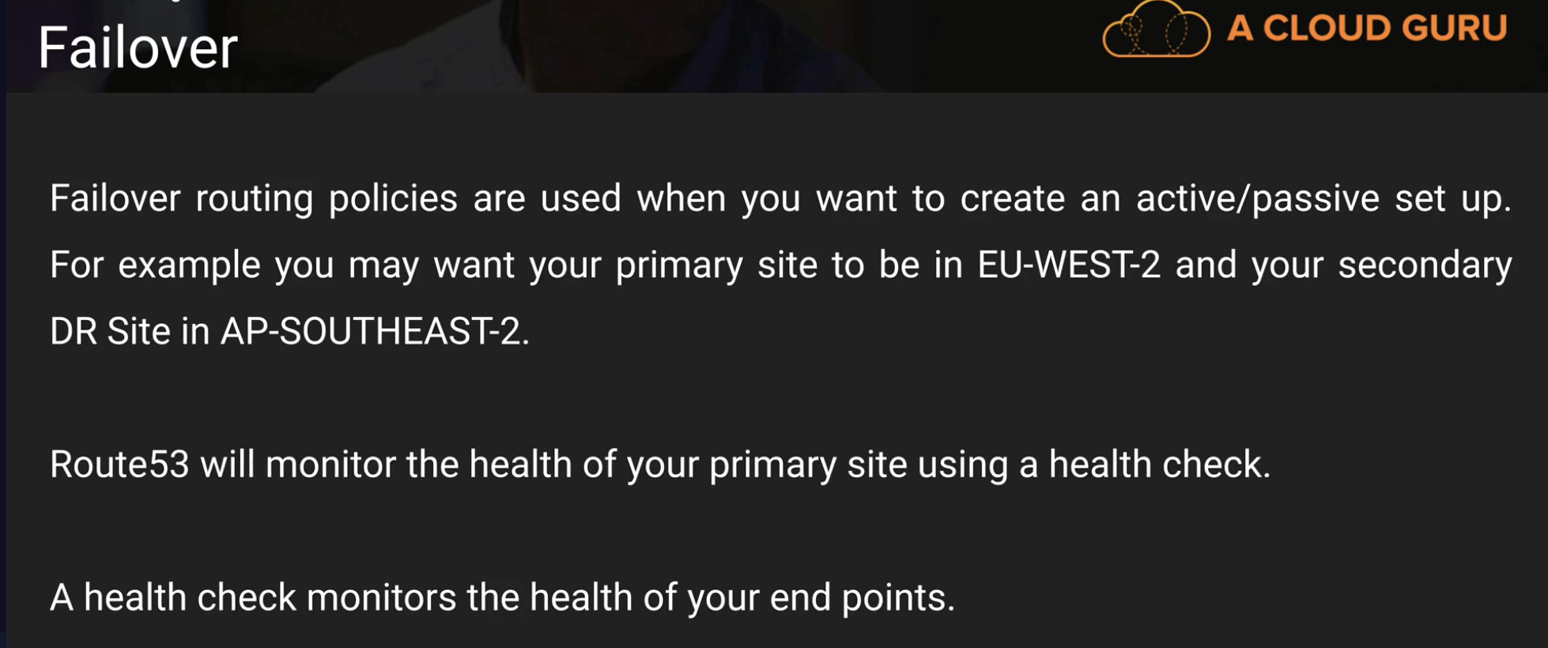

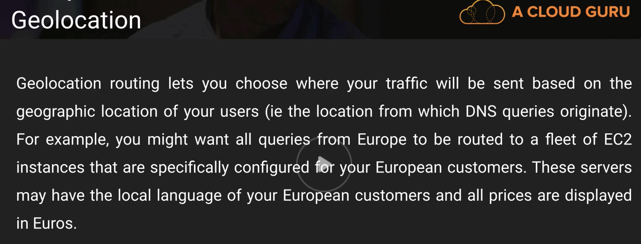

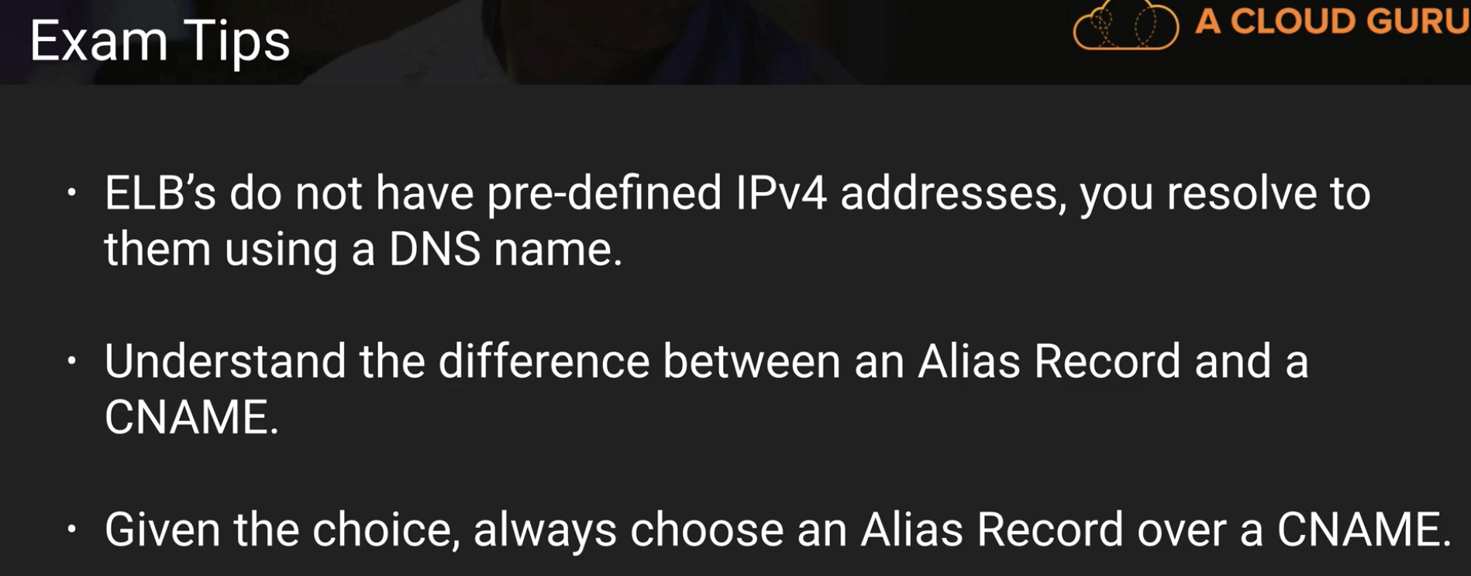

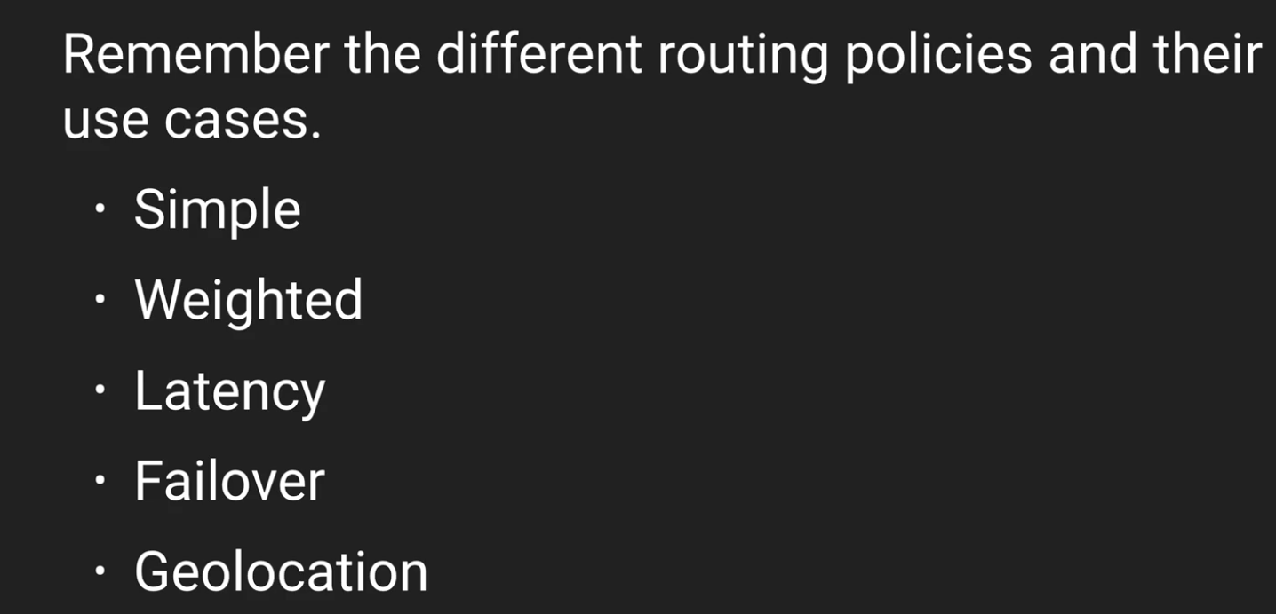

**Quiz:**

**Route53 does not support zone apex records (naked domain names). – False**

**Does Route53 support MX Records? – Yes**

**True or False: There is a limit to the number of domain names that you can manage using Route 53?**

**True and False. With Route 53, there is a default limit of 50 domain names. However, this limit can be increased by contacting AWS support.**

**Route53 is named so because ________.**

**The DNS Port is on Port 53 and Route53 is a DNS Service.**

**Virtual Private Cloud**

VPC is virtual data center in the cloud.

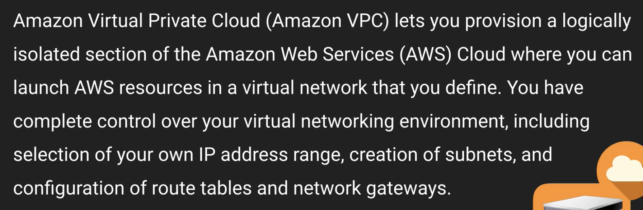

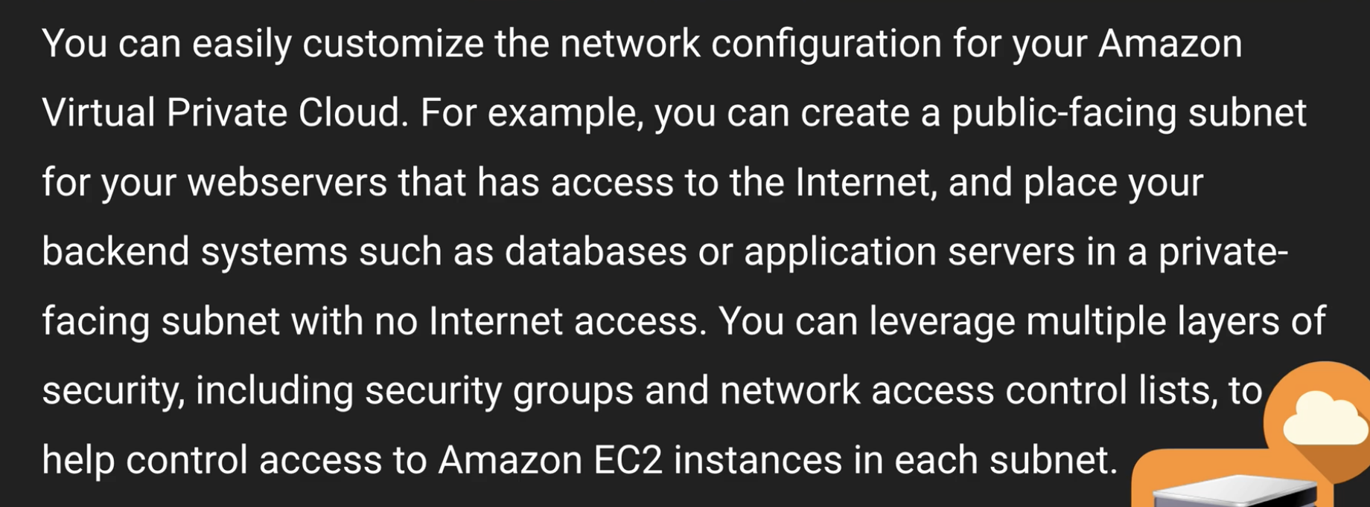

**\*\*\*\*\*\*\*\*\*one subnet is one availability zone.**

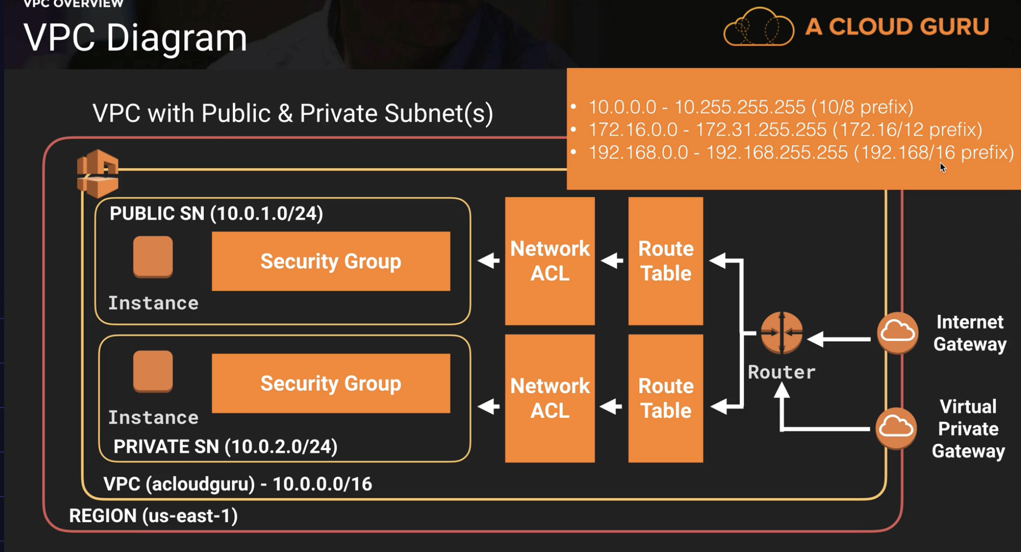

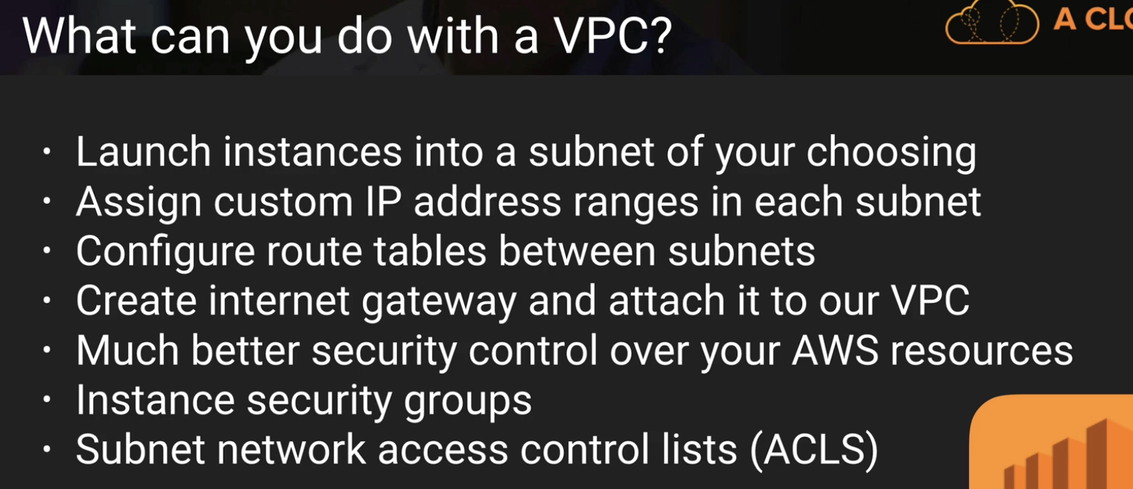

Using ACLS you can block IP address.

Note: all the points below are for default VPC

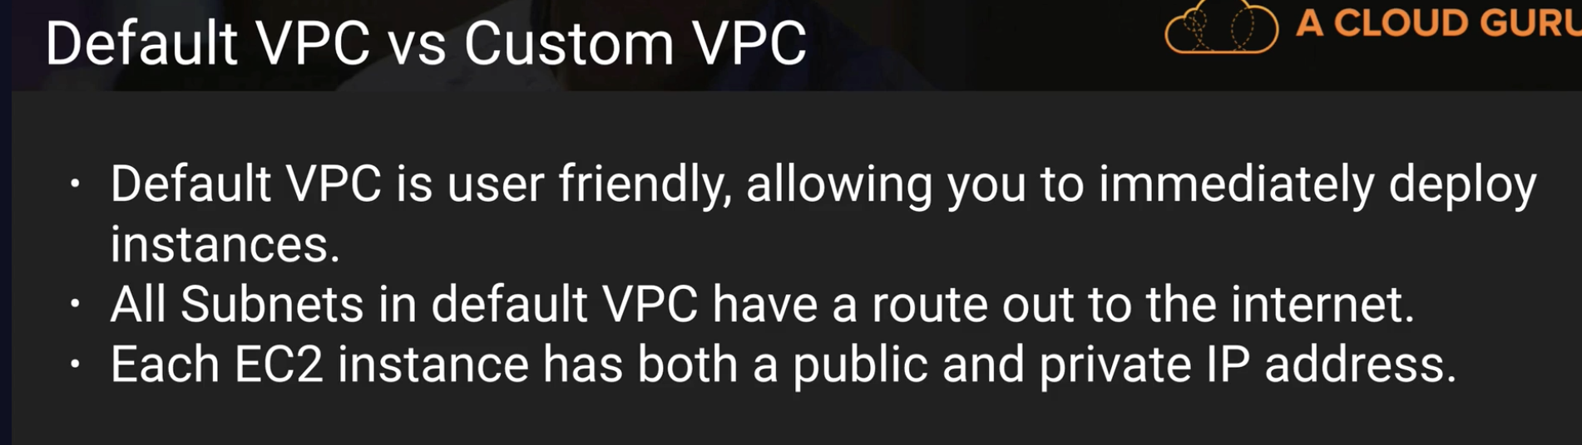

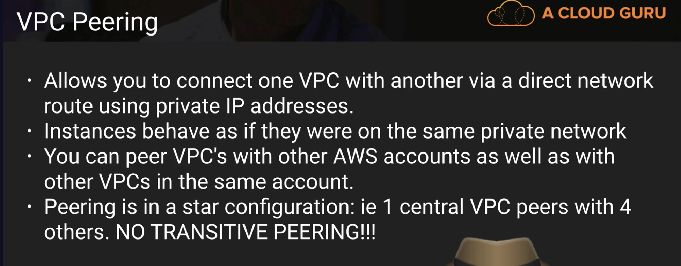

VPC B cannot talk to VPC D through VPC A. so there is NO transitive peering.

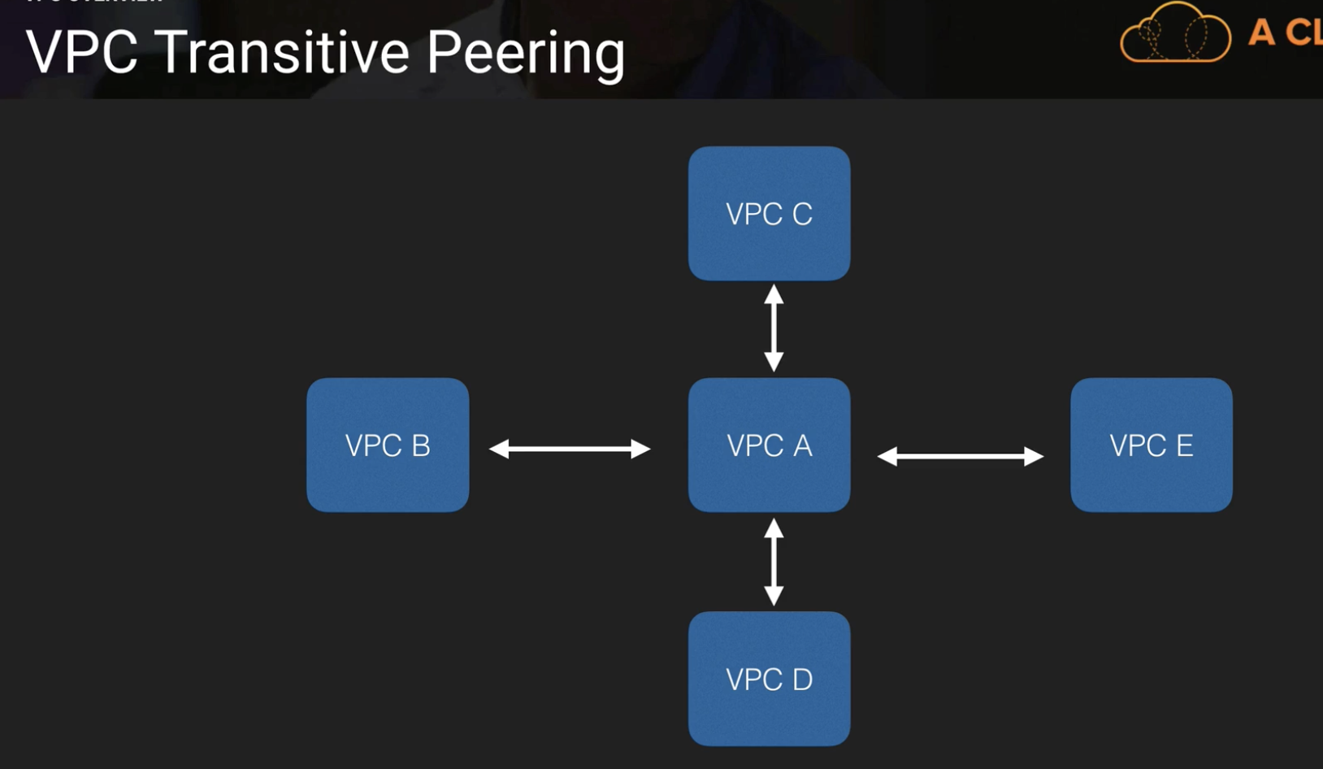

**In the below slide,**

**Security groups are stateful – If u open port 80, inbound and outbound are automatically open.**

**With Network Access control Lists you have to do inbound and outbound separately.**

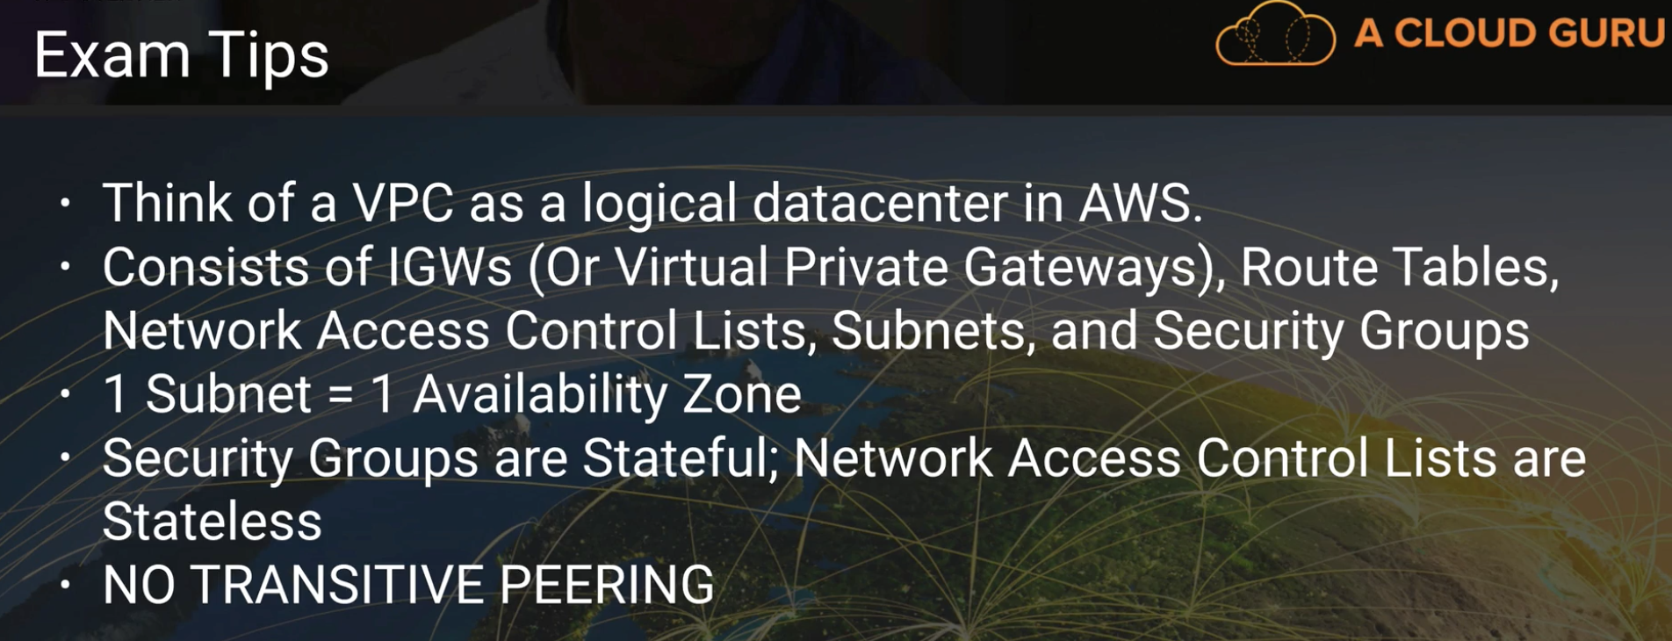

**10.0.1.0/24 – 256 hosts but you get only 251 because:**

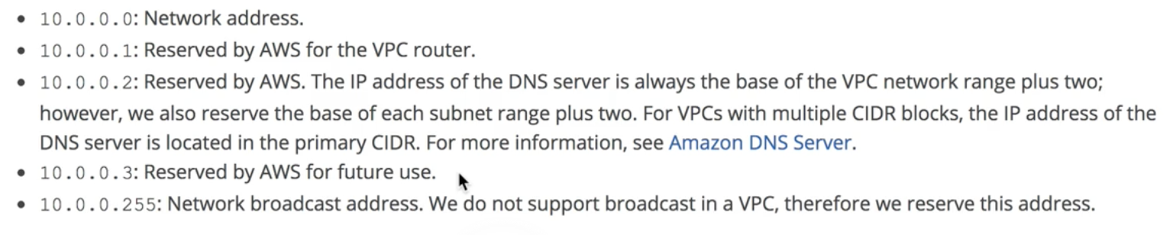

**You cannot have multiple Internet gateways for same VPC**

**Using NAT Gateway:**

**Nat Gateways are more preferred than NAT Instances**

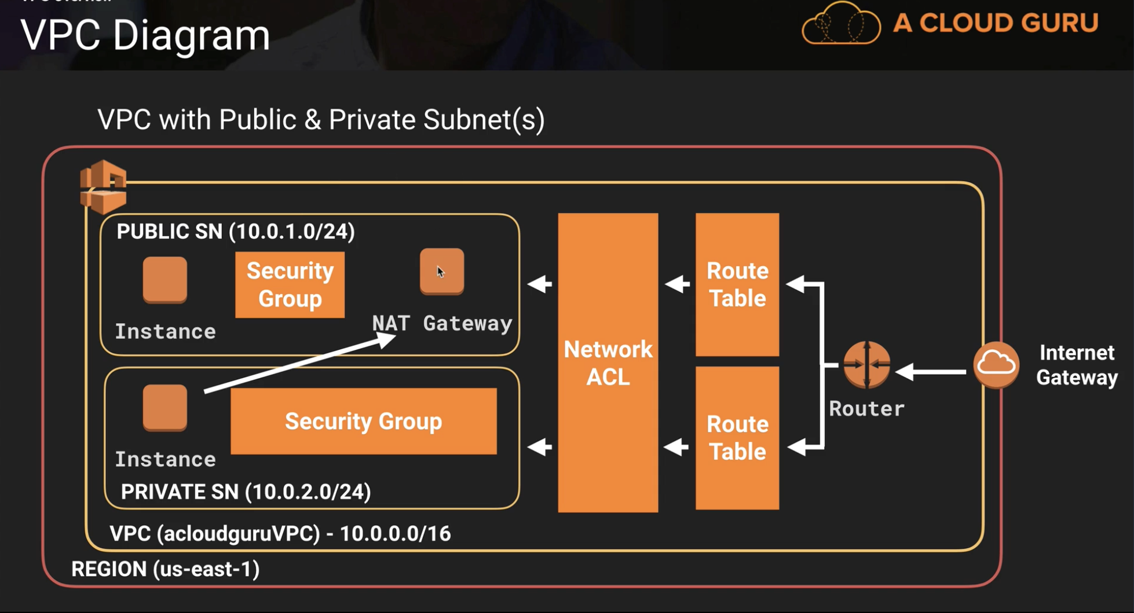

In the below slide, first step means 🡪 NAT cannot be just a source or destination. It has not send and receive traffic. So, we disable Source/Destination check

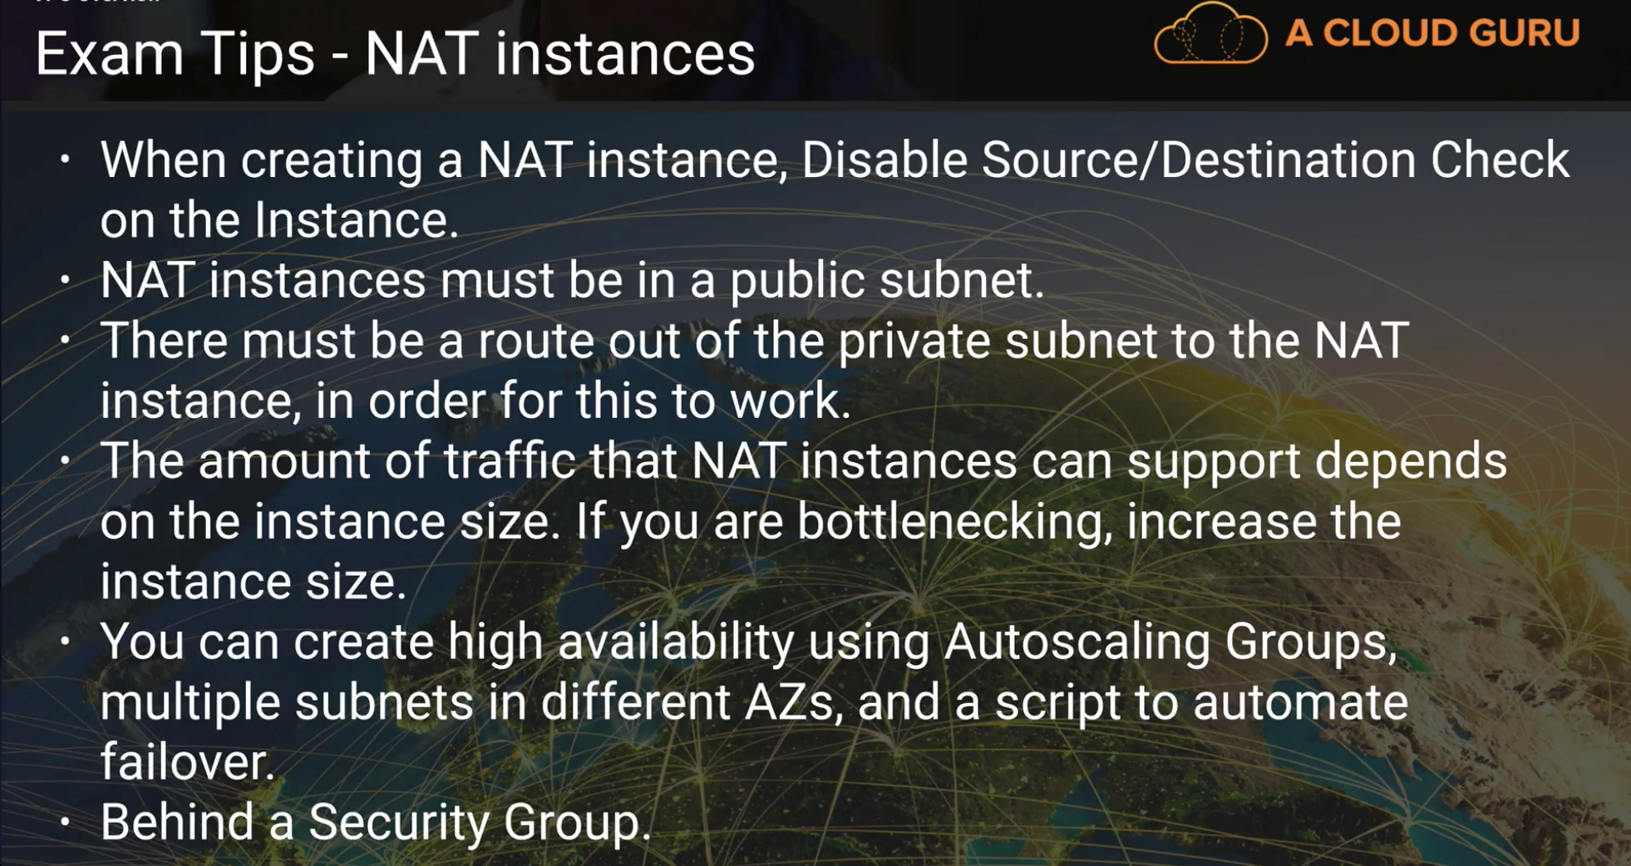

**In this slide, scale has changed to 45Gbps.**

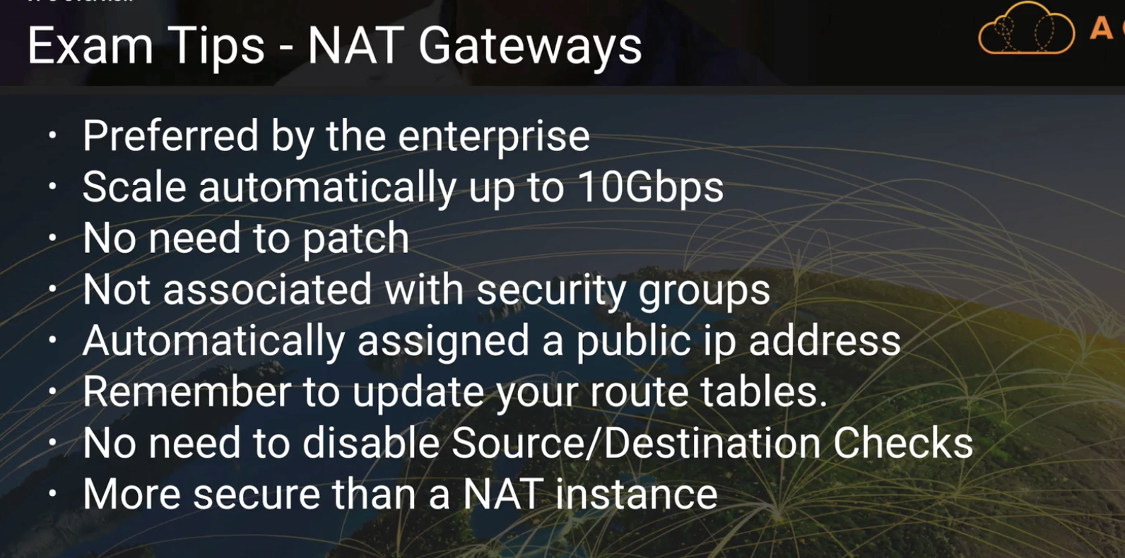

**Note:**

**\*\*One Subnet can be associated with one NetworkACL.**

**\*\*A newly created NACL will have inbound and outbound rules denied. But a default NACL given by AWS will have all inbound and outbound rules allowed.**

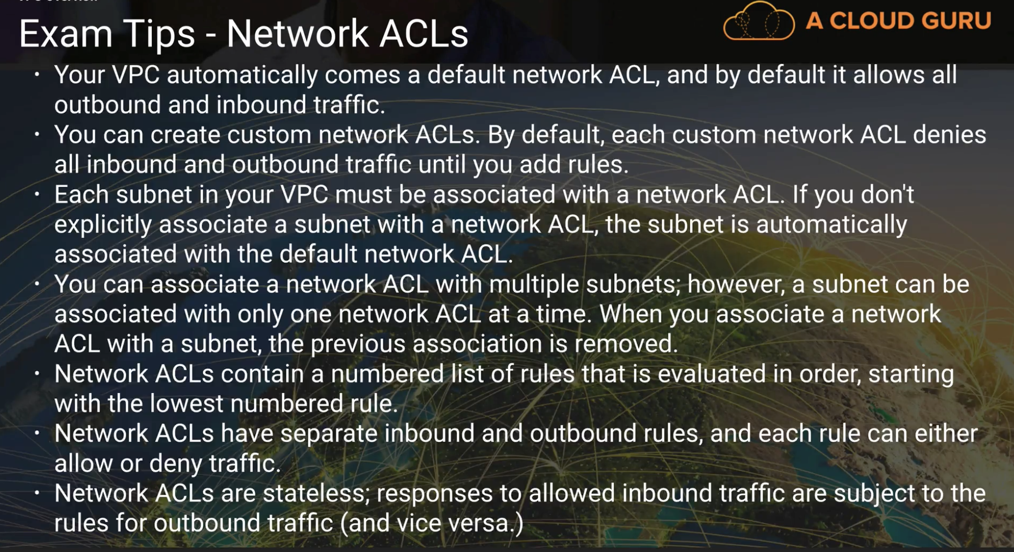

**In NACL, outbound rules must be open to ephemeral ports.**

**Ephemeral port - server response can be connected to THESE client’s port numbers.**



**\*\*For Application load balancers, you need at least two subnets specified. (i.e 2 AZs)**

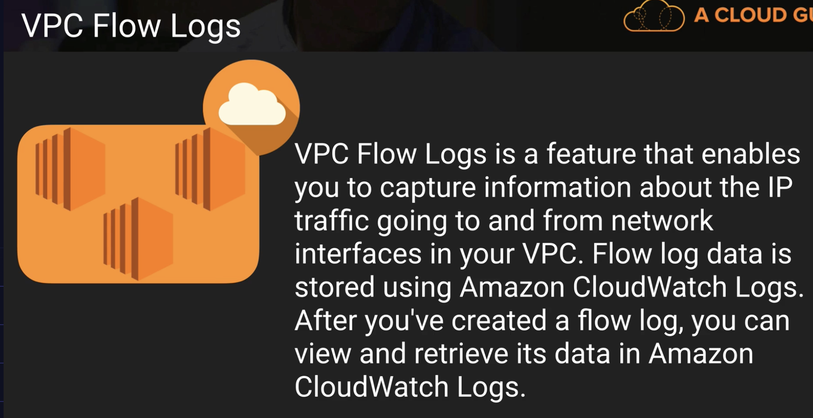

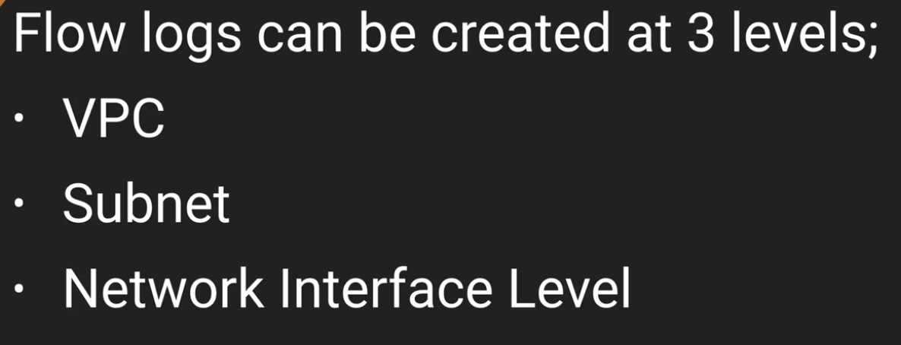

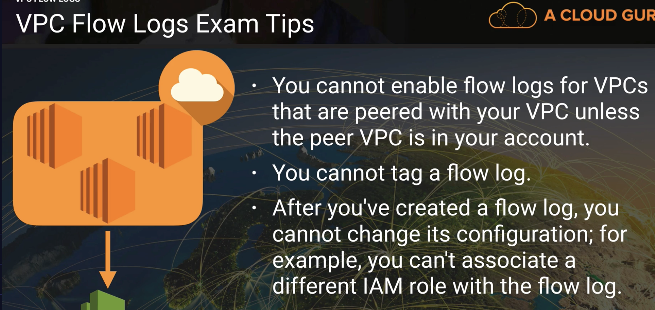

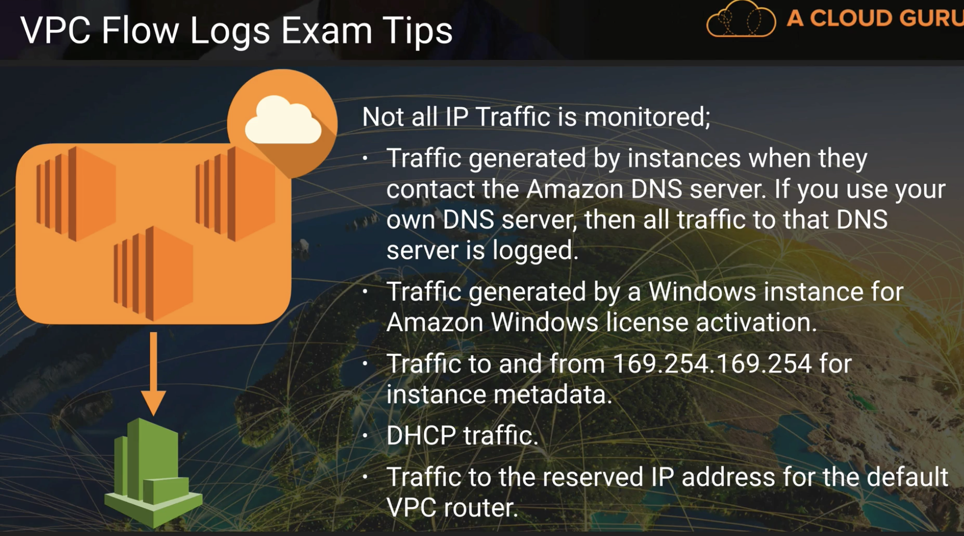

**\*\*Bastion is used to communicate to private subnets in the VPC**

**\*\*NAT Instances are always behind a security group.**

**\*\*NAT Gateways are security independent (Amazon deals with the security).**

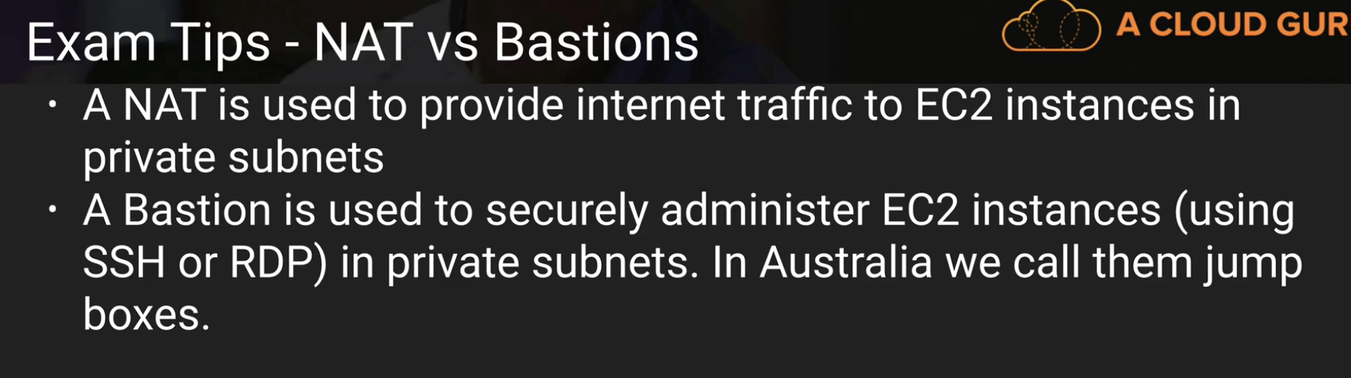

**VPC end points:**

It is creating an Internal gateway to reach services like S3 without passing through the public traffic.

VPC SUMMARY

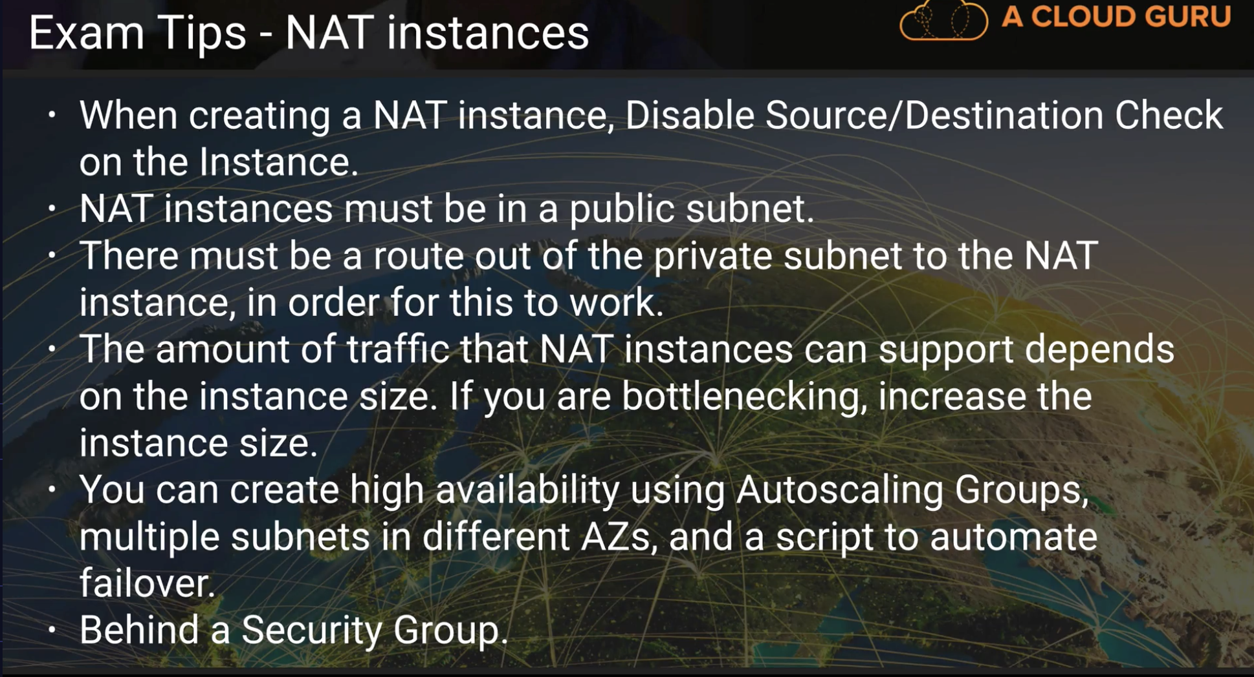

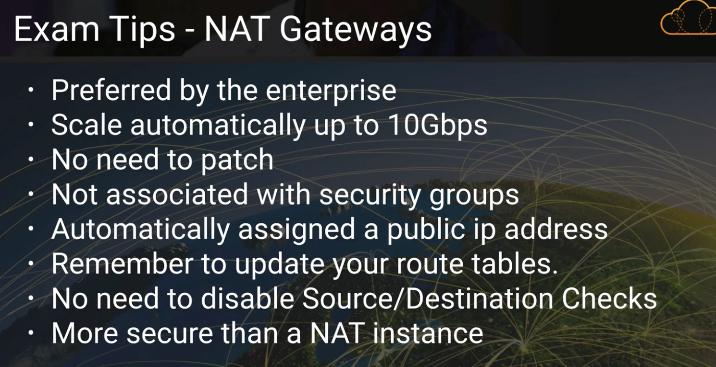

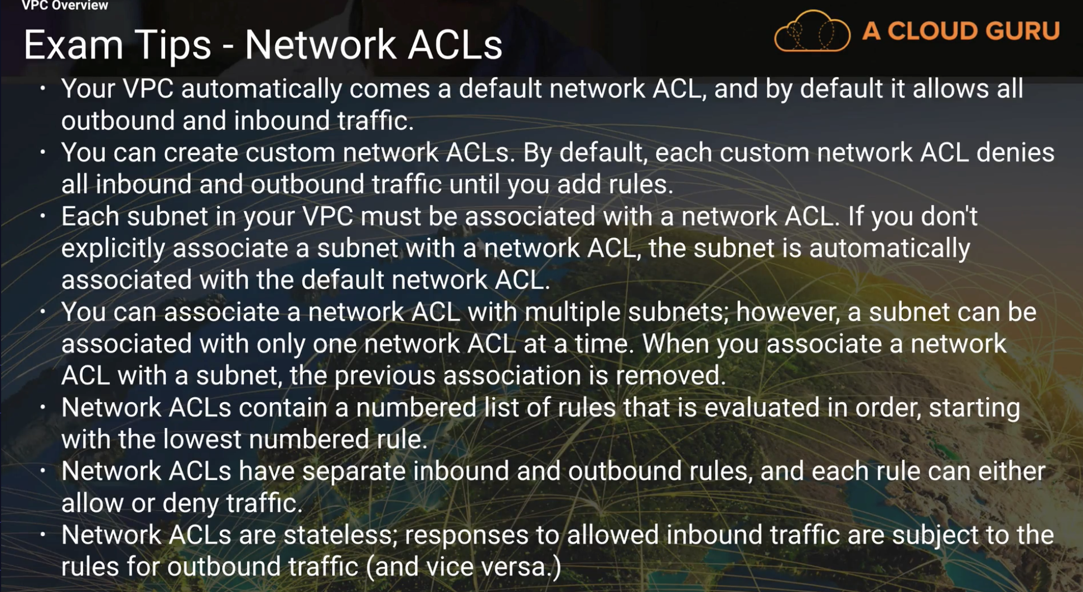

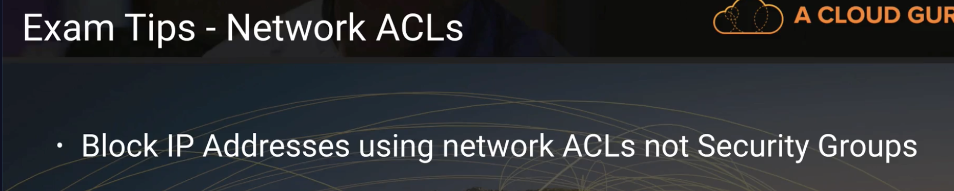

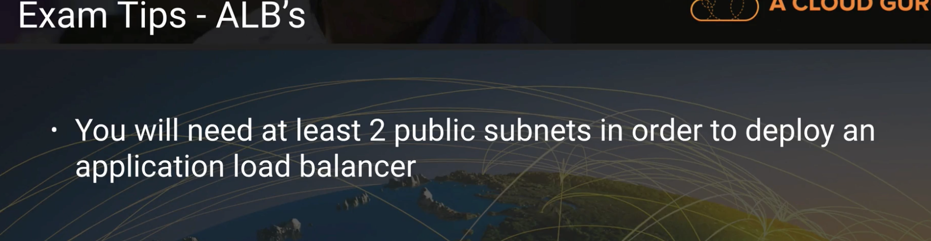

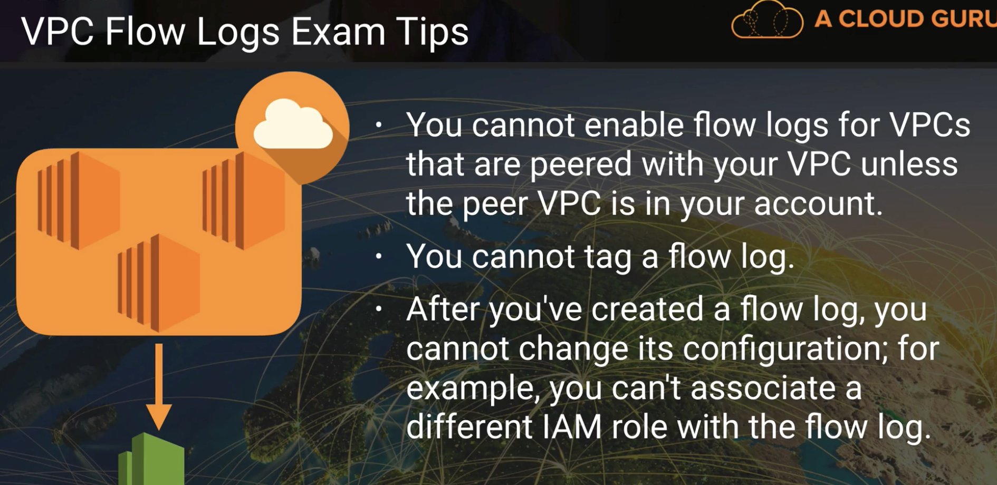

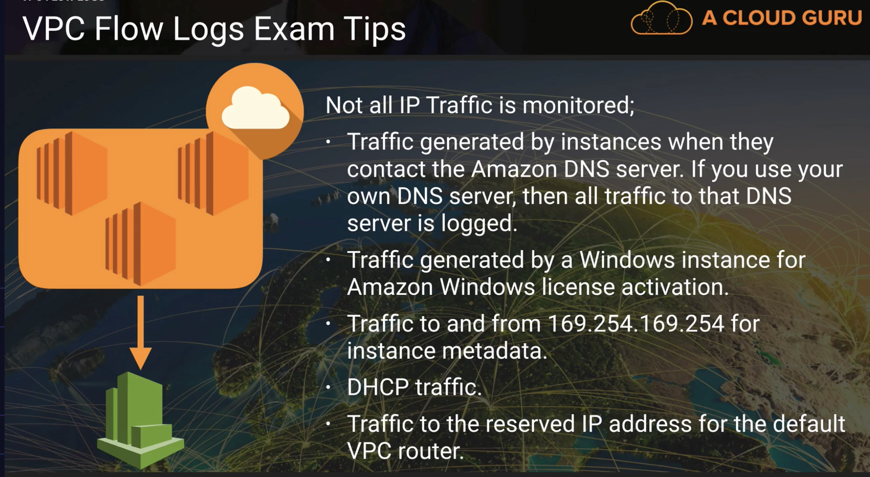

Original:

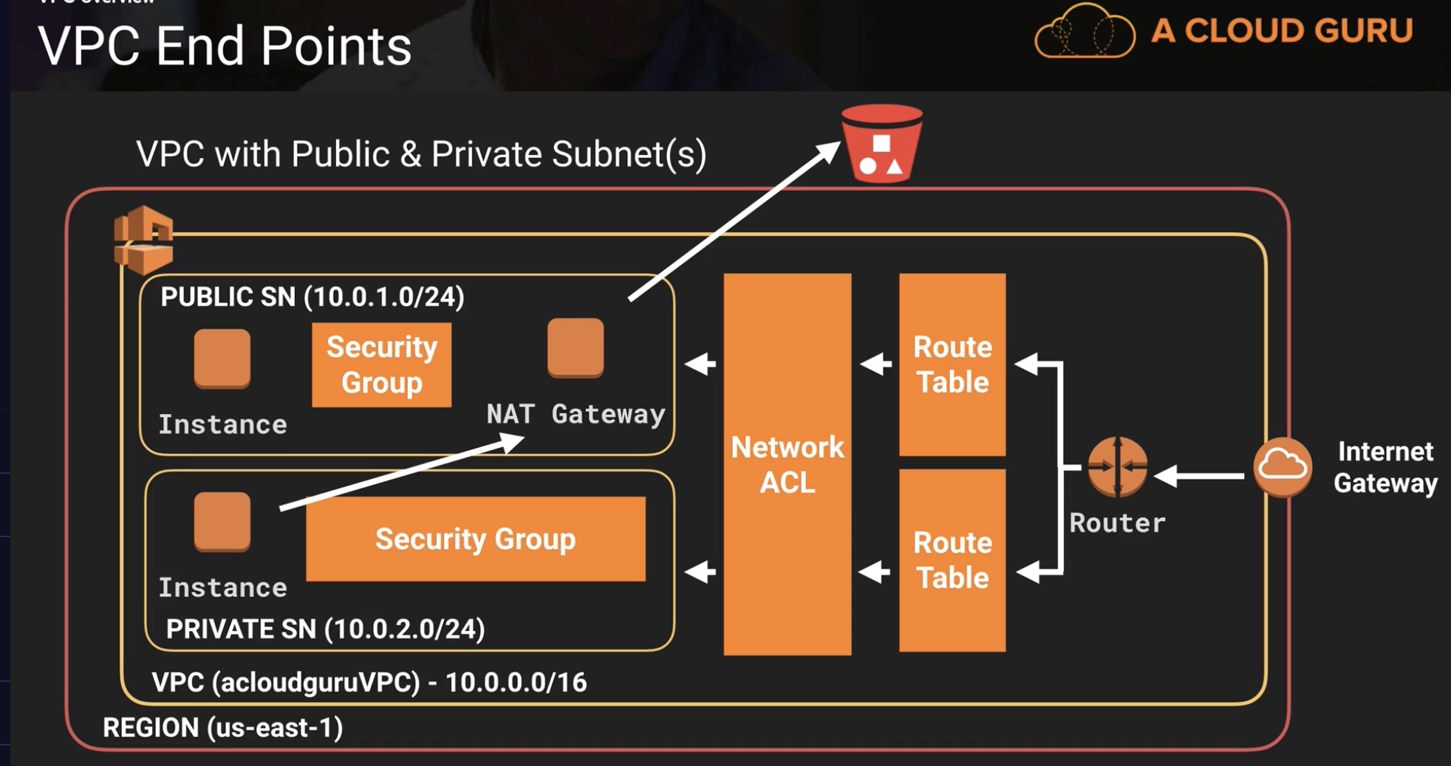

using VPC end point:

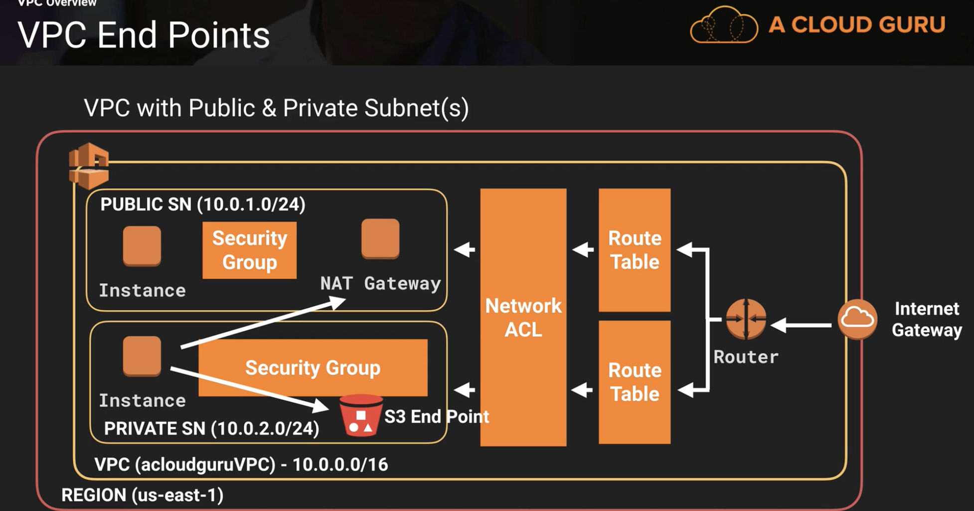

**Security groups act like a firewall at the instance level, whereas ________ are an additional layer of security that act at the subnet level. - Network ACLs**

**How many internet gateways can I attach to my custom VPC? – 1**

**Select the incorrect statement:**

**A subnet can be associated with multiple Access Control Lists. – This one**

**In Amazon VPC, an instance retains its private IP.**

**You may only have 1 internet gateway per VPC.**

**It is possible to have private subnets in VPC.**

**\*How many VPC's am I allowed in each AWS Region by default? - 5**

